FrameNotes Video Notes
FrameNotes generated this readable video note. Each fragment includes a time range, key image, and matched transcript.

Fragment 1
Time range: 00:00 - 00:06

Matched transcript
No. No, the rest would have got to be Mr. Bright, but he is certainly Mr. Seuss. The blue chase will meet with that star Jim Clancy for a couple of weeks.

Fragment 2
Time range: 00:06 - 00:12
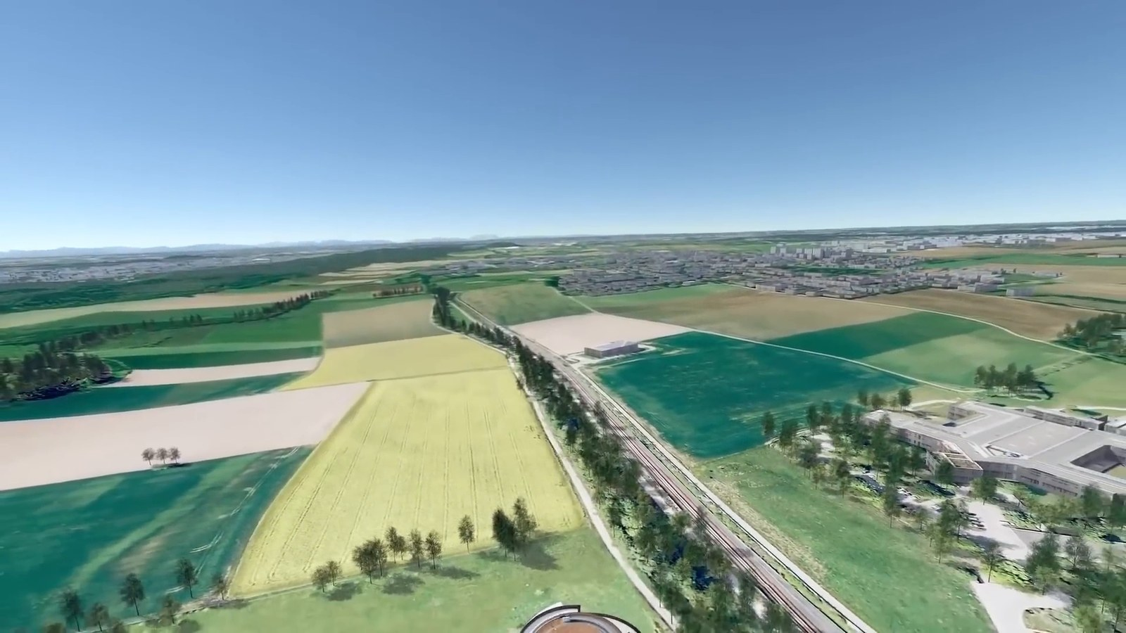
Matched transcript
The blue chase will meet with that star Jim Clancy for a couple of weeks. Earth. Our home planet.

Fragment 3
Time range: 00:12 - 00:18
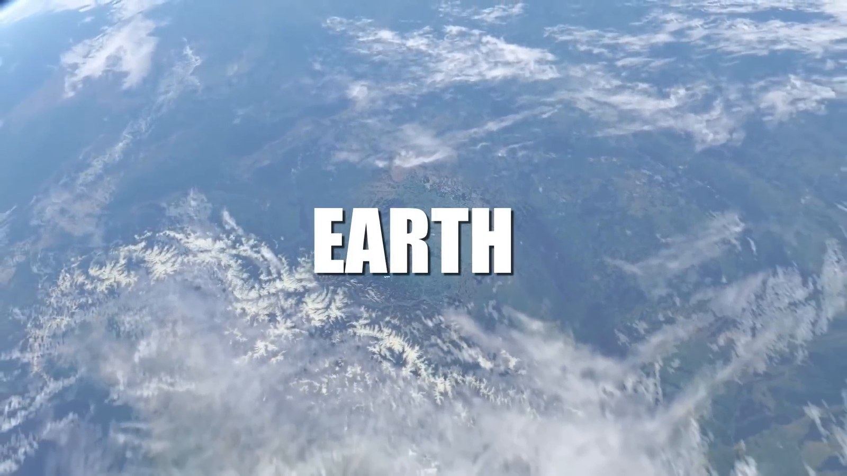
Matched transcript
A tiny blue dot floating in the immense cosmic ocean. Here resides everyone you ever knew.

Fragment 4
Time range: 00:18 - 00:21
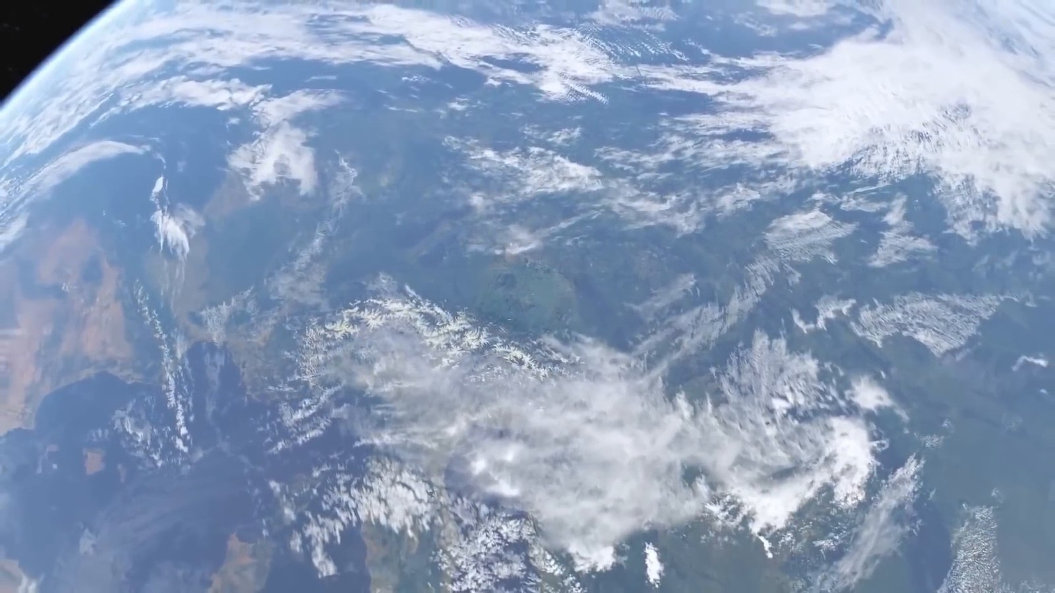
Matched transcript
Here resides everyone you ever knew. Every human who ever lived. Every story that was ever told.

Fragment 5
Time range: 00:21 - 00:27
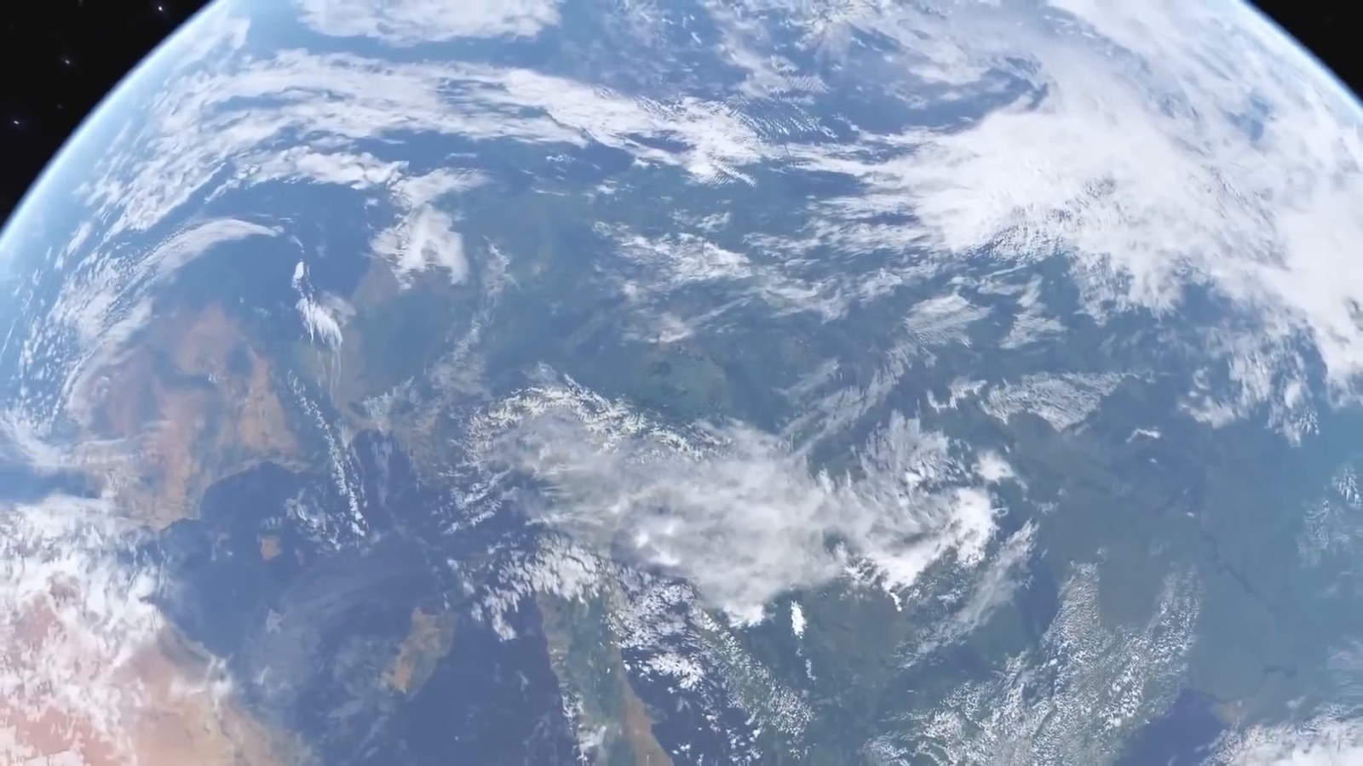
Matched transcript
Every story that was ever told. It's where our journey begins. But as we zoom out, beyond our atmosphere,

Fragment 6
Time range: 00:27 - 00:33
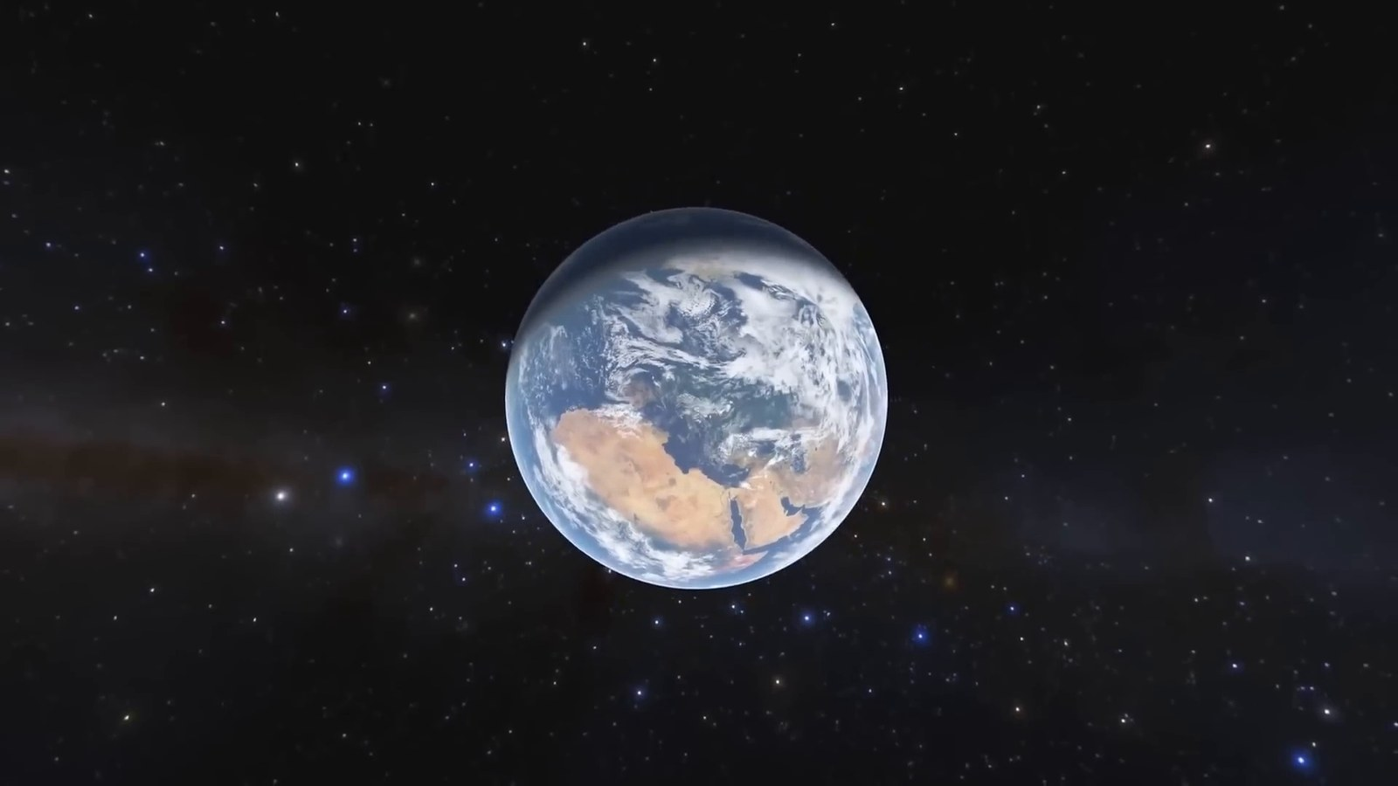
Matched transcript
But as we zoom out, beyond our atmosphere, past the moon, beyond the familiar planets and the sun, we embark on an epic quest, a

Fragment 7
Time range: 00:33 - 00:39
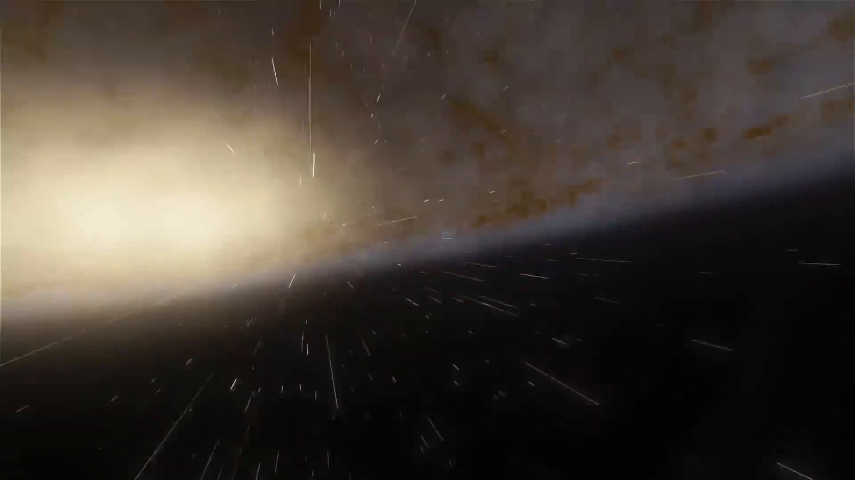
Matched transcript
past the moon, beyond the familiar planets and the sun, we embark on an epic quest, a quest to grasp the true scale of our universe. As we leave Earth's embrace, the first marker

Fragment 8
Time range: 00:39 - 00:45
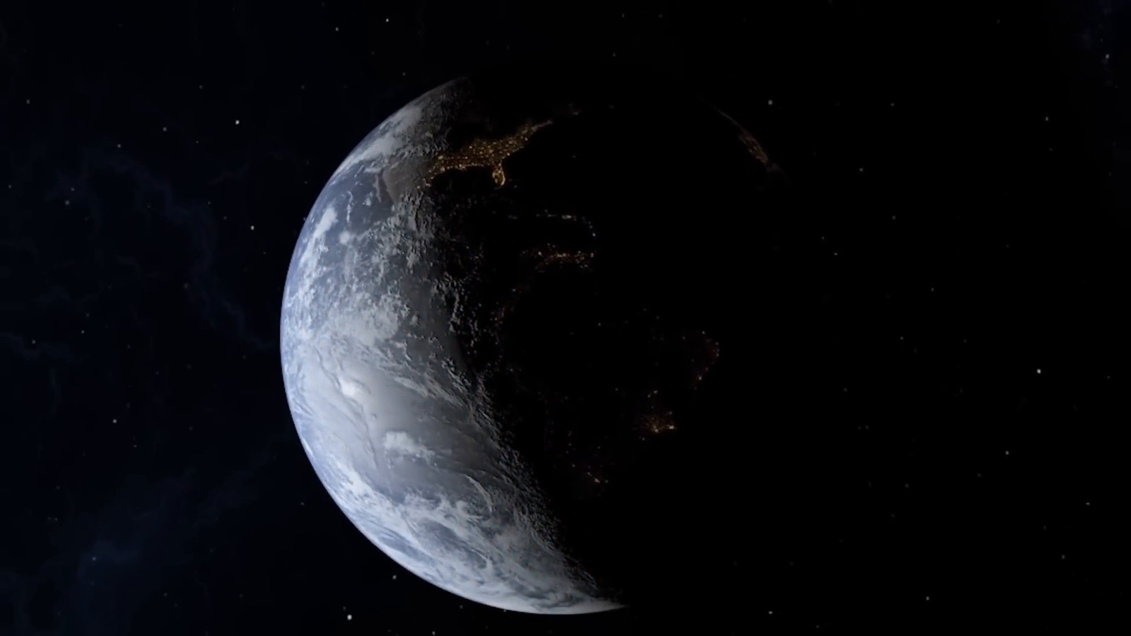
Matched transcript
quest to grasp the true scale of our universe. As we leave Earth's embrace, the first marker on our cosmic journey is the moon, about 384,400 kilometers away, a distance so vast that if

Fragment 9
Time range: 00:45 - 00:51
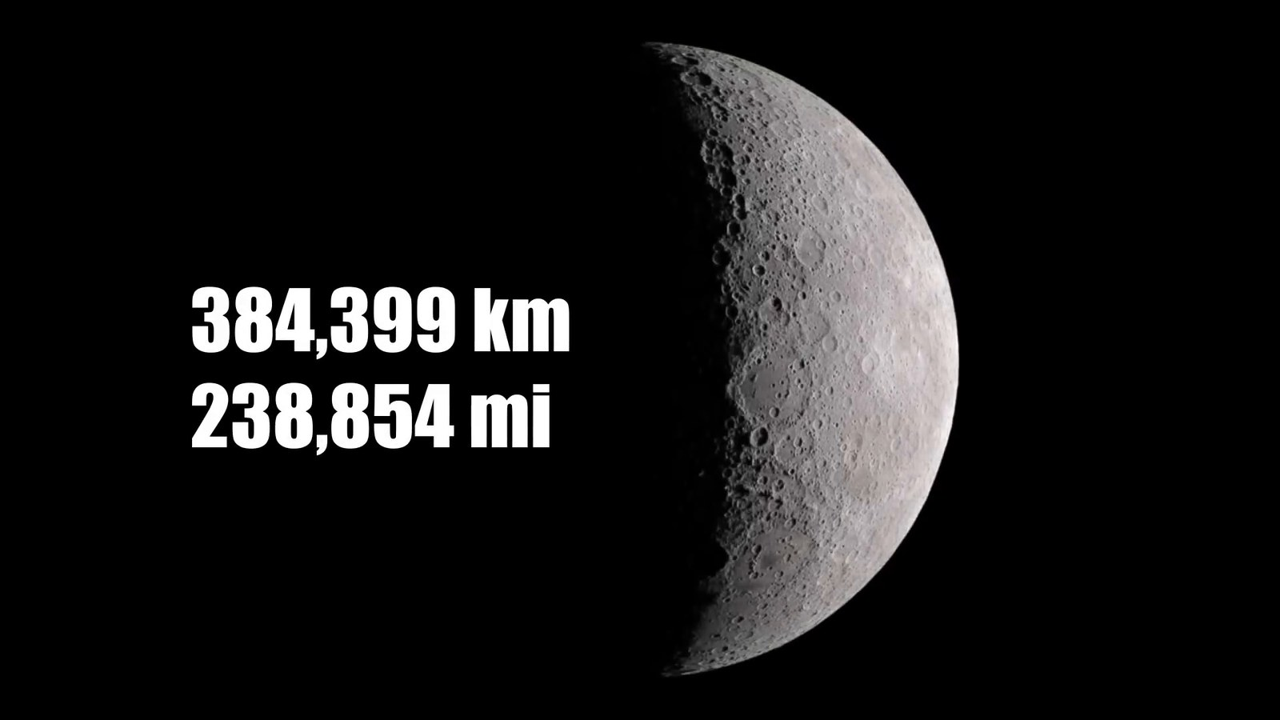
Matched transcript
on our cosmic journey is the moon, about 384,400 kilometers away, a distance so vast that if you were to drive a car at a constant speed of 100 kilometers per hour, it would take

Fragment 10
Time range: 00:51 - 00:56
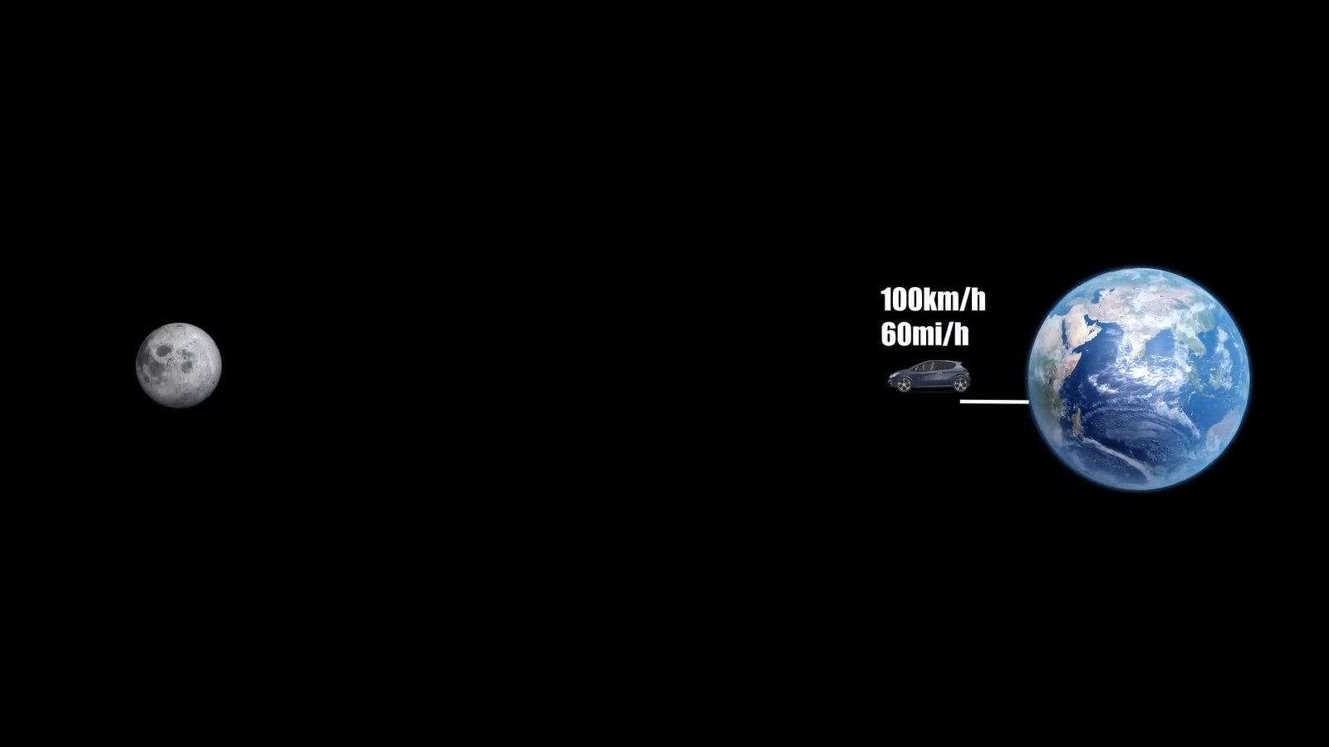
Matched transcript
you were to drive a car at a constant speed of 100 kilometers per hour, it would take you over 160 days to reach it. And from this lunar vantage point, Earth appears as a fragile

Fragment 11
Time range: 00:56 - 01:02
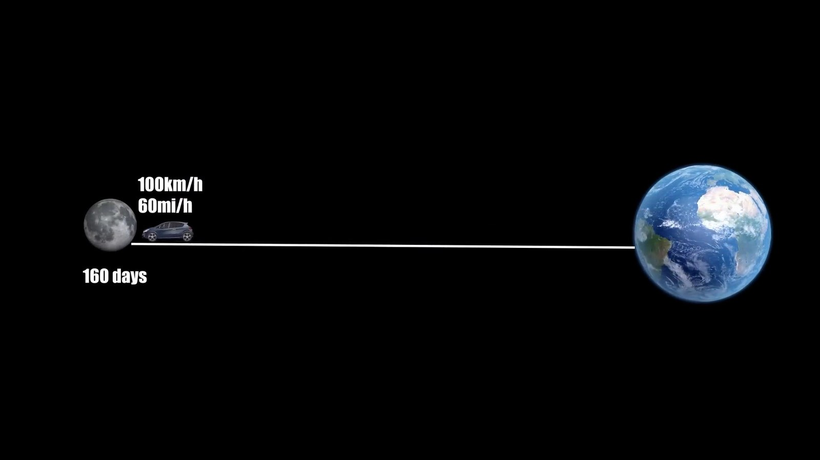
Matched transcript
you over 160 days to reach it. And from this lunar vantage point, Earth appears as a fragile sphere of blues and greens, cradled in the black void of space, a sight that puts our existence

Fragment 12
Time range: 01:02 - 01:08
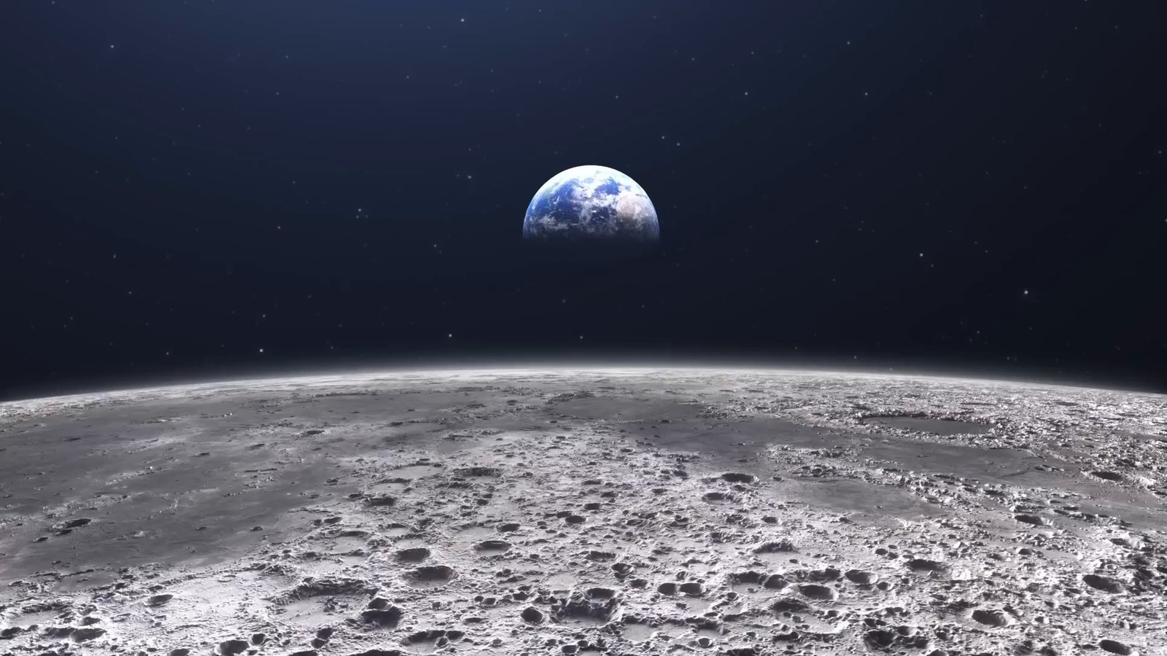
Matched transcript
sphere of blues and greens, cradled in the black void of space, a sight that puts our existence into a humbling perspective. This is Earth as seen from the moon.

Fragment 13
Time range: 01:08 - 01:14
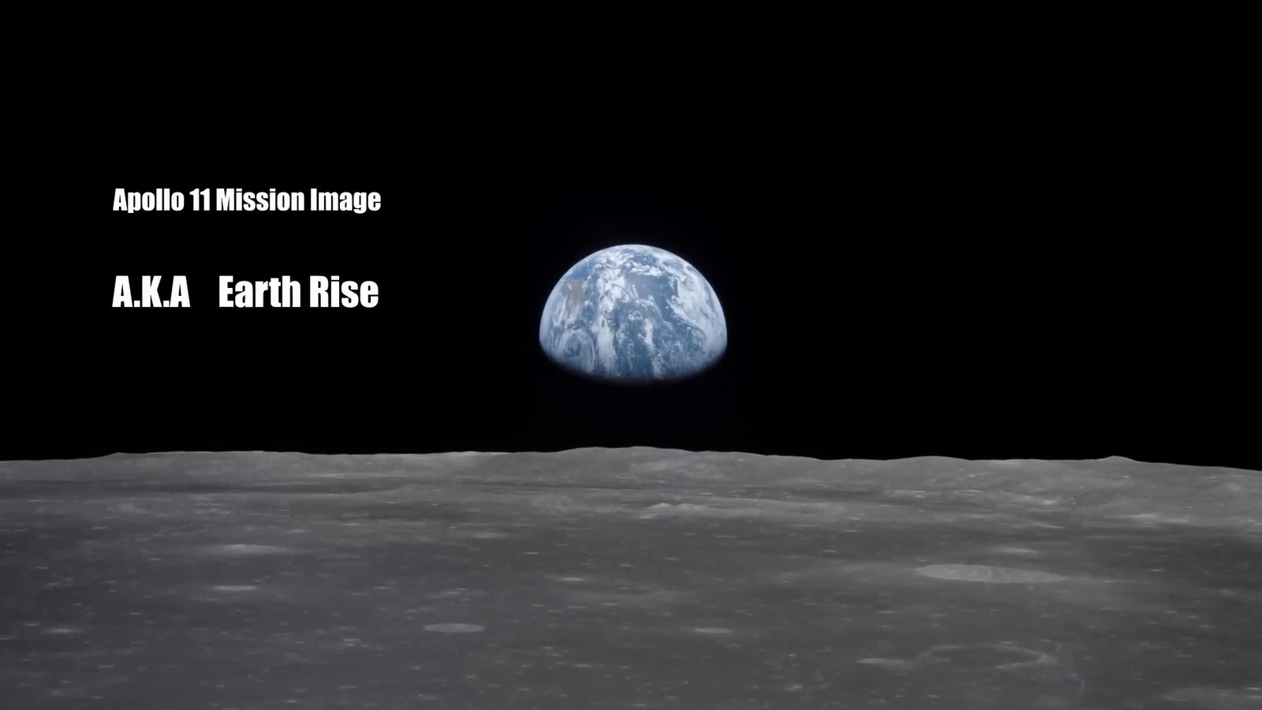
Matched transcript
into a humbling perspective. This is Earth as seen from the moon. As we continue our outward journey, the next milestone is the sun, lying approximately one

Fragment 14
Time range: 01:14 - 01:20
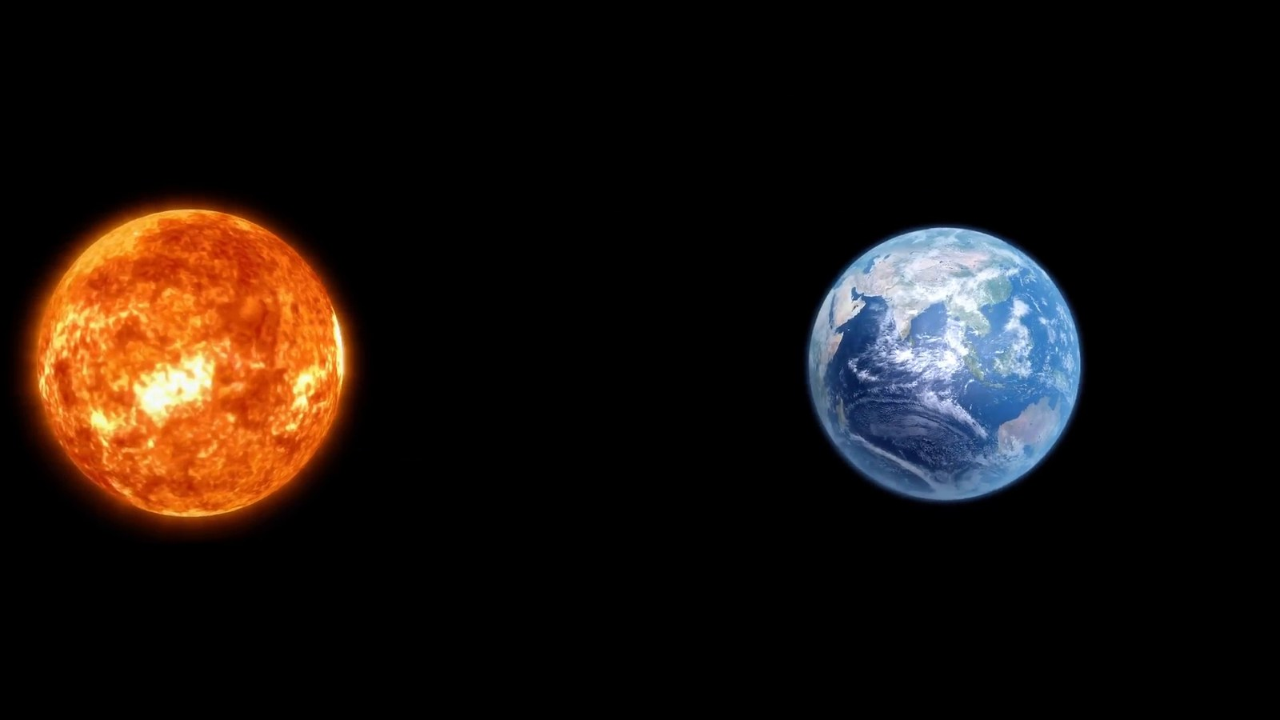
Matched transcript
As we continue our outward journey, the next milestone is the sun, lying approximately one astronomical unit away from Earth. This unit, equivalent to about 150 million kilometers,

Fragment 15
Time range: 01:20 - 01:24
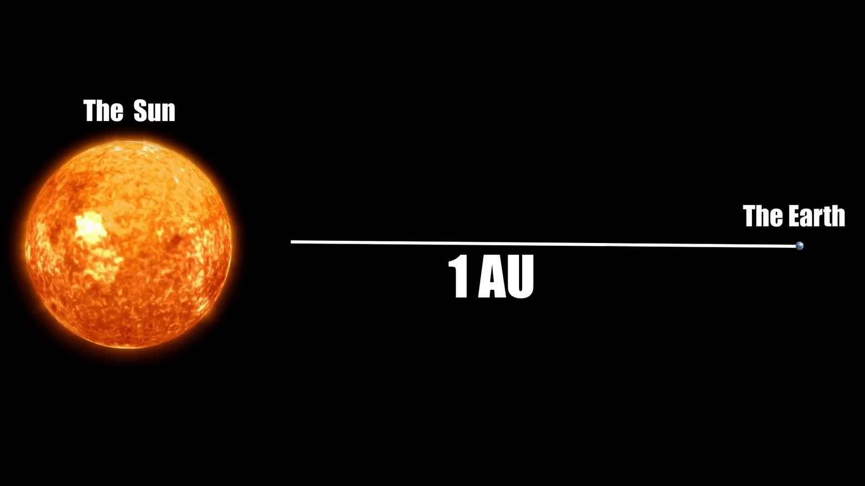
Matched transcript
astronomical unit away from Earth. This unit, equivalent to about 150 million kilometers,

Fragment 16
Time range: 01:24 - 01:29
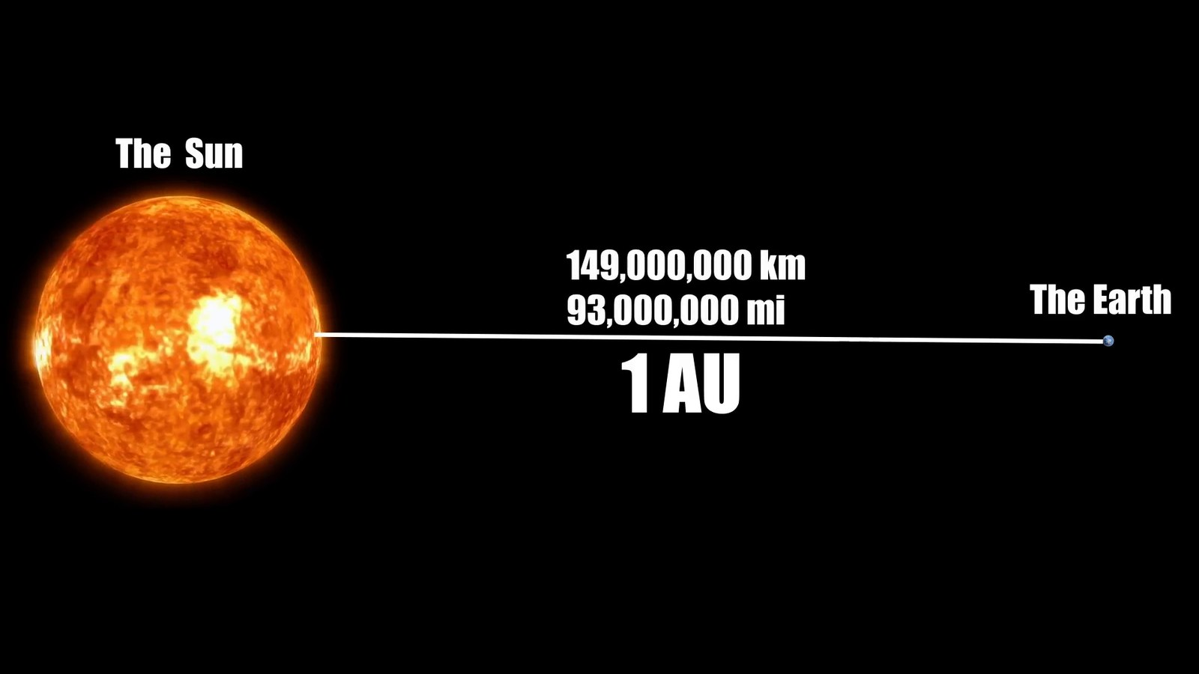
Matched transcript
astronomical unit away from Earth. This unit, equivalent to about 150 million kilometers, is the standard measuring stick for distances in our solar system. Imagine this. Light,

Fragment 17
Time range: 01:29 - 01:35
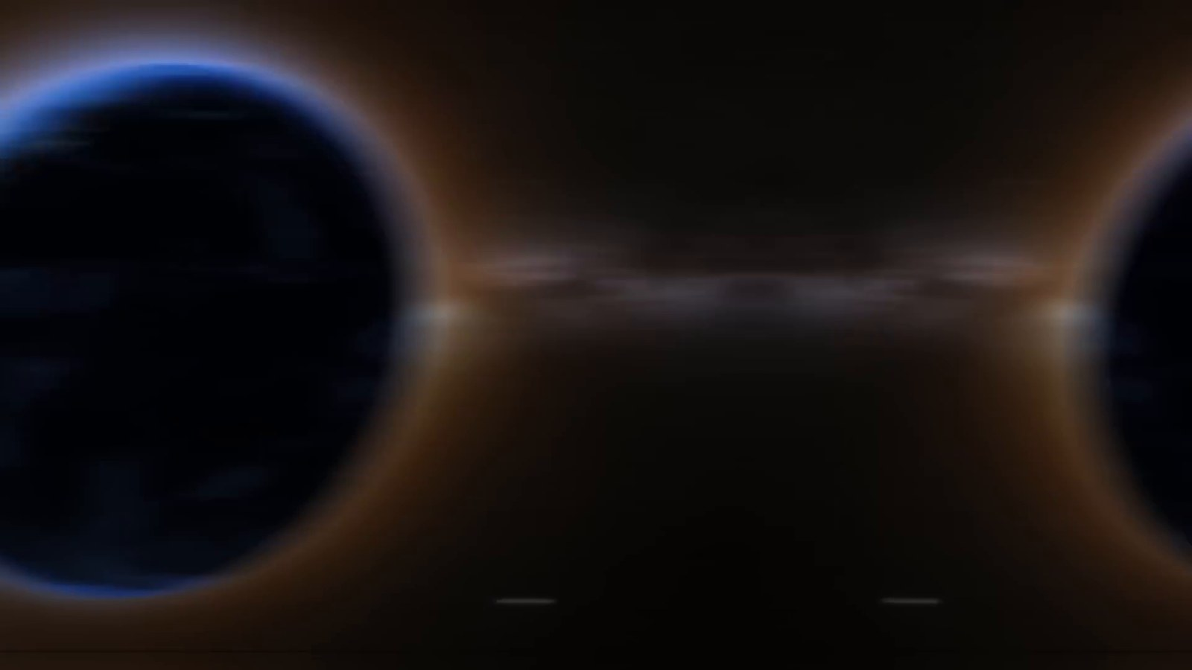
Matched transcript
is the standard measuring stick for distances in our solar system. Imagine this. Light, traveling at an astounding speed of 300,000 kilometers per second,

Fragment 18
Time range: 01:35 - 01:41
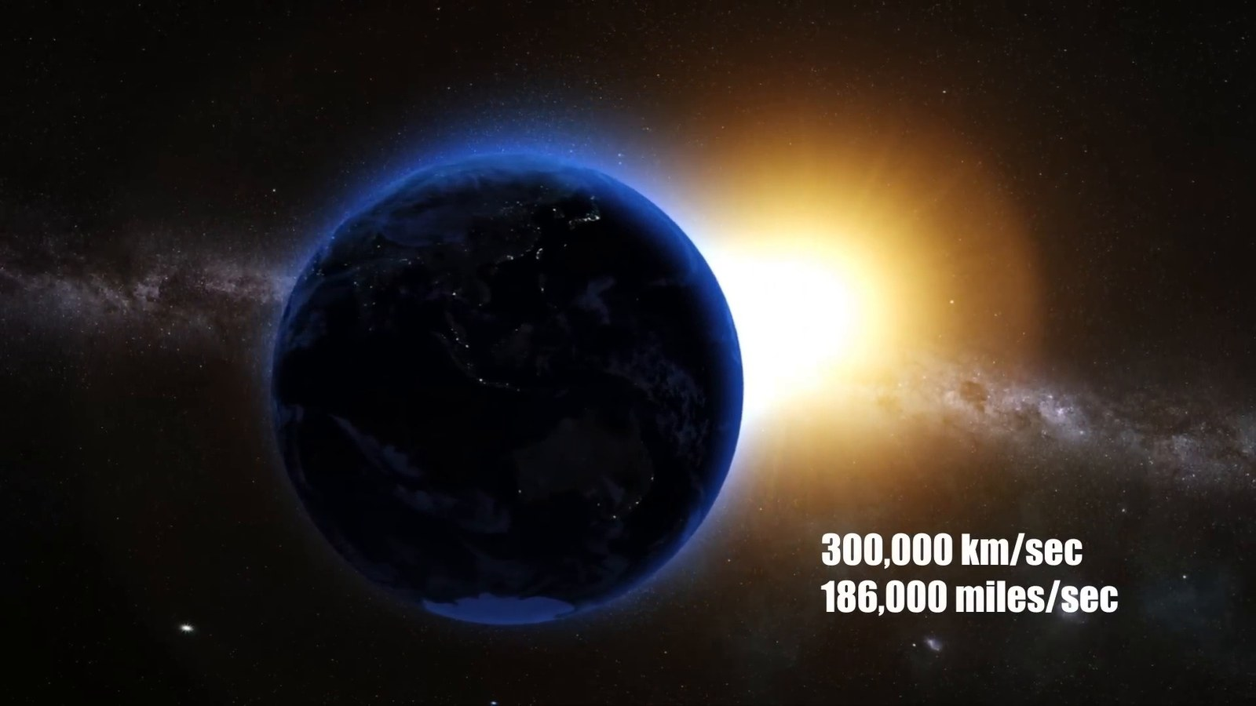
Matched transcript
traveling at an astounding speed of 300,000 kilometers per second, takes about 8 minutes and 20 seconds to journey from the sun to Earth. If you were to travel this distance in a commercial jet, flying at 900 kilometers per hour,

Fragment 19
Time range: 01:41 - 01:49
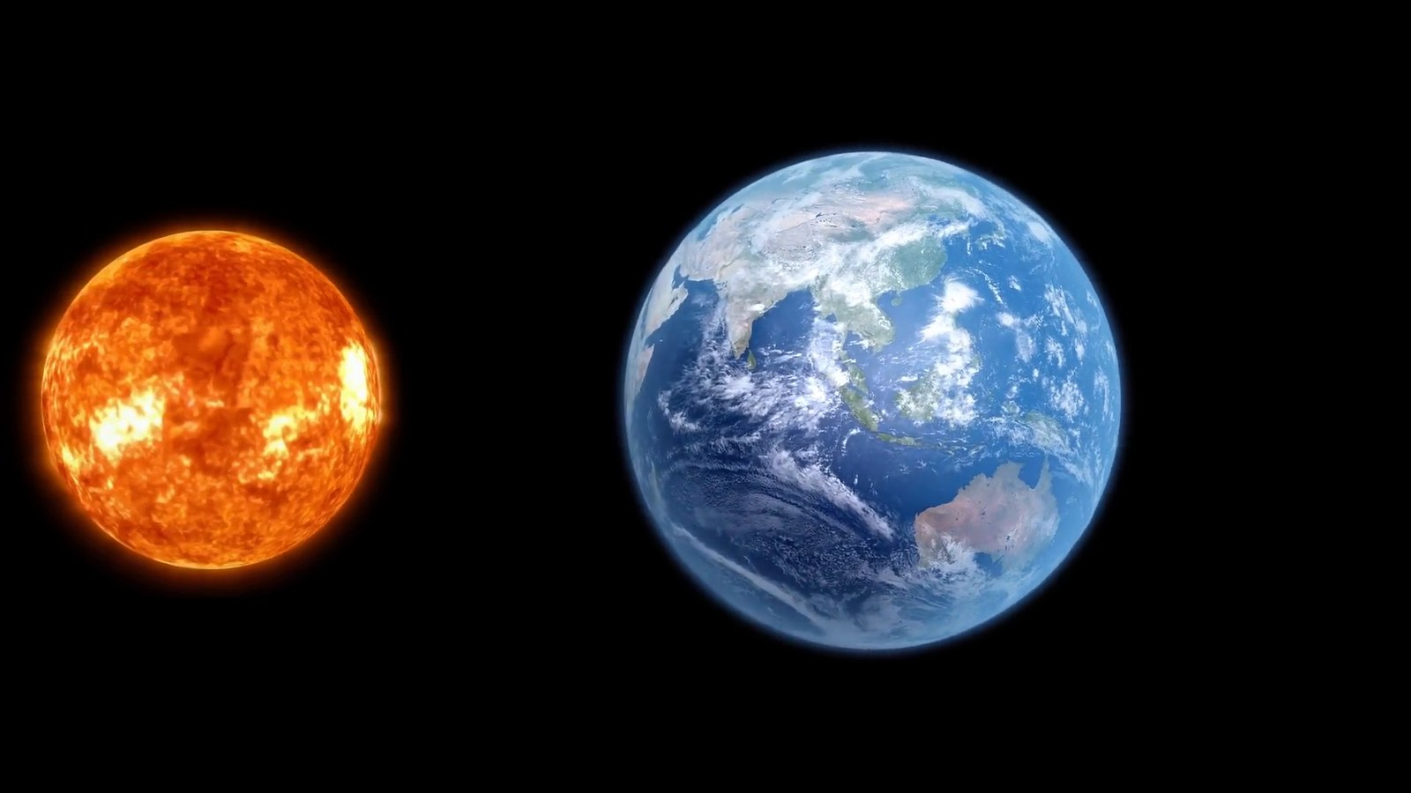
Matched transcript
If you were to travel this distance in a commercial jet, flying at 900 kilometers per hour, it would take you about 19 years. This immense distance is a stark reminder of the vastness of

Fragment 20
Time range: 01:49 - 01:52
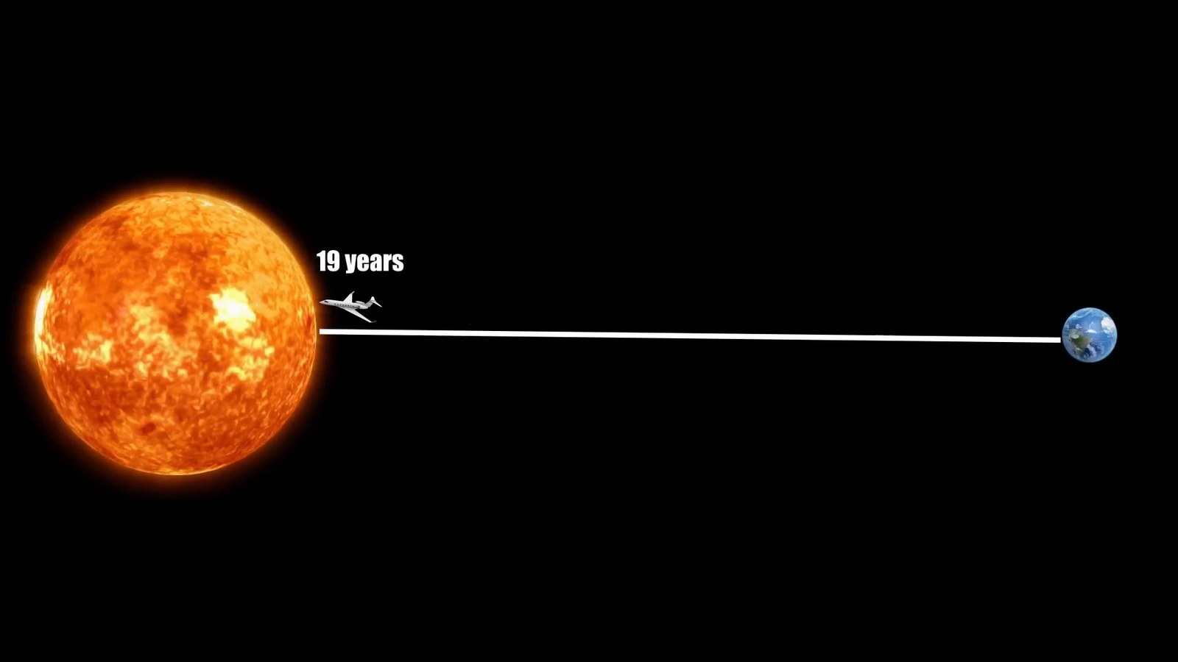
Matched transcript
it would take you about 19 years. This immense distance is a stark reminder of the vastness of

Fragment 21
Time range: 01:52 - 01:56
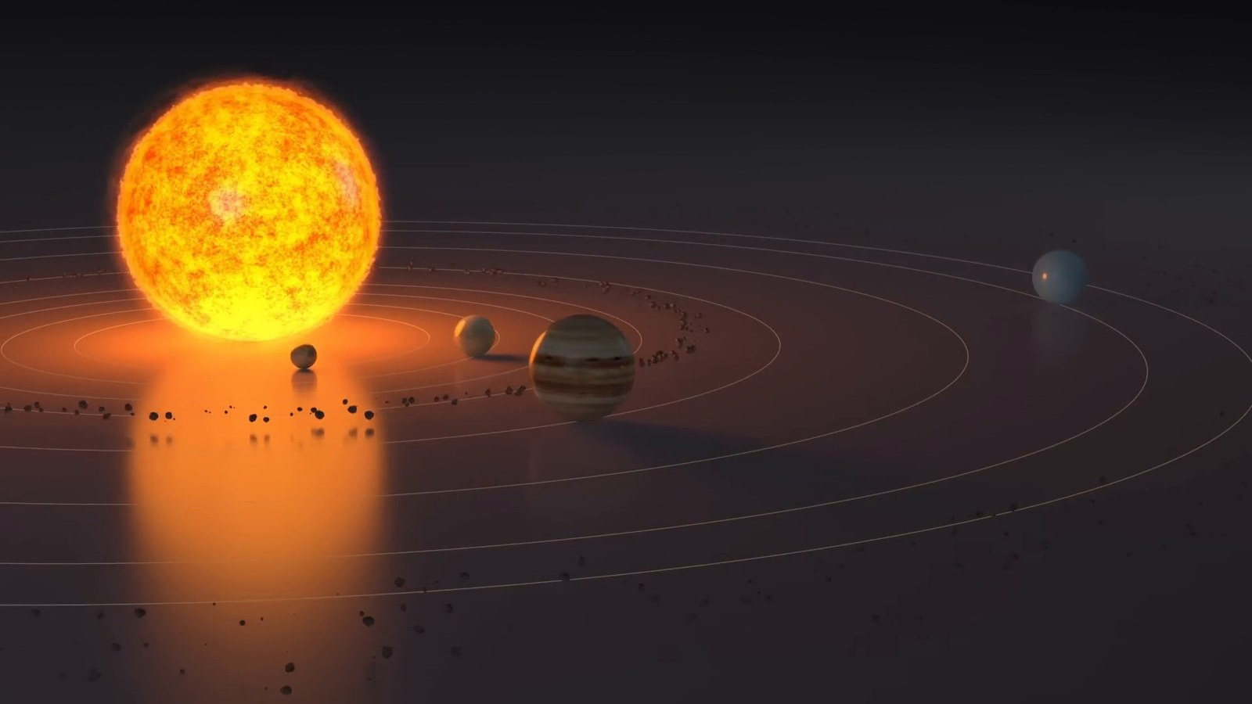
Matched transcript
it would take you about 19 years. This immense distance is a stark reminder of the vastness of space, even within our own solar system. The Sun, a fiery behemoth, provides life-sustaining energy

Fragment 22
Time range: 01:56 - 02:03
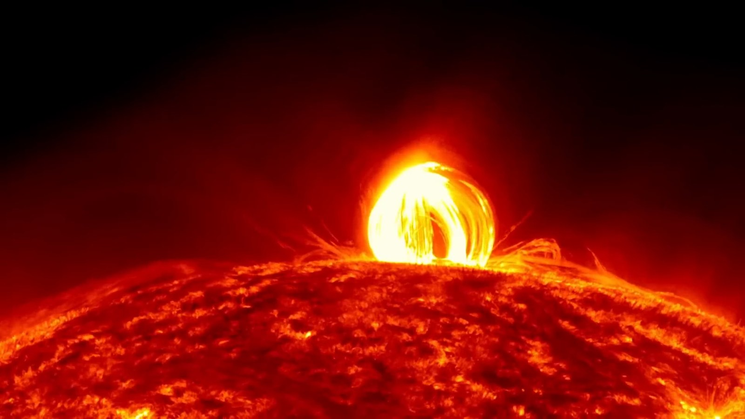
Matched transcript
space, even within our own solar system. The Sun, a fiery behemoth, provides life-sustaining energy to our planet from this incredible distance. Venturing beyond our home planet and its solar

Fragment 23
Time range: 02:03 - 02:09
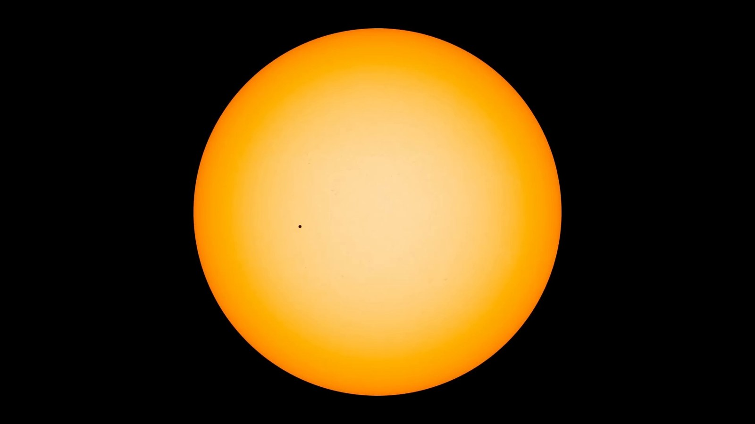
Matched transcript
to our planet from this incredible distance. Venturing beyond our home planet and its solar companion, the Sun, we set our sights on Mars, our enigmatic red neighbor. Mars, at its closest

Fragment 24
Time range: 02:09 - 02:17
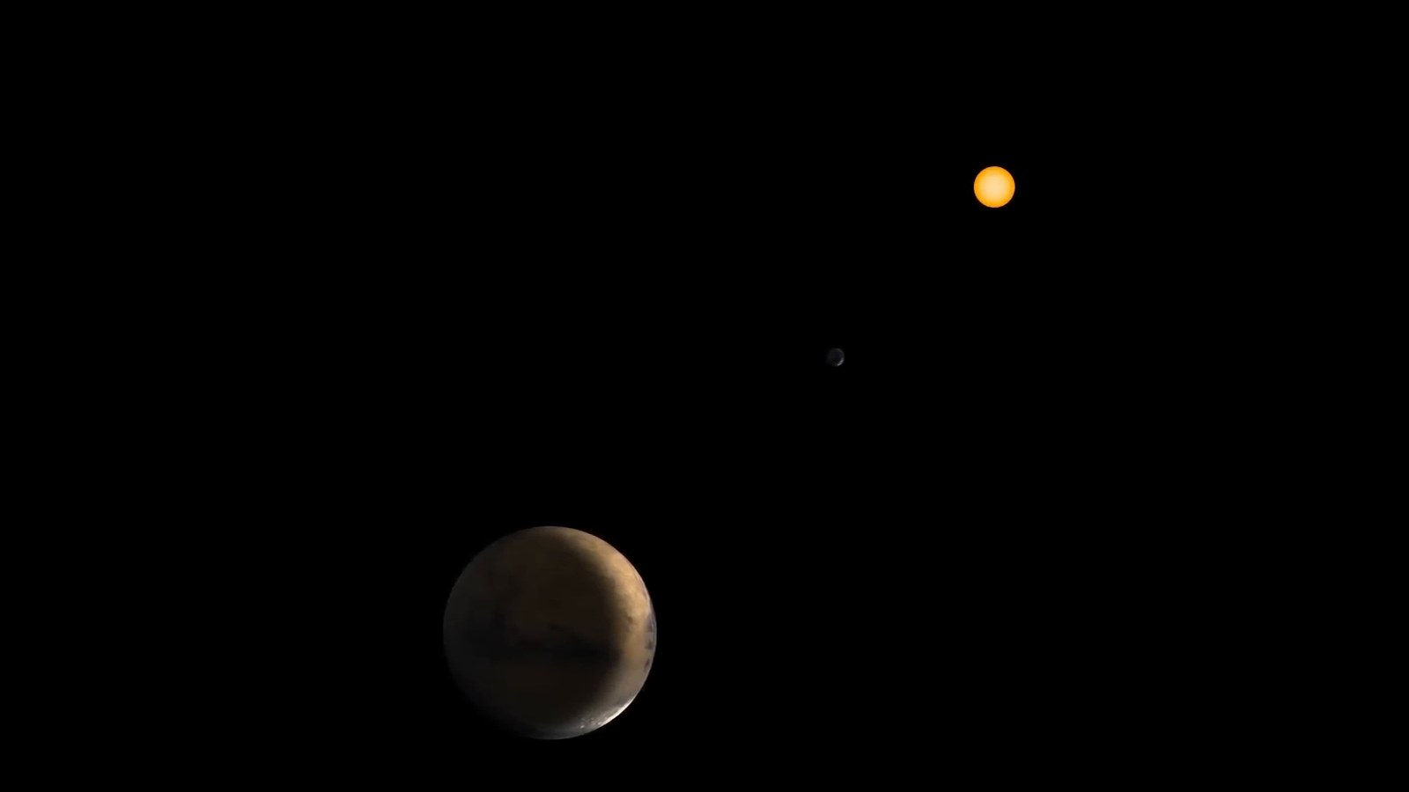
Matched transcript
companion, the Sun, we set our sights on Mars, our enigmatic red neighbor. Mars, at its closest approached to Earth is about 54.6 million kilometers away. However, this distance can

Fragment 25
Time range: 02:17 - 02:21
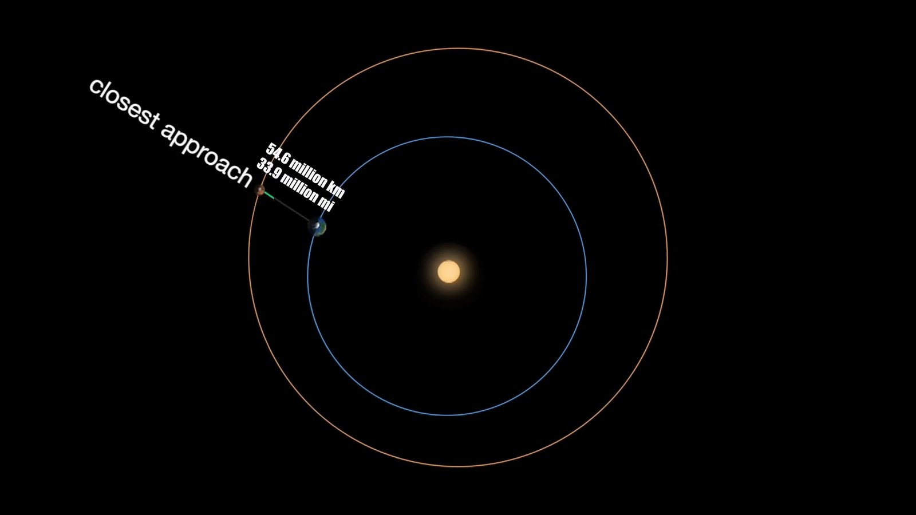
Matched transcript
approached to Earth is about 54.6 million kilometers away. However, this distance can stretch up to 401 million kilometers when the two planets are on opposite sides of the

Fragment 26
Time range: 02:21 - 02:27
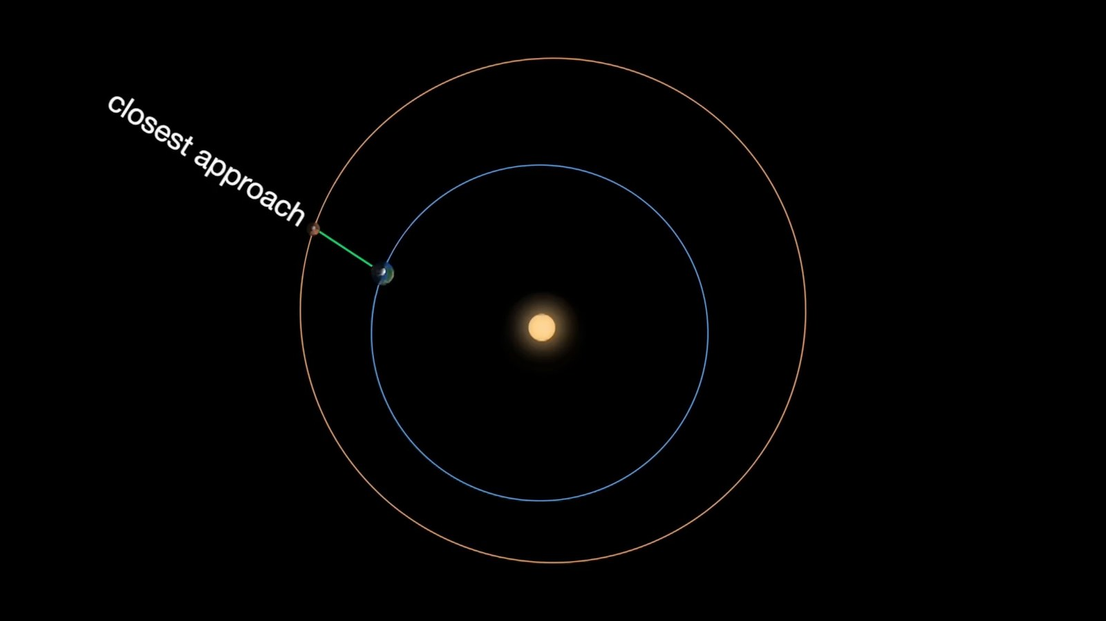
Matched transcript
stretch up to 401 million kilometers when the two planets are on opposite sides of the Sun. To put that in perspective, traveling to Mars at the speed of a commercial jet would

Fragment 27
Time range: 02:27 - 02:33
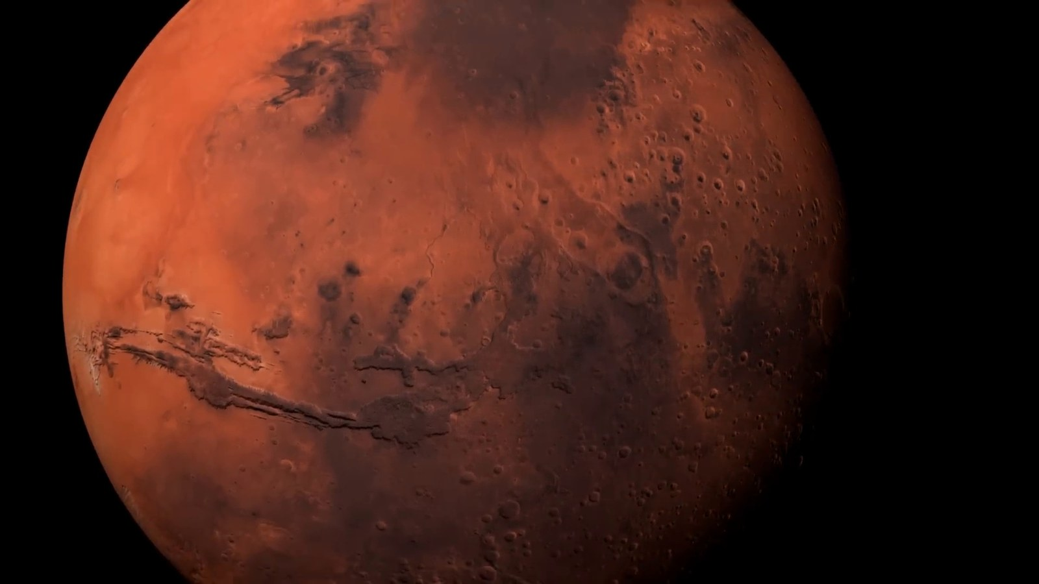
Matched transcript
Sun. To put that in perspective, traveling to Mars at the speed of a commercial jet would take upwards of 50 years. This vast expanse of space between Earth and Mars has been a

Fragment 28
Time range: 02:33 - 02:36
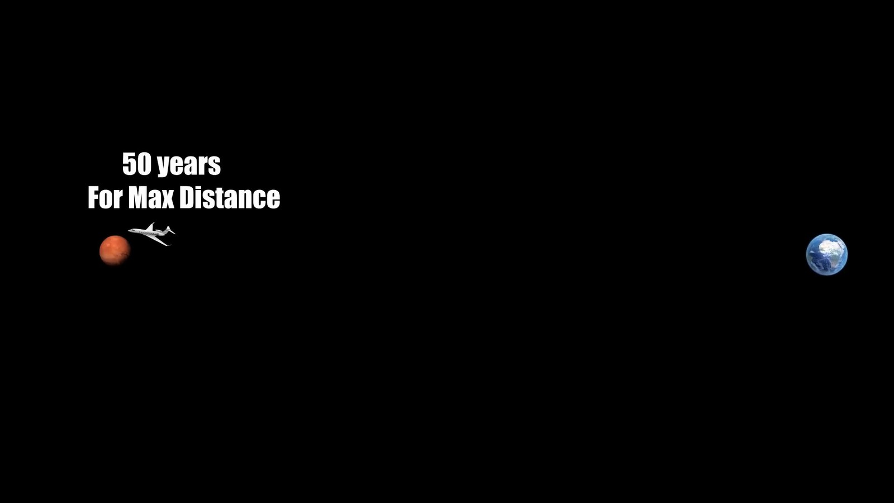
Matched transcript
take upwards of 50 years. This vast expanse of space between Earth and Mars has been a

Fragment 29
Time range: 02:36 - 02:42
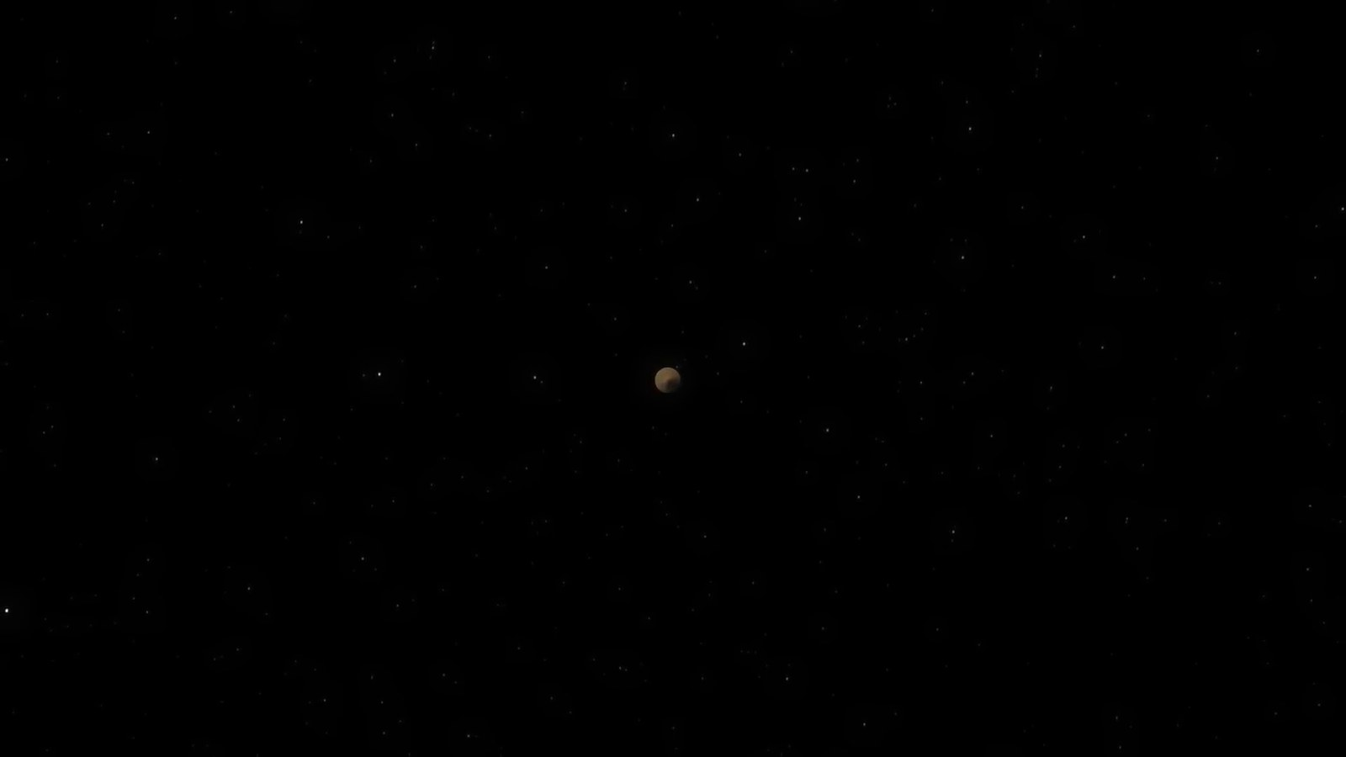
Matched transcript
take upwards of 50 years. This vast expanse of space between Earth and Mars has been a significant challenge for space exploration. The rovers and probes we have sent to the red planet embark on a journey that is not just far but fraught with complexities due to the constantly changing distances and orbital dynamics As we journey to the outermost reaches of our solar

Fragment 30
Time range: 02:42 - 02:49
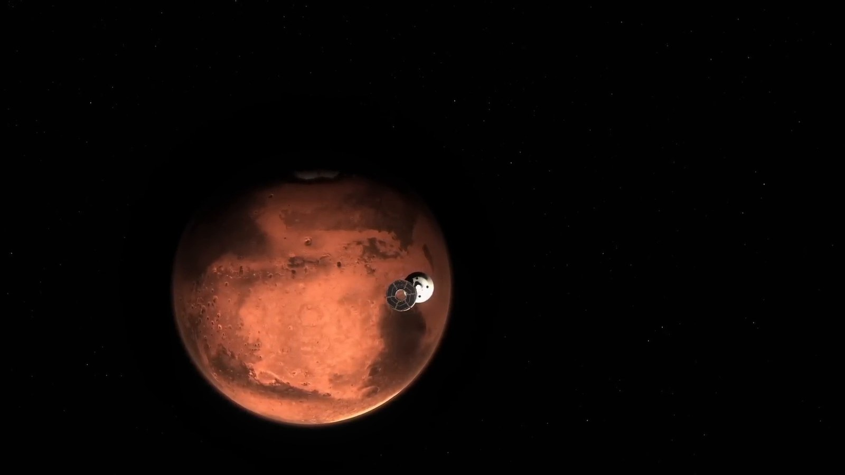
Matched transcript
red planet embark on a journey that is not just far but fraught with complexities due to the constantly changing distances and orbital dynamics As we journey to the outermost reaches of our solar

Fragment 31
Time range: 02:49 - 02:55
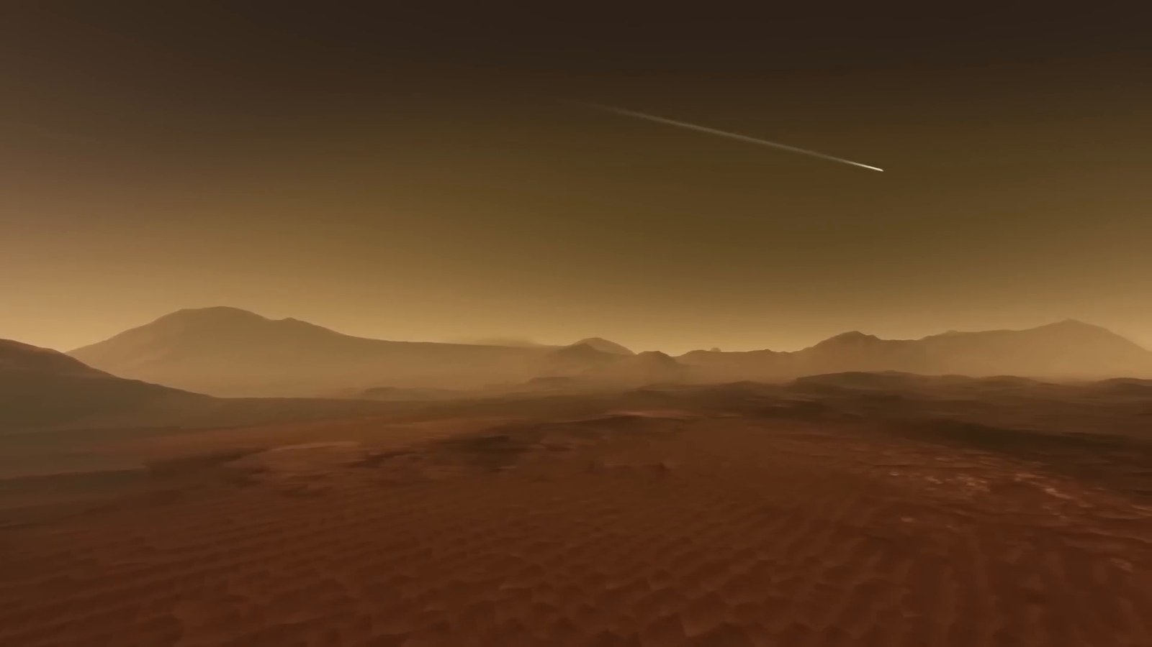
Matched transcript
red planet embark on a journey that is not just far but fraught with complexities due to the constantly changing distances and orbital dynamics As we journey to the outermost reaches of our solar system, we encounter Neptune, the distant ice giant. Lying roughly 4.5 billion kilometers from

Fragment 32
Time range: 02:55 - 03:01
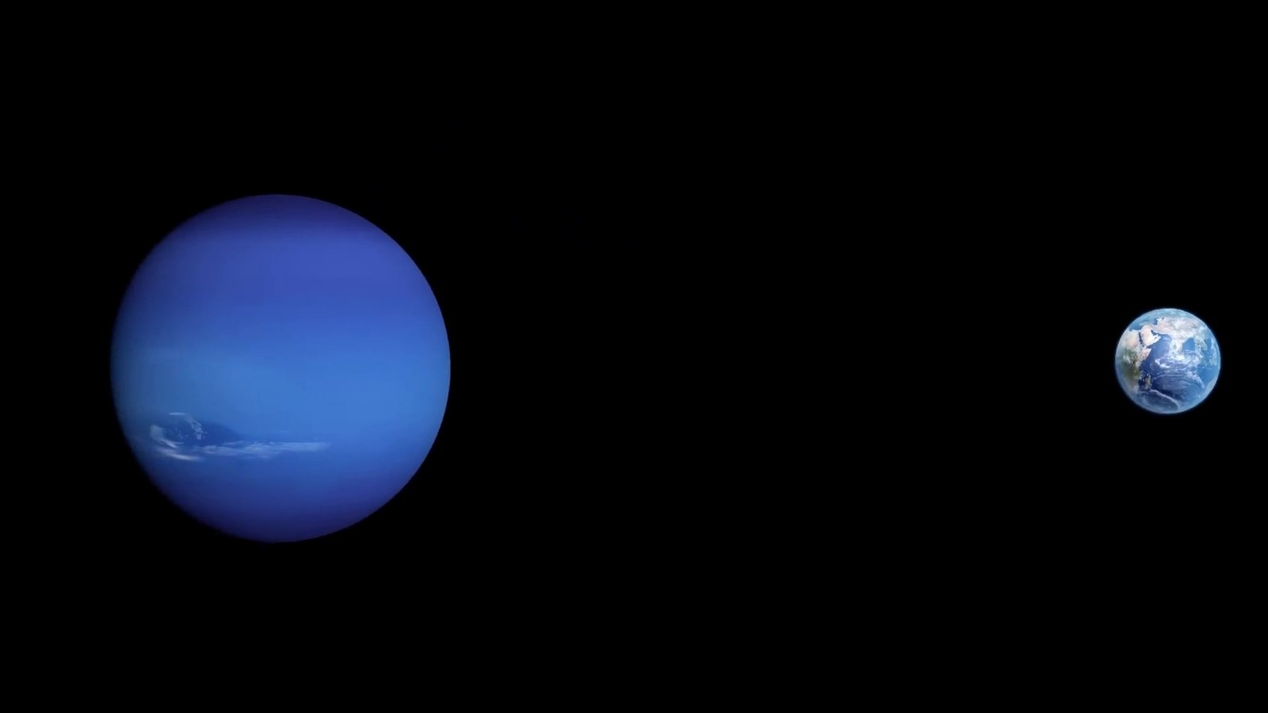
Matched transcript
system, we encounter Neptune, the distant ice giant. Lying roughly 4.5 billion kilometers from

Fragment 33
Time range: 03:01 - 03:07
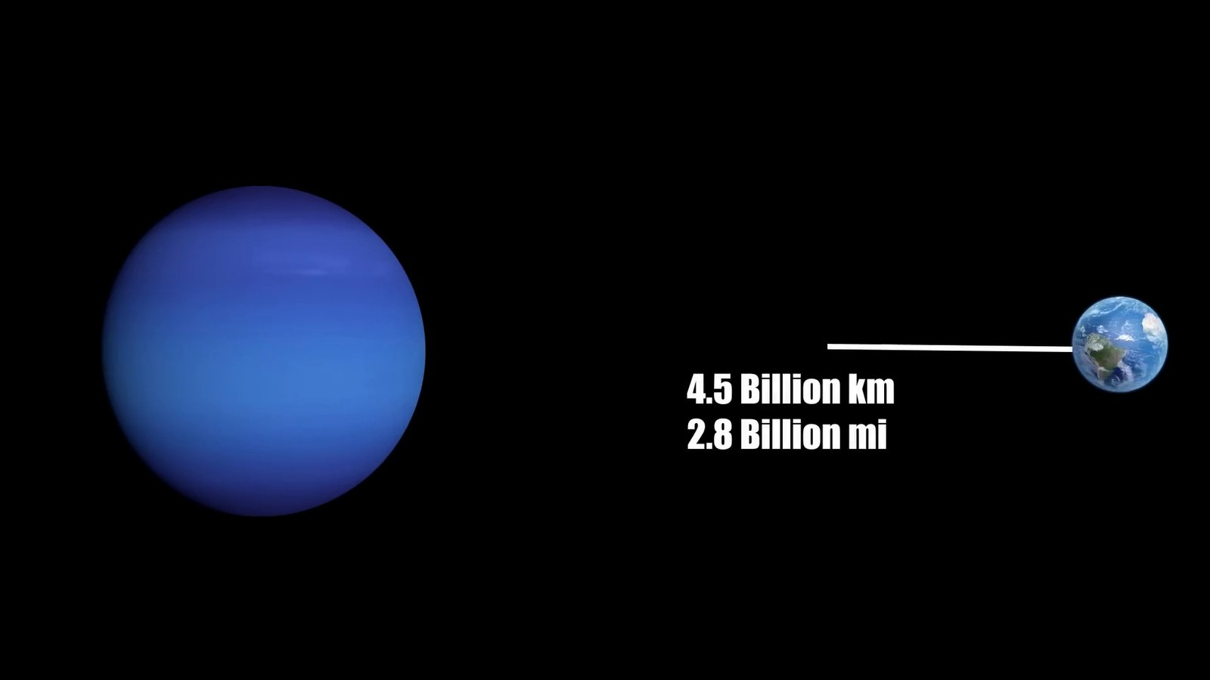
Matched transcript
system, we encounter Neptune, the distant ice giant. Lying roughly 4.5 billion kilometers from Earth, Neptune marks the edge of our solar neighborhood. Sunlight, racing across the vacuum

Fragment 34
Time range: 03:07 - 03:10
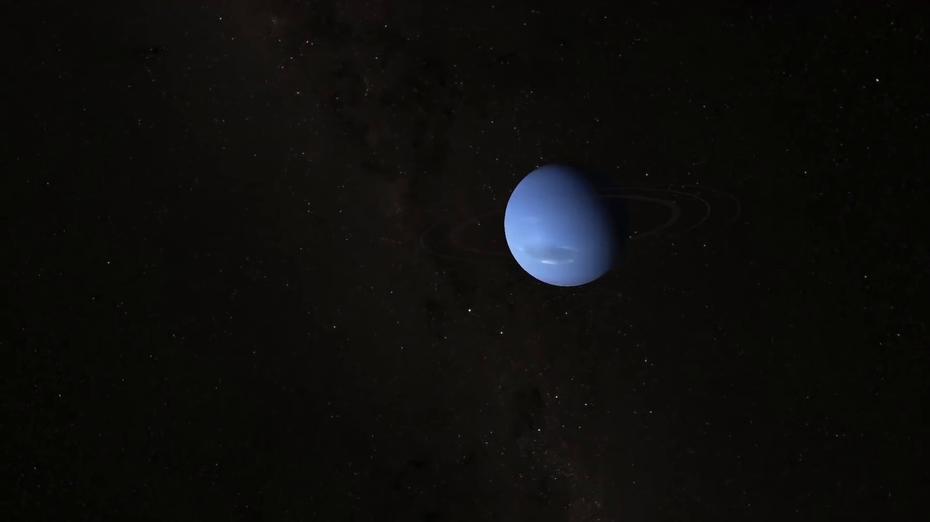
Matched transcript
Earth, Neptune marks the edge of our solar neighborhood. Sunlight, racing across the vacuum of space takes about 4 hours and 15 minutes to reach Neptune from the Sun. This staggering

Fragment 35
Time range: 03:10 - 03:16
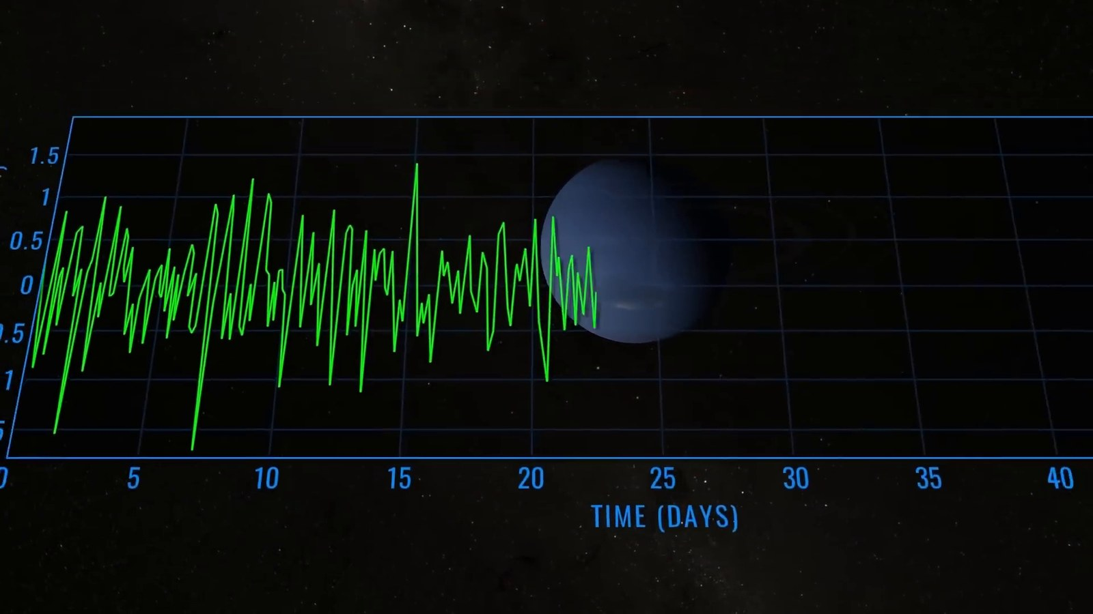
Matched transcript
of space takes about 4 hours and 15 minutes to reach Neptune from the Sun. This staggering distance showcases the enormity of our solar system.

Fragment 36
Time range: 03:16 - 03:22
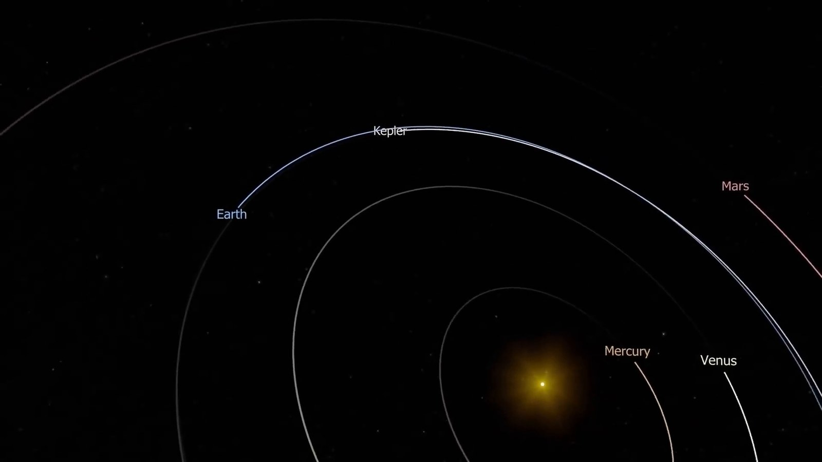
Matched transcript
distance showcases the enormity of our solar system. Launched in 1977, the Voyager 1 space probe represents humanity's insatiable curiosity

Fragment 37
Time range: 03:22 - 03:28
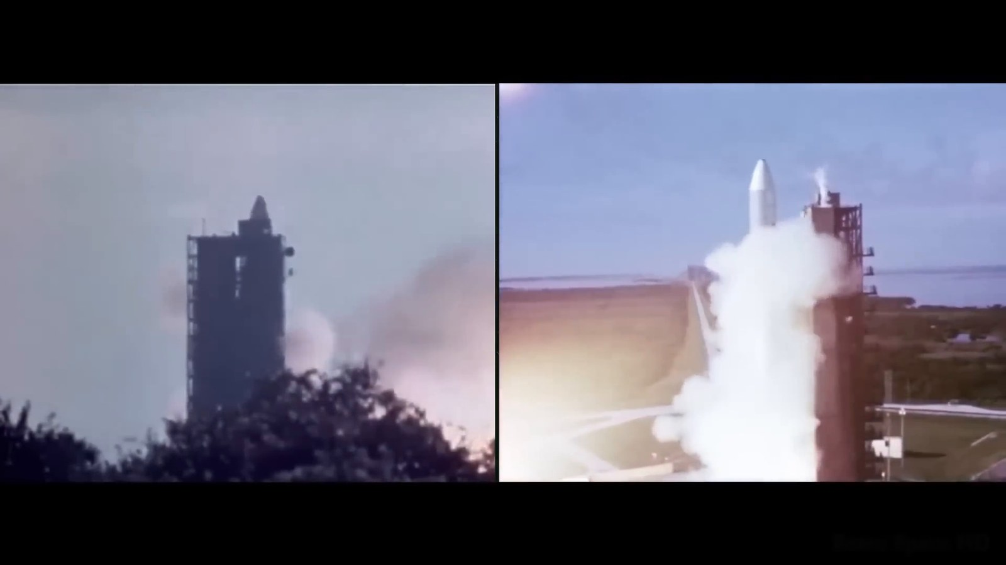
Matched transcript
Launched in 1977, the Voyager 1 space probe represents humanity's insatiable curiosity and our desire to explore beyond known boundaries. As of now, Voyager 1 has traveled for over

Fragment 38
Time range: 03:28 - 03:34
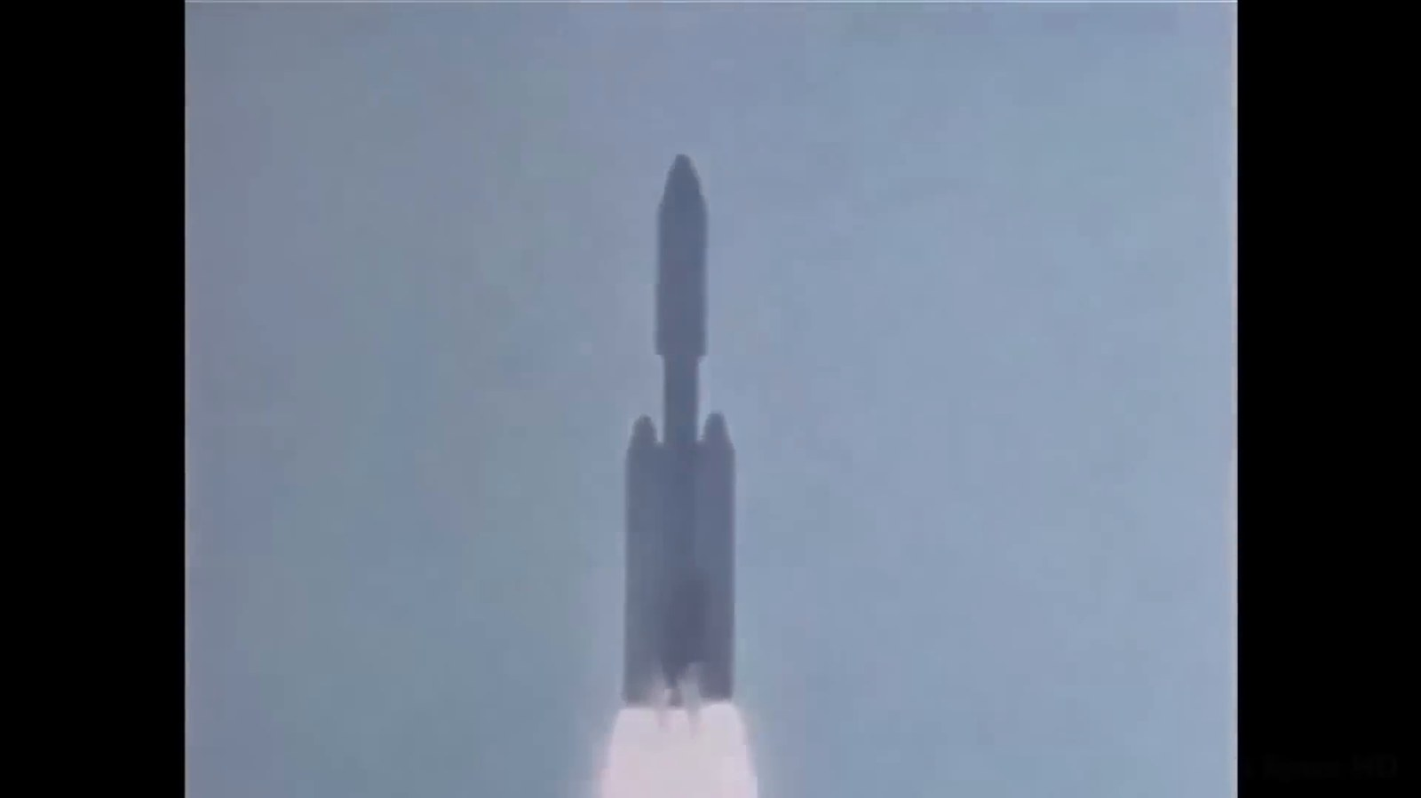
Matched transcript
and our desire to explore beyond known boundaries. As of now, Voyager 1 has traveled for over four decades, covering a staggering distance of more than 22 billion kilometers from Earth.

Fragment 39
Time range: 03:34 - 03:40
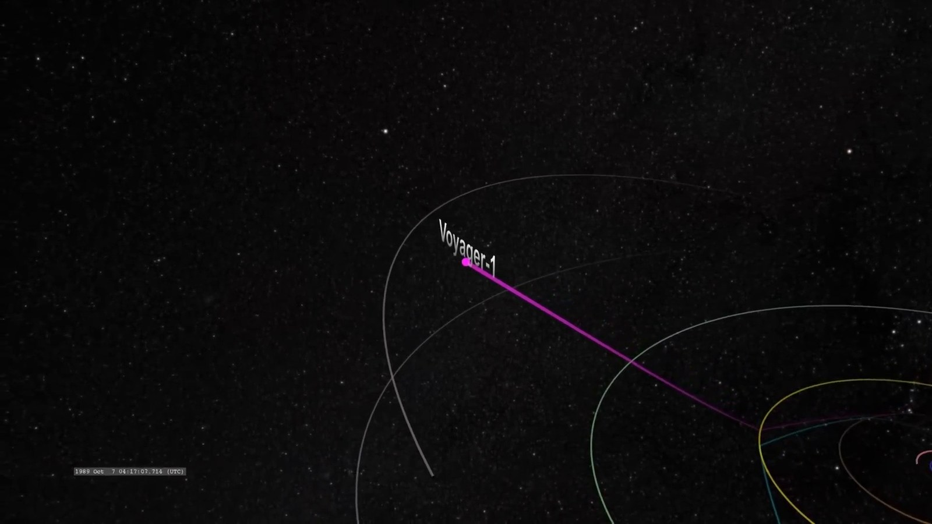
Matched transcript
four decades, covering a staggering distance of more than 22 billion kilometers from Earth. It's the farthest human-made object from our planet, a silent wanderer in the cosmic sea.

Fragment 40
Time range: 03:40 - 03:46
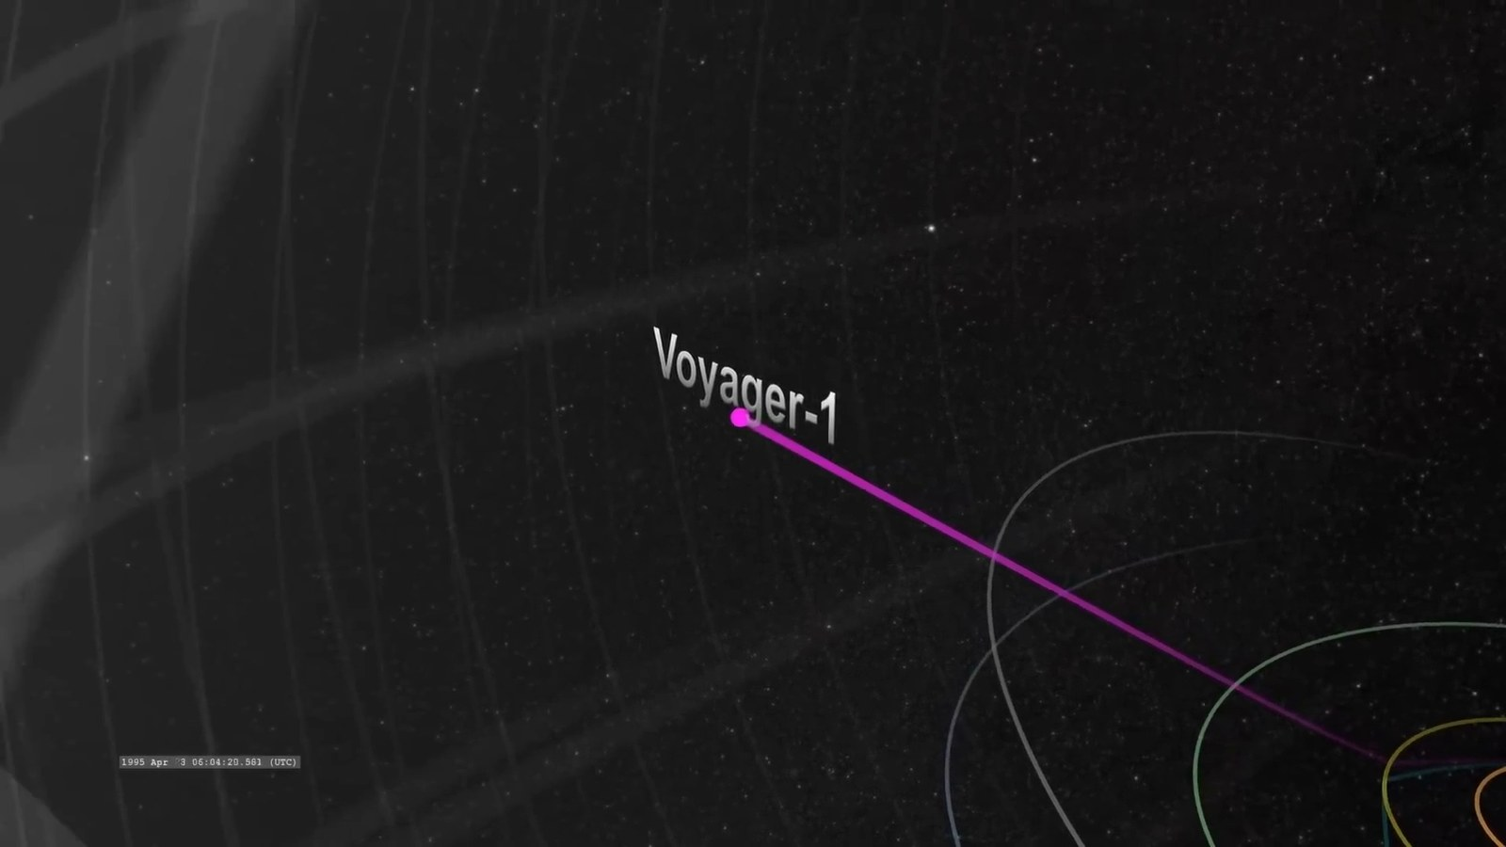
Matched transcript
It's the farthest human-made object from our planet, a silent wanderer in the cosmic sea. In 1990, at the suggestion of the renowned astronomer Carl Sagan, Voyager 1 turned its

Fragment 41
Time range: 03:46 - 03:49
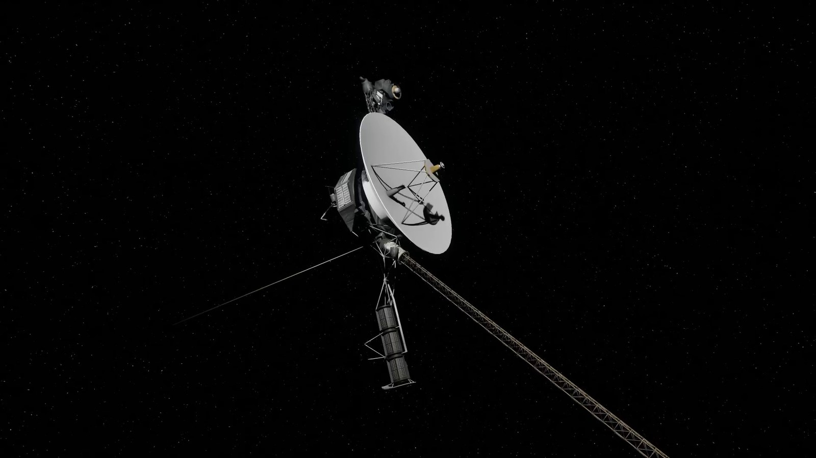
Matched transcript
In 1990, at the suggestion of the renowned astronomer Carl Sagan, Voyager 1 turned its

Fragment 42
Time range: 03:49 - 03:55
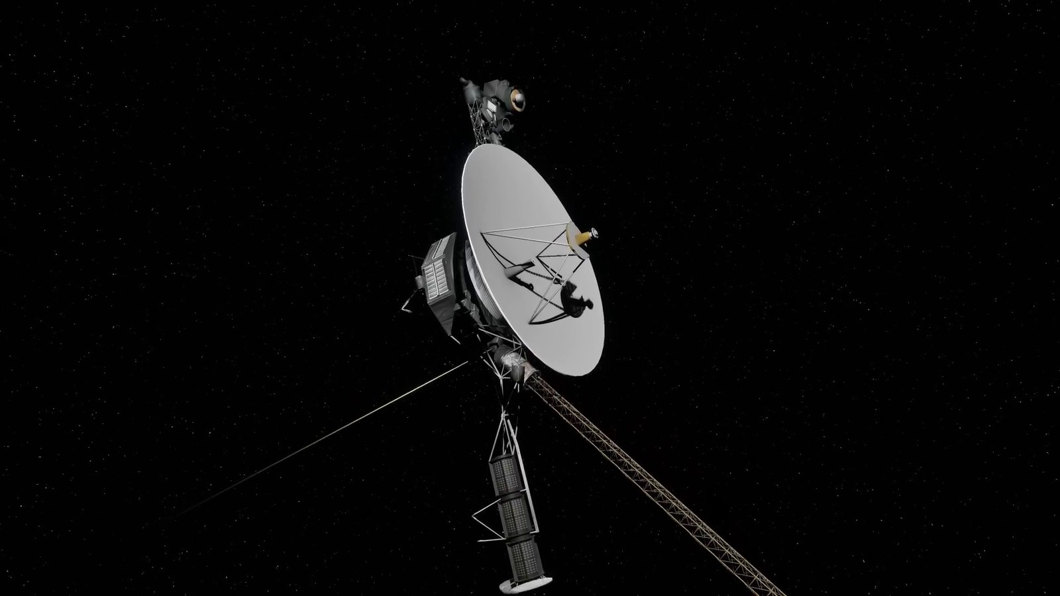
Matched transcript
In 1990, at the suggestion of the renowned astronomer Carl Sagan, Voyager 1 turned its camera back towards Earth for one final photograph. This resulted in the iconic pale blue dot

Fragment 43
Time range: 03:55 - 04:02
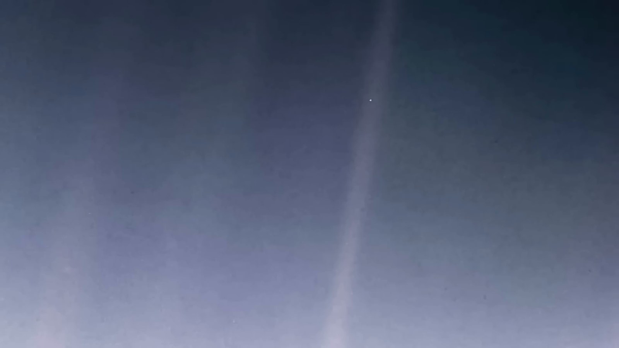
Matched transcript
camera back towards Earth for one final photograph. This resulted in the iconic pale blue dot image. At a distance of about 6 billion kilometers from Earth, our planet appeared as a tiny,

Fragment 44
Time range: 04:02 - 04:08
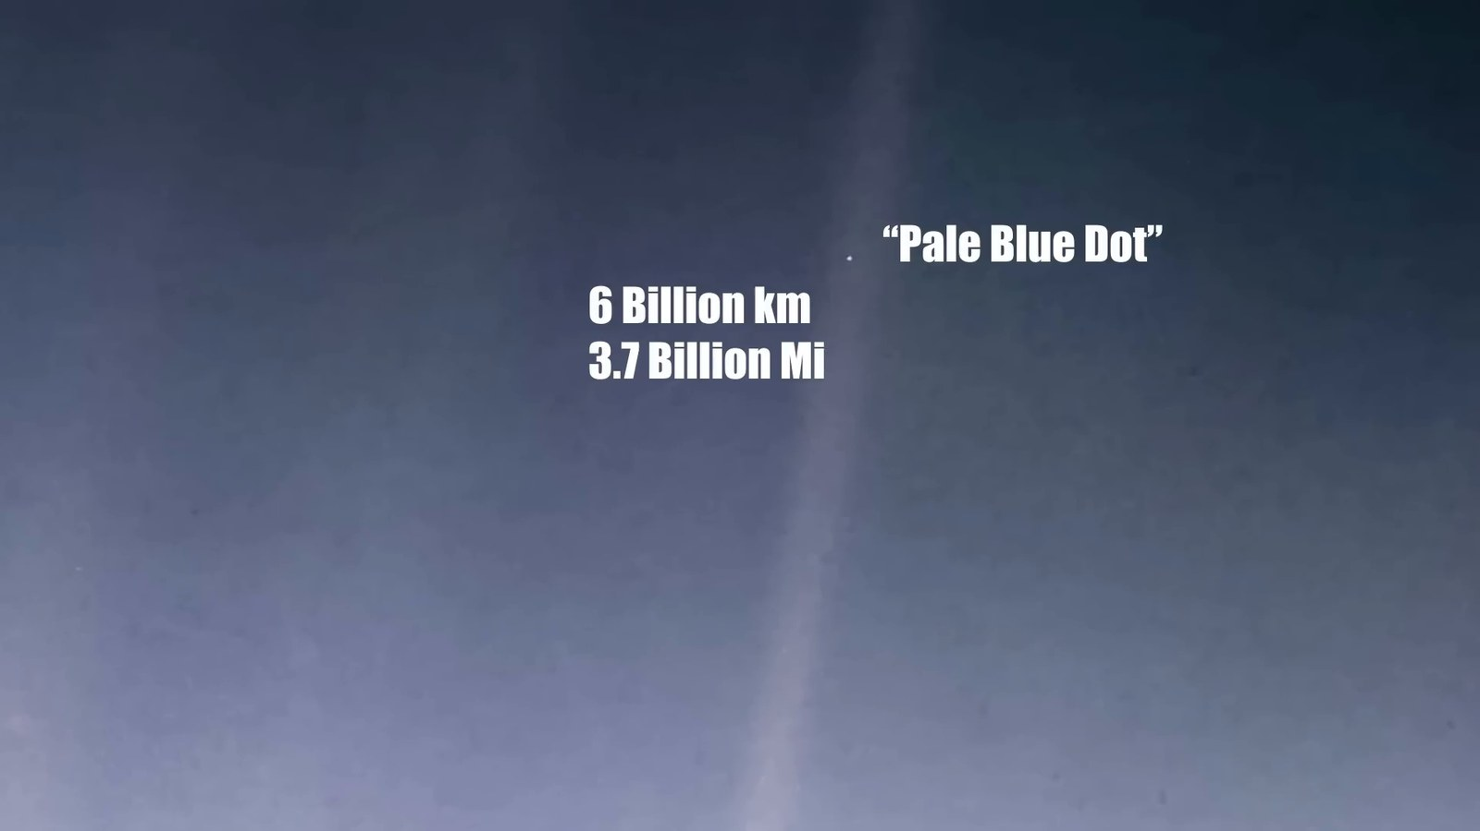
Matched transcript
image. At a distance of about 6 billion kilometers from Earth, our planet appeared as a tiny, faint dot in the vastness of space. Sagan poetically reflected on this image, emphasizing

Fragment 45
Time range: 04:08 - 04:12
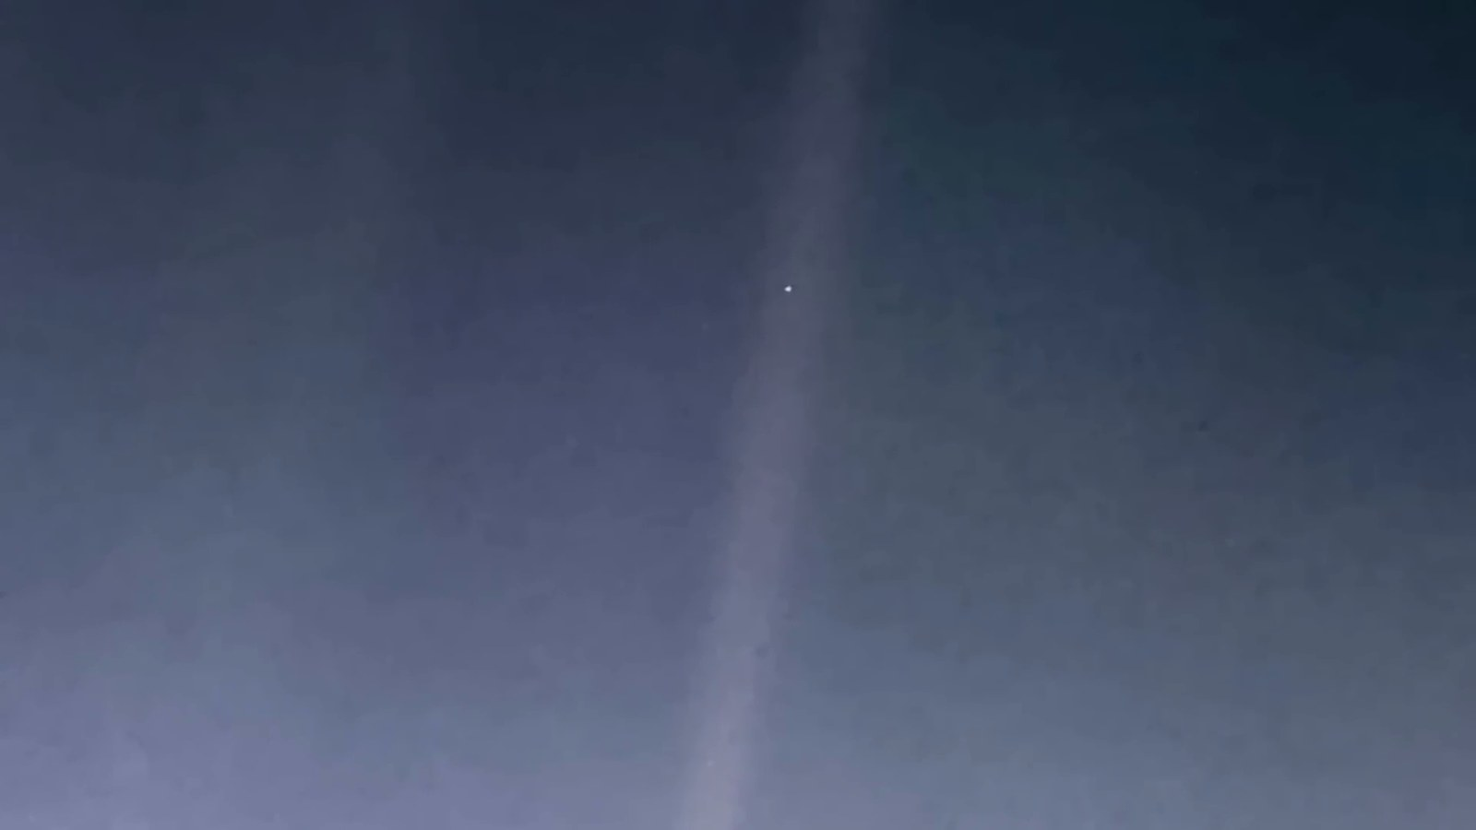
Matched transcript
faint dot in the vastness of space. Sagan poetically reflected on this image, emphasizing our responsibility to cherish and preserve our only home, a small speck in the immense universe.

Fragment 46
Time range: 04:12 - 04:17
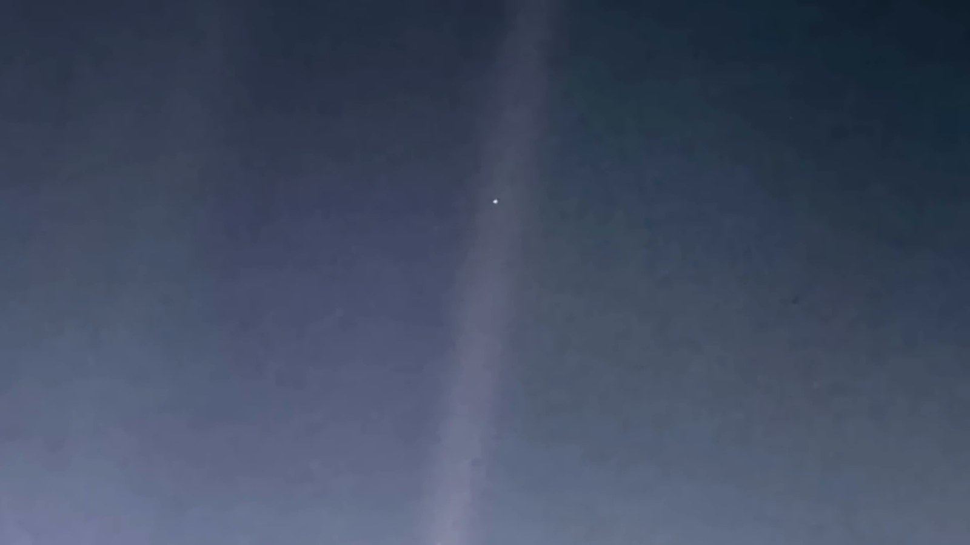
Matched transcript
our responsibility to cherish and preserve our only home, a small speck in the immense universe.

Fragment 47
Time range: 04:17 - 04:23
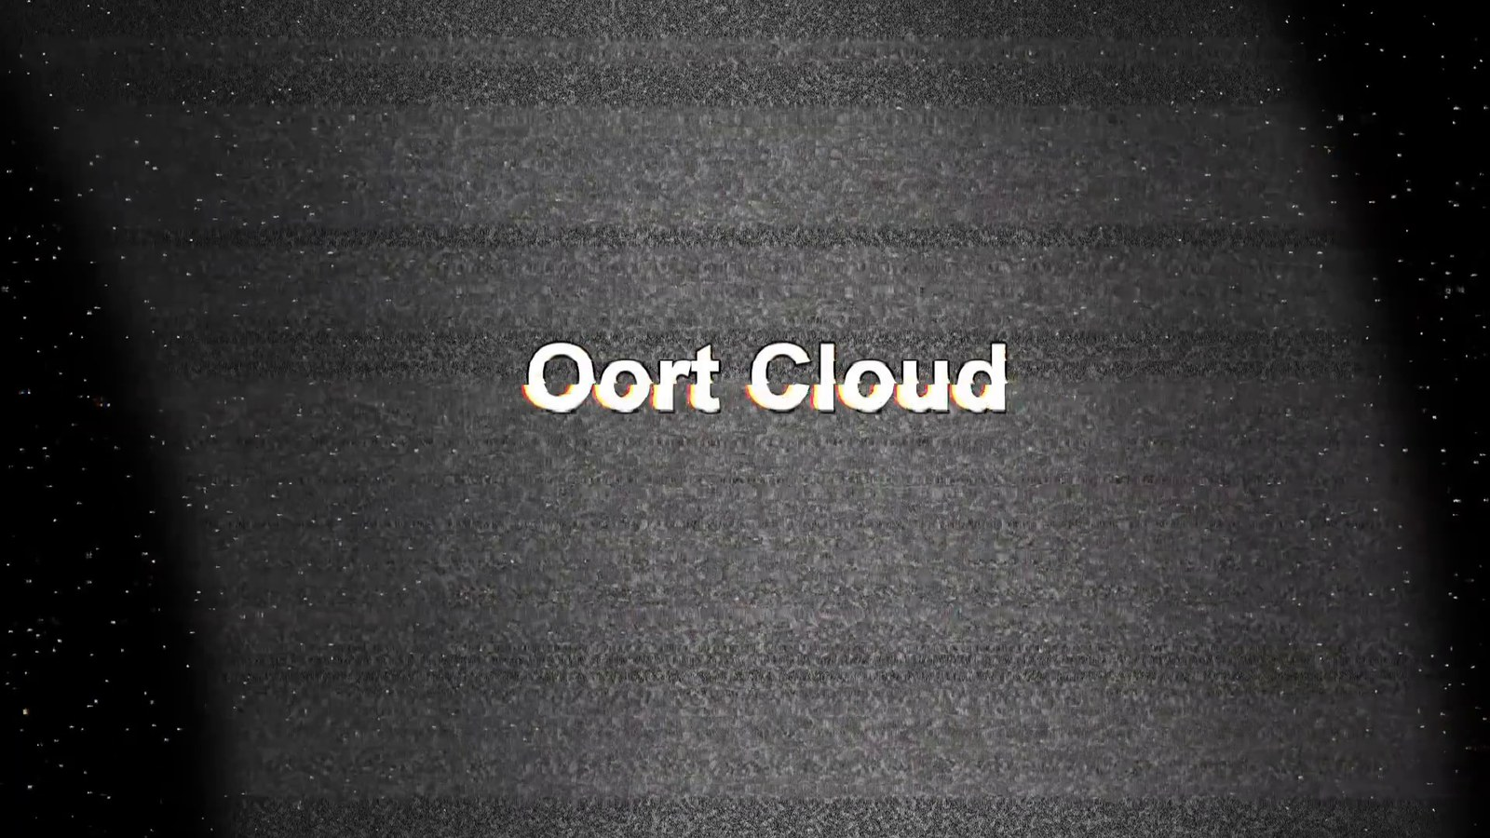
Matched transcript
At the very fringes of our solar system lies the Oort cloud, a vast theoretical sphere of icy

Fragment 48
Time range: 04:23 - 04:29
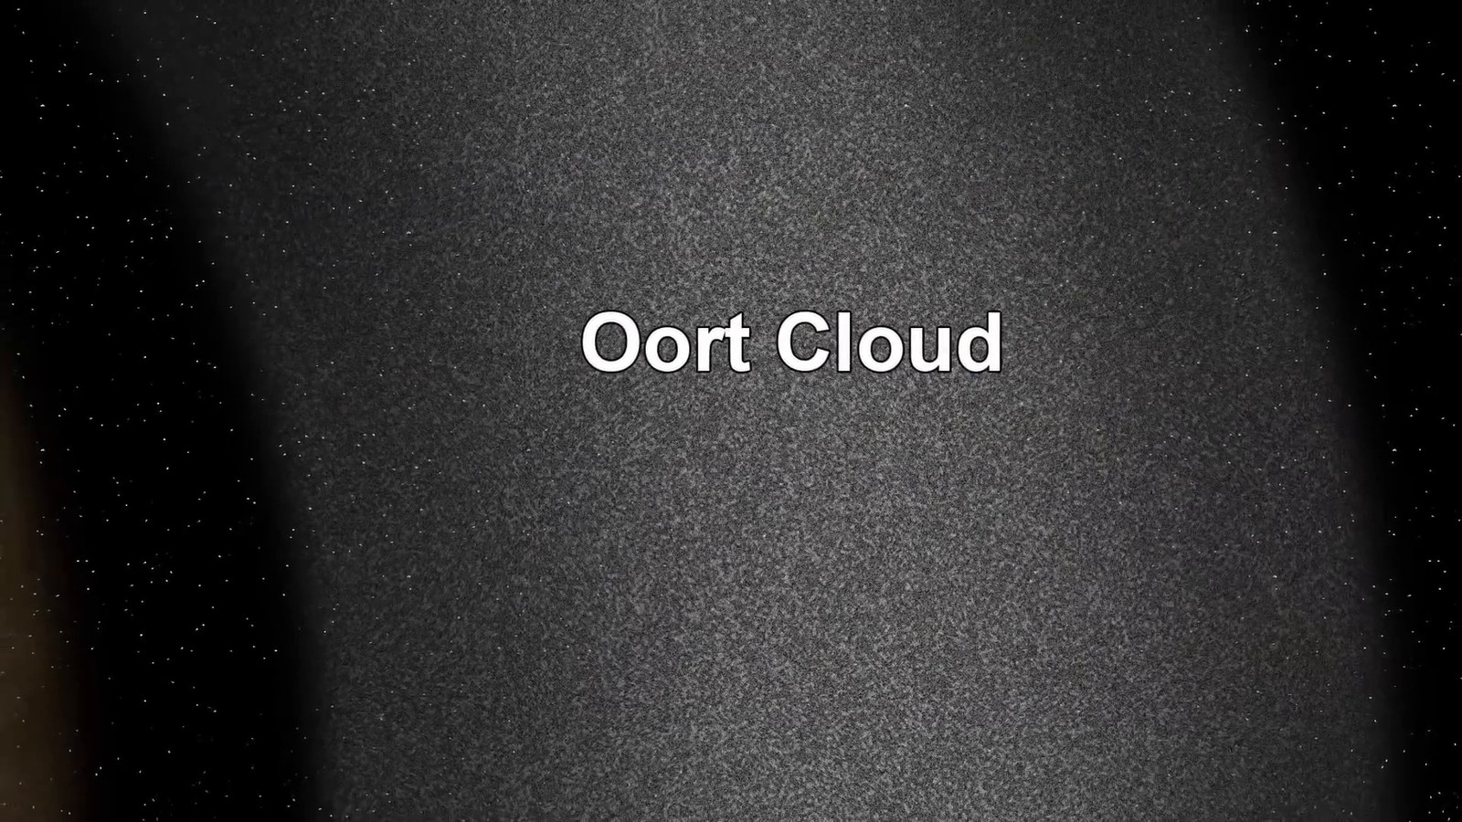
Matched transcript
At the very fringes of our solar system lies the Oort cloud, a vast theoretical sphere of icy objects. This distant cloud is thought to extend up to a staggering 100,000 astronomical

Fragment 49
Time range: 04:29 - 04:35
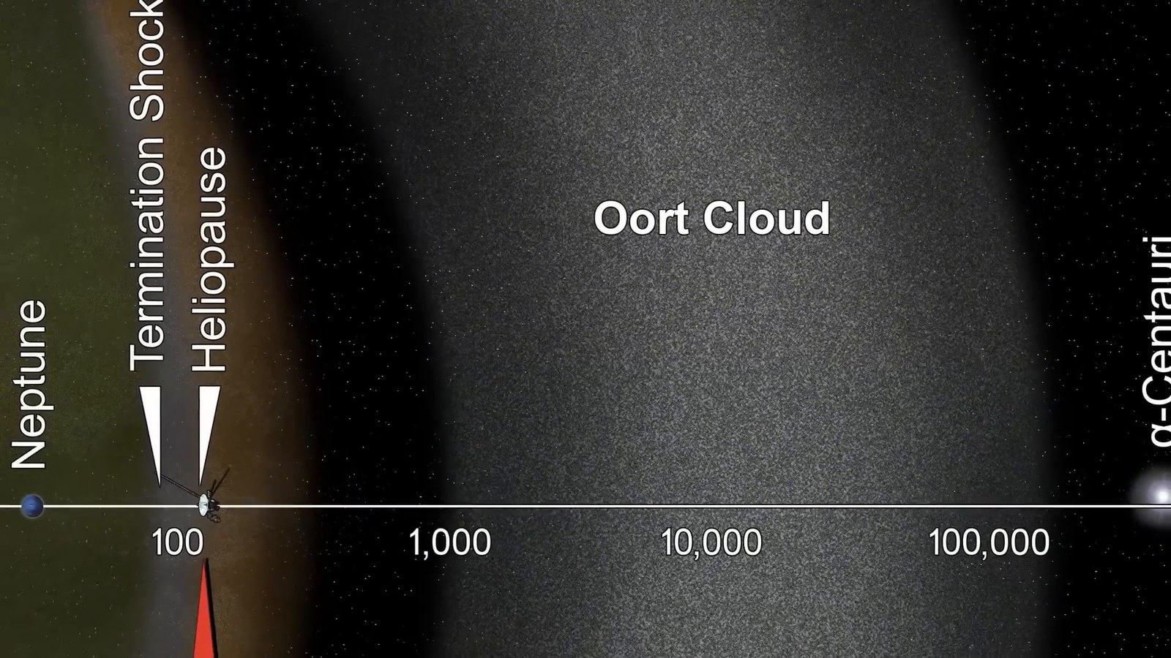
Matched transcript
objects. This distant cloud is thought to extend up to a staggering 100,000 astronomical units from the Sun. That's about 1.9 light-years, a distance so immense that it's on the cusp

Fragment 50
Time range: 04:35 - 04:41
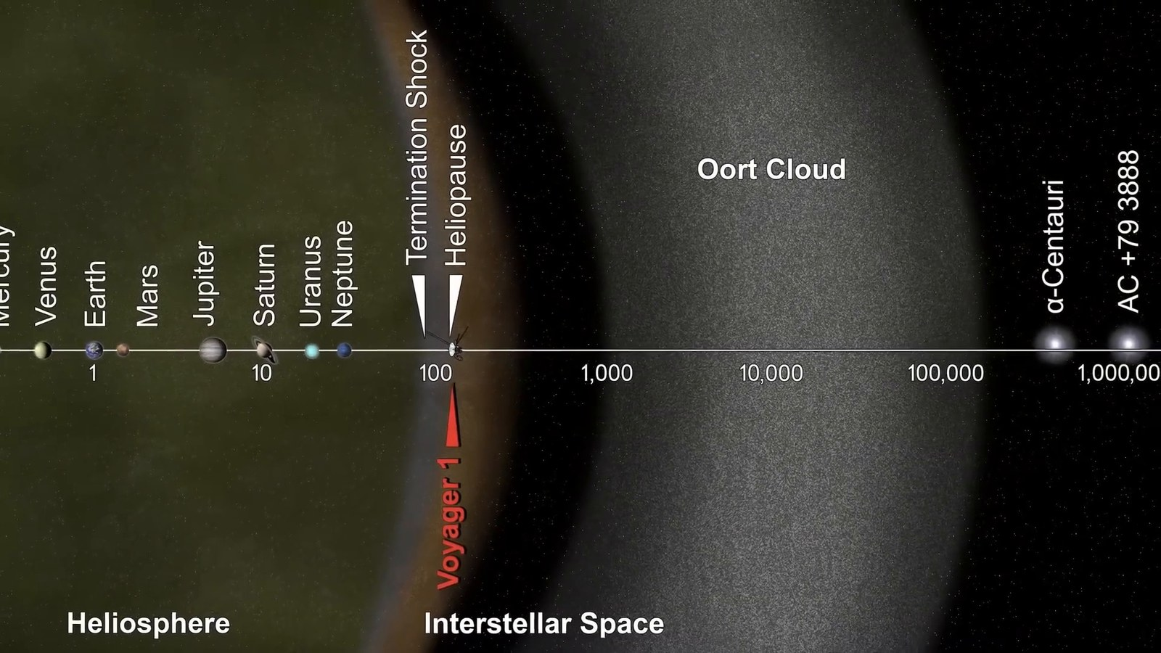
Matched transcript
units from the Sun. That's about 1.9 light-years, a distance so immense that it's on the cusp of interstellar space. Scientists determine the boundary of interstellar space, known

Fragment 51
Time range: 04:41 - 04:47
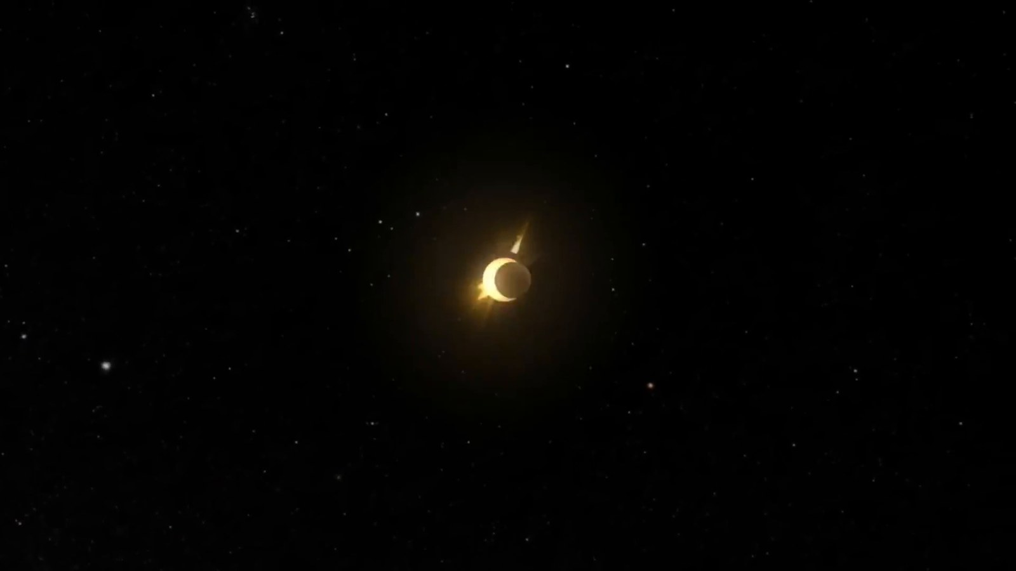
Matched transcript
of interstellar space. Scientists determine the boundary of interstellar space, known as the heliopause, where the Sun's solar wind is stopped by the interstellar medium.

Fragment 52
Time range: 04:47 - 04:53
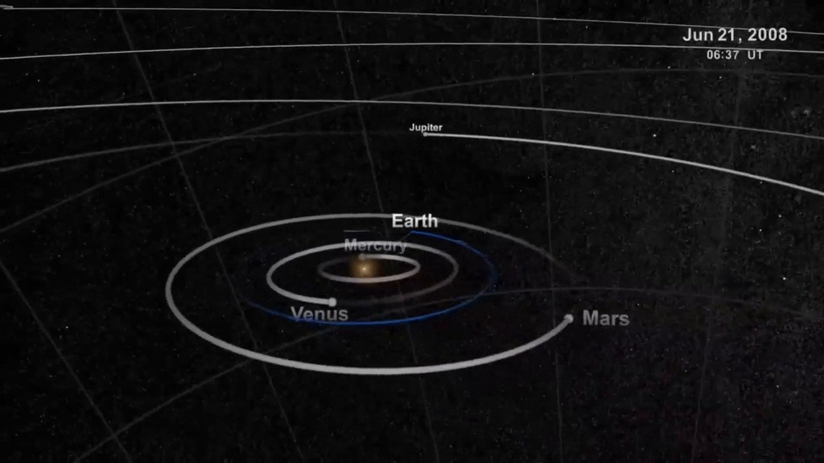
Matched transcript
as the heliopause, where the Sun's solar wind is stopped by the interstellar medium. This is where the influence of our sun ceases and the vast realm of interstellar space begins.

Fragment 53
Time range: 04:53 - 04:56
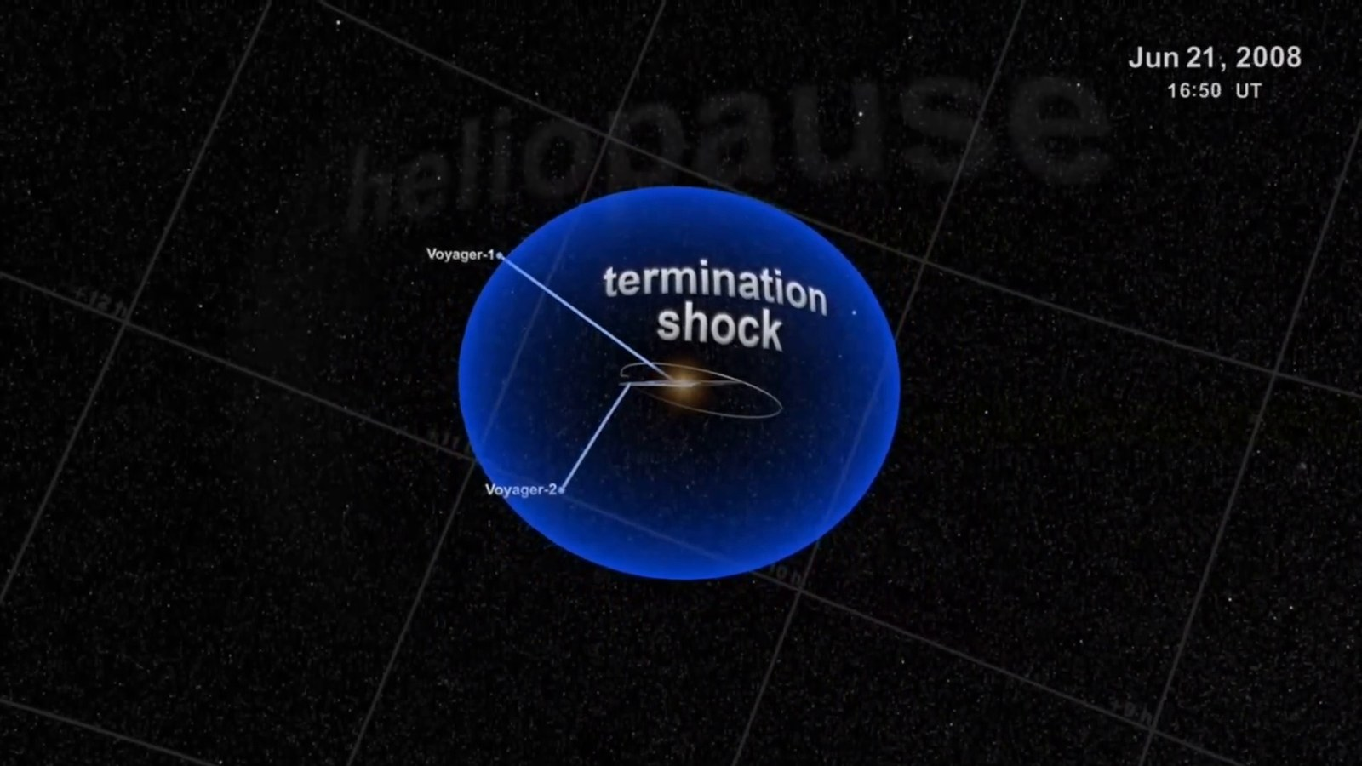
Matched transcript
This is where the influence of our sun ceases and the vast realm of interstellar space begins.

Fragment 54
Time range: 04:56 - 05:03
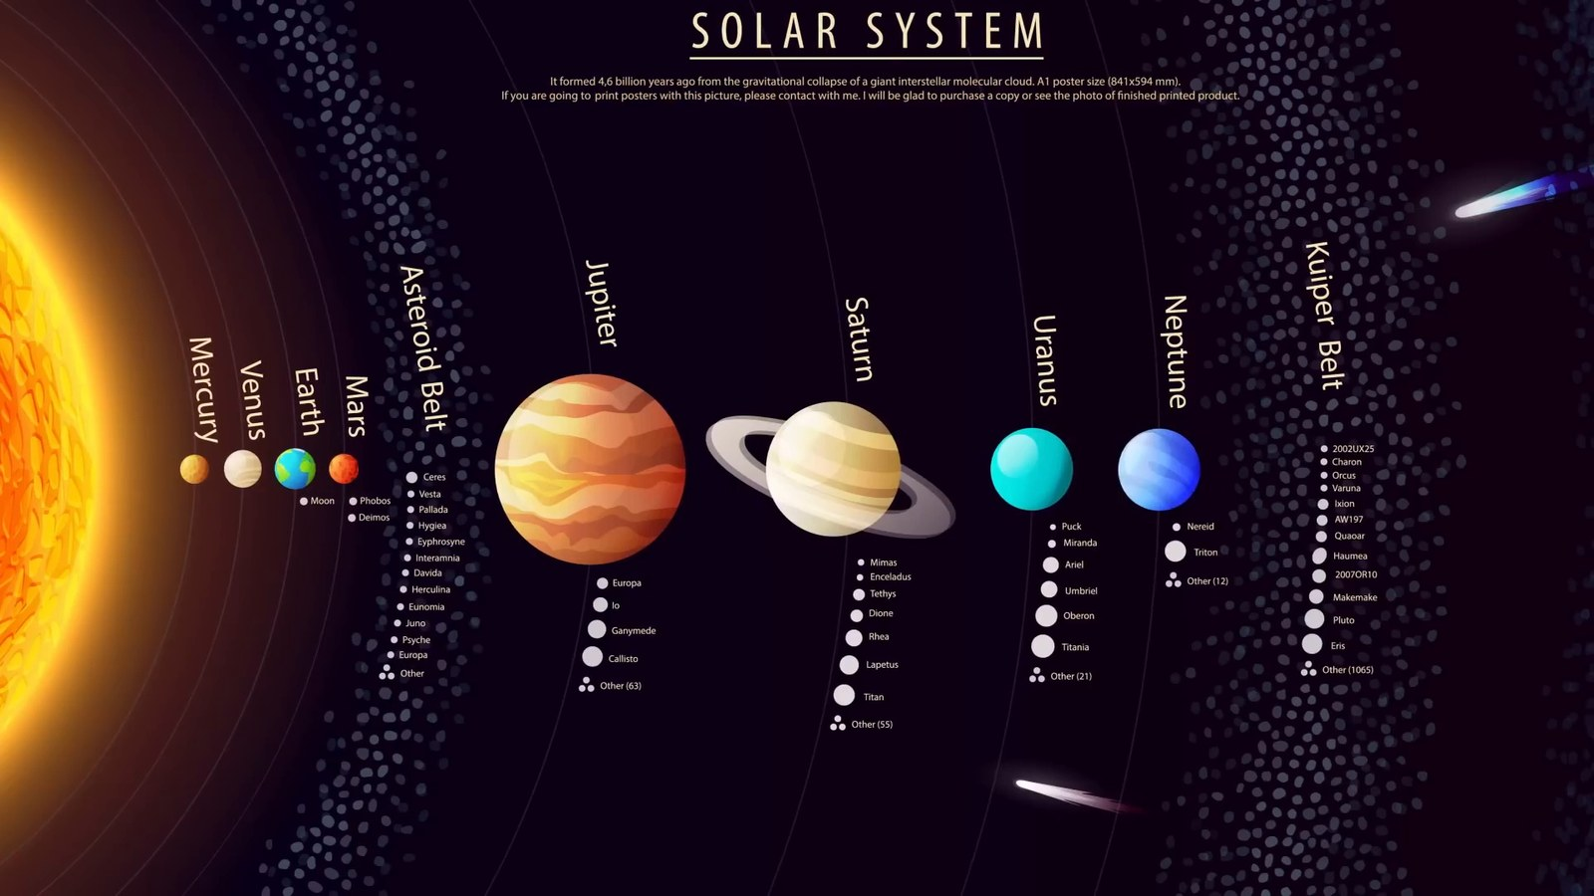
Matched transcript
This is where the influence of our sun ceases and the vast realm of interstellar space begins. The Oort cloud represents the final frontier of our solar system, a boundary zone where the sun's influence wanes and the cosmic journey into the galaxy truly begins.

Fragment 55
Time range: 05:03 - 05:09
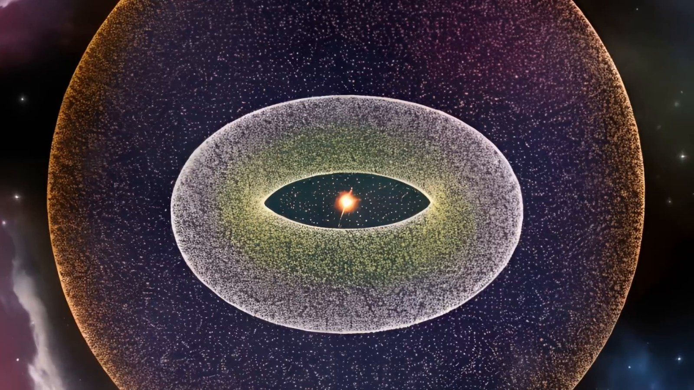
Matched transcript
the sun's influence wanes and the cosmic journey into the galaxy truly begins. As we venture beyond the confines of our solar system, our next point of interest is Alpha

Fragment 56
Time range: 05:09 - 05:15
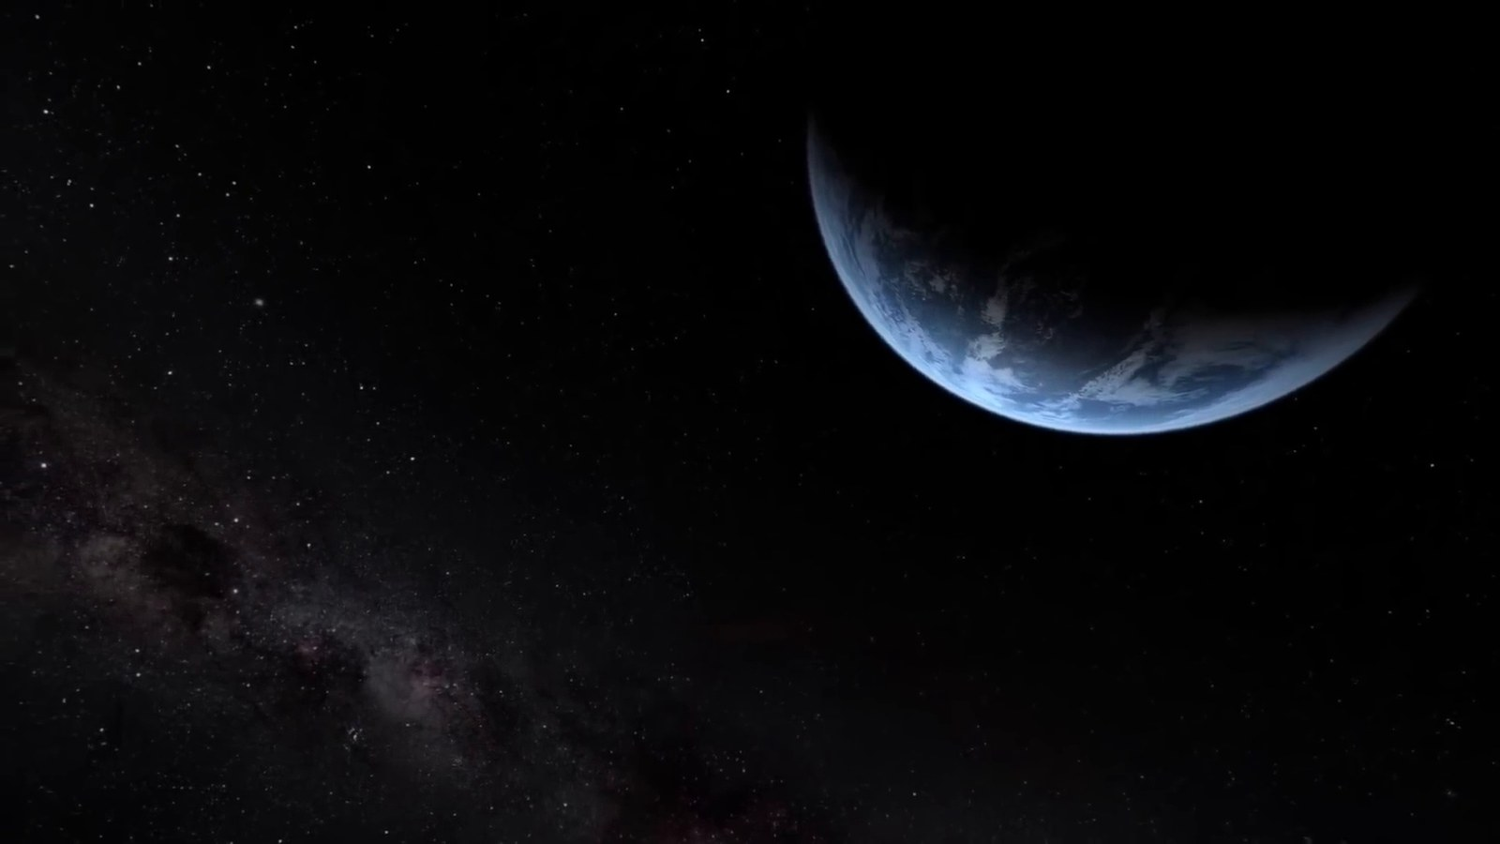
Matched transcript
As we venture beyond the confines of our solar system, our next point of interest is Alpha Centauri, the closest star system to our Sun. Located about 41.3 trillion kilometers away,

Fragment 57
Time range: 05:15 - 05:21
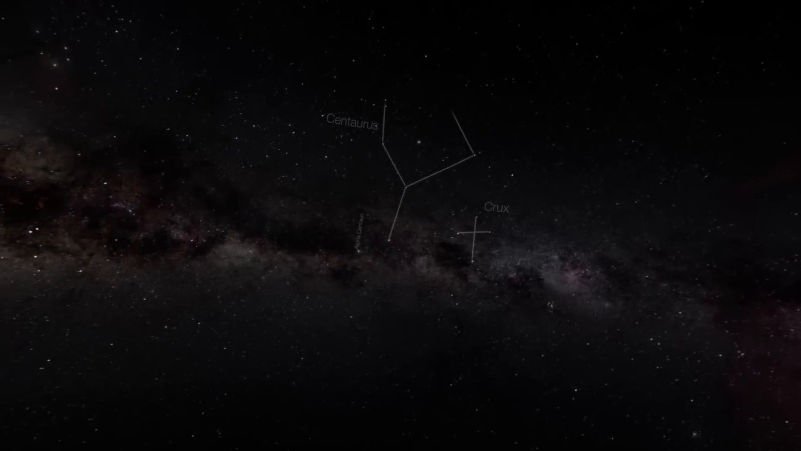
Matched transcript
Centauri, the closest star system to our Sun. Located about 41.3 trillion kilometers away, this distance is equivalent to over 276,000 astronomical units. At such colossal distances,

Fragment 58
Time range: 05:21 - 05:27
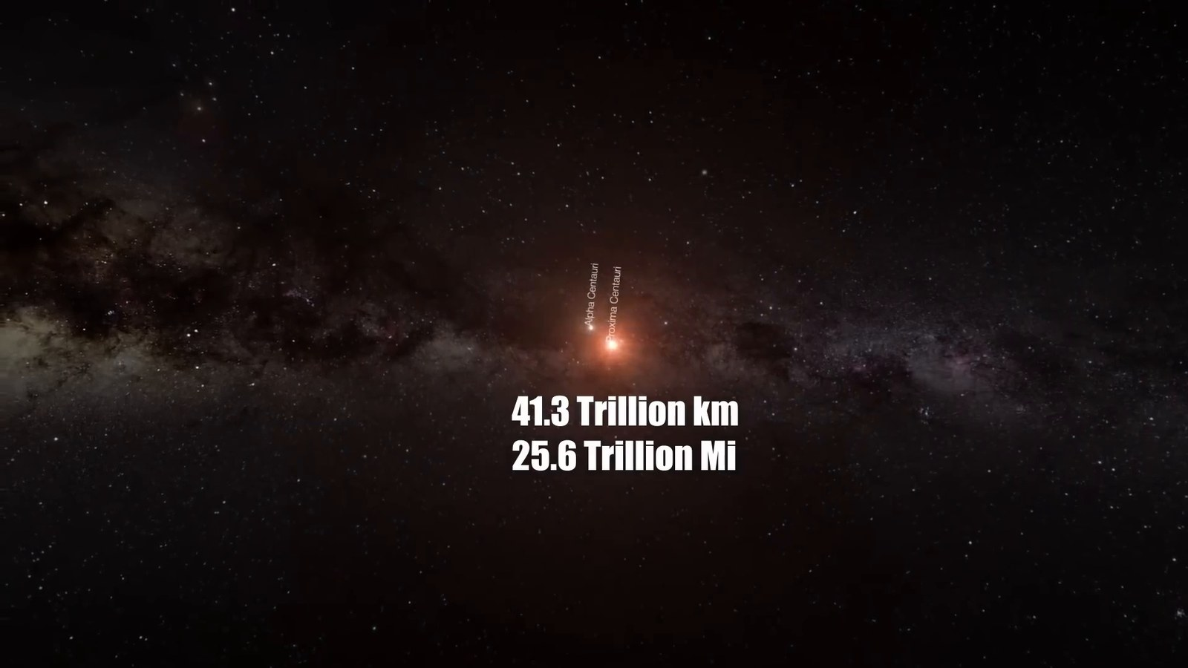
Matched transcript
this distance is equivalent to over 276,000 astronomical units. At such colossal distances,

Fragment 59
Time range: 05:27 - 05:31
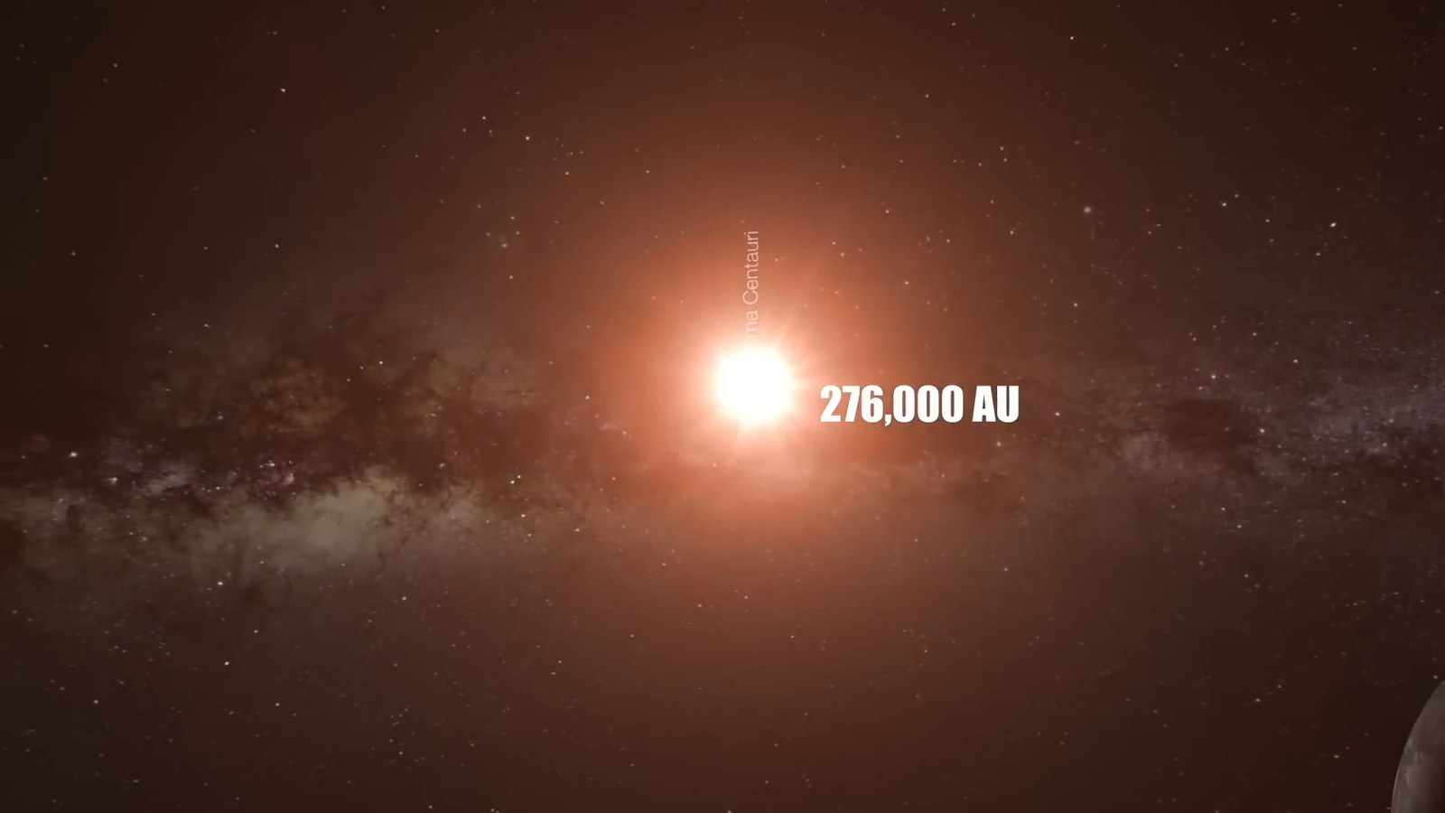
Matched transcript
this distance is equivalent to over 276,000 astronomical units. At such colossal distances, the AU a measure so convenient within our solar system begins to lose its practicality Hence astronomers use the light year the distance light travels in one year for interstellar measurements

Fragment 60
Time range: 05:31 - 05:37
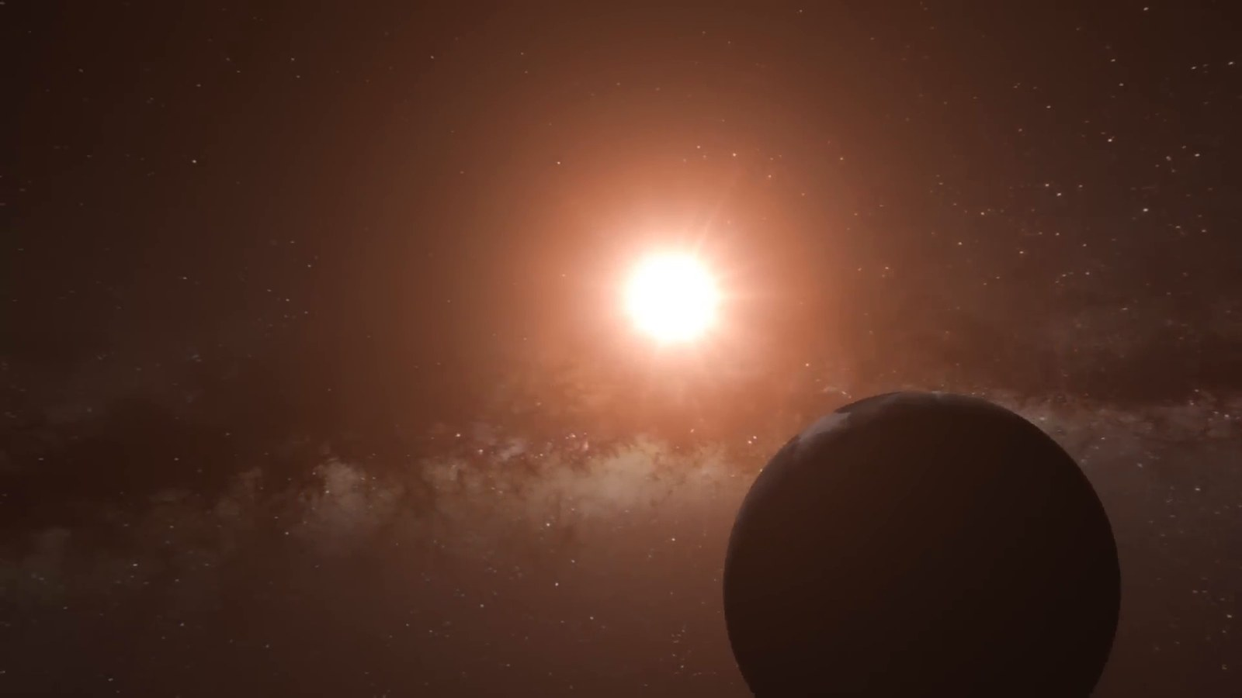
Matched transcript
the AU a measure so convenient within our solar system begins to lose its practicality Hence astronomers use the light year the distance light travels in one year for interstellar measurements

Fragment 61
Time range: 05:37 - 05:43
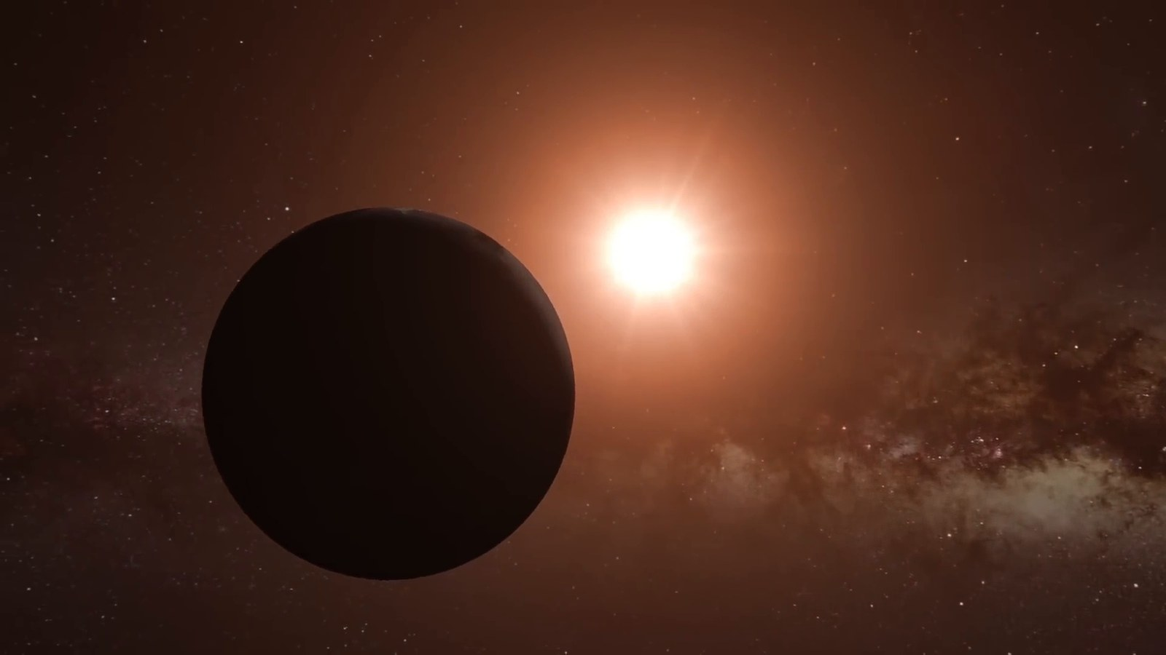
Matched transcript
the AU a measure so convenient within our solar system begins to lose its practicality Hence astronomers use the light year the distance light travels in one year for interstellar measurements Alpha Centauri is about 4.4 light years away from us.

Fragment 62
Time range: 05:43 - 05:49
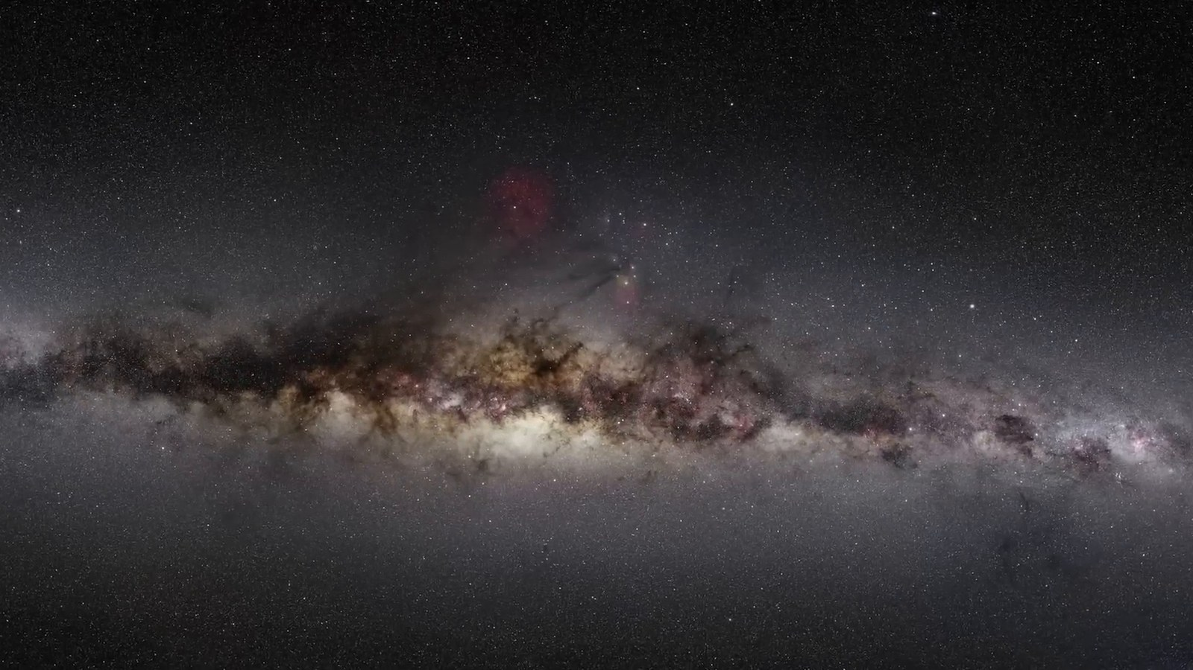
Matched transcript
Alpha Centauri is about 4.4 light years away from us. Considering our current space travel technology, a journey to Alpha Centauri is almost unfathomable.

Fragment 63
Time range: 05:49 - 05:55
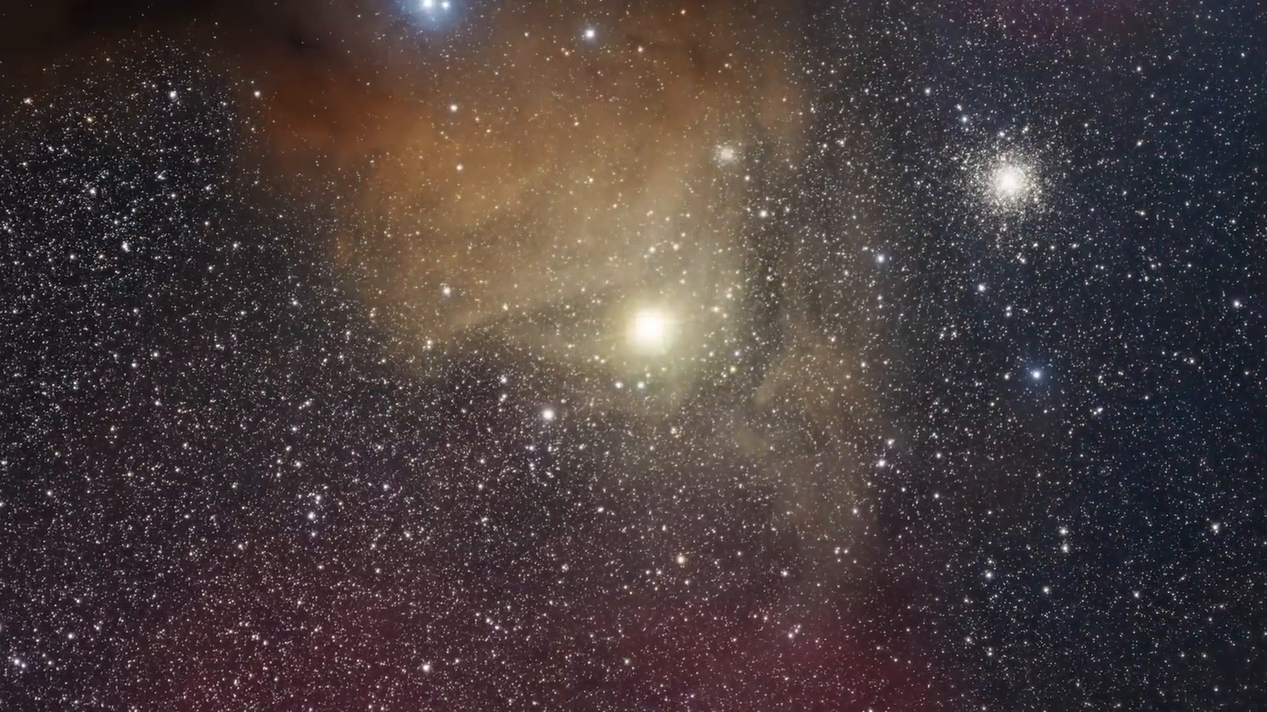
Matched transcript
Considering our current space travel technology, a journey to Alpha Centauri is almost unfathomable. For instance, the Voyager spacecraft, traveling at about 17 kilometers per second, would take over 70,000 years to reach this neighboring star system.

Fragment 64
Time range: 05:55 - 06:01
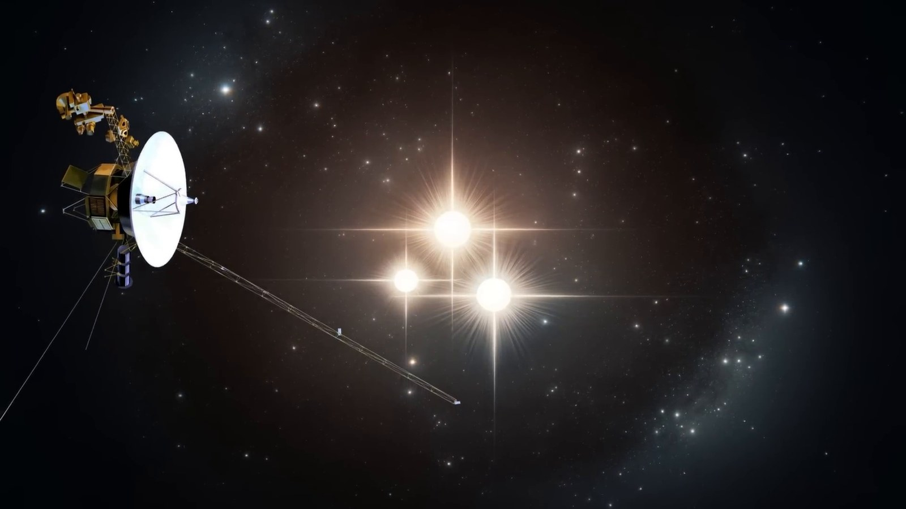
Matched transcript
For instance, the Voyager spacecraft, traveling at about 17 kilometers per second, would take over 70,000 years to reach this neighboring star system.

Fragment 65
Time range: 06:01 - 06:04
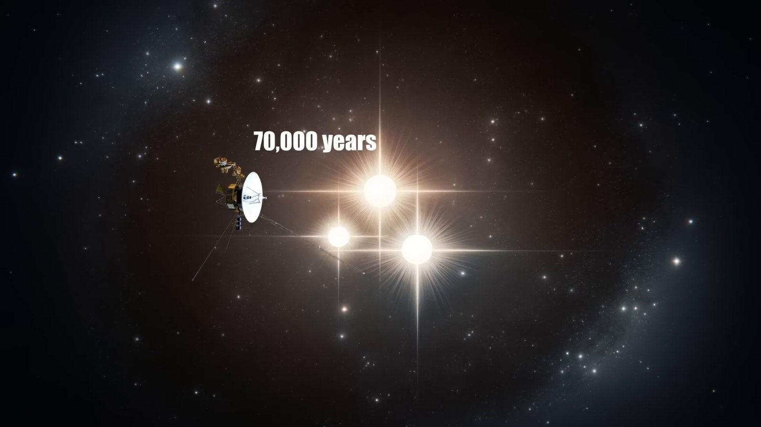
Matched transcript
For instance, the Voyager spacecraft, traveling at about 17 kilometers per second, would take over 70,000 years to reach this neighboring star system. This immense distance underscores the vastness of space that separates the stars and highlights the challenges of interstellar travel.

Fragment 66
Time range: 06:04 - 06:10
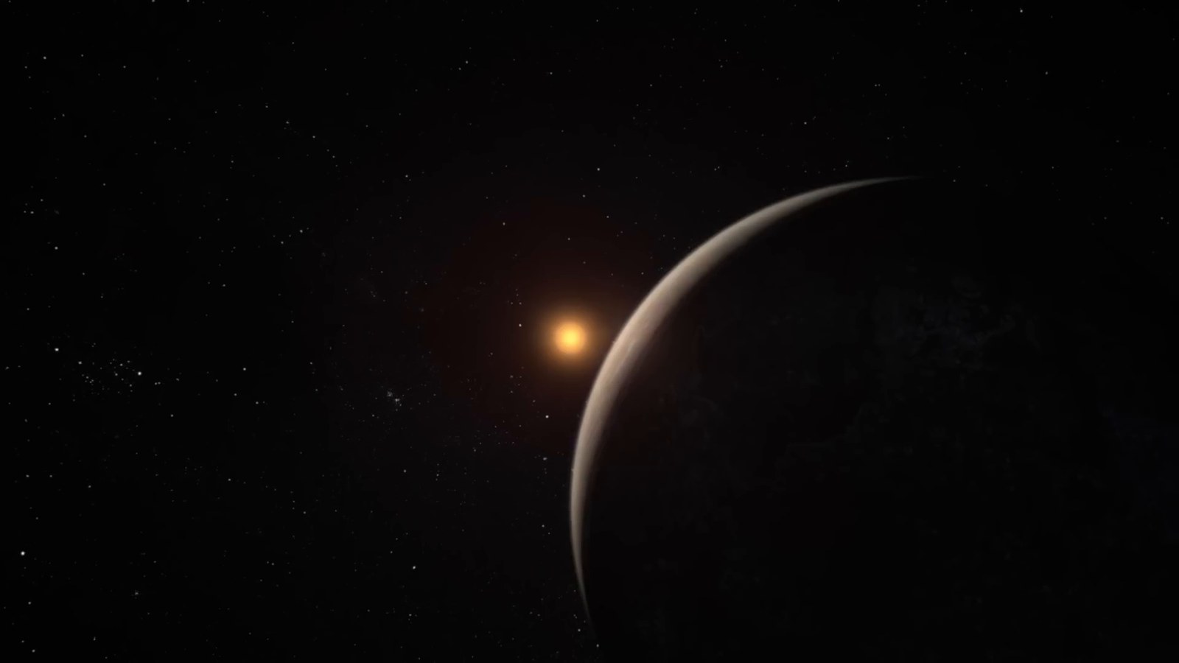
Matched transcript
This immense distance underscores the vastness of space that separates the stars and highlights the challenges of interstellar travel.

Fragment 67
Time range: 06:10 - 06:16
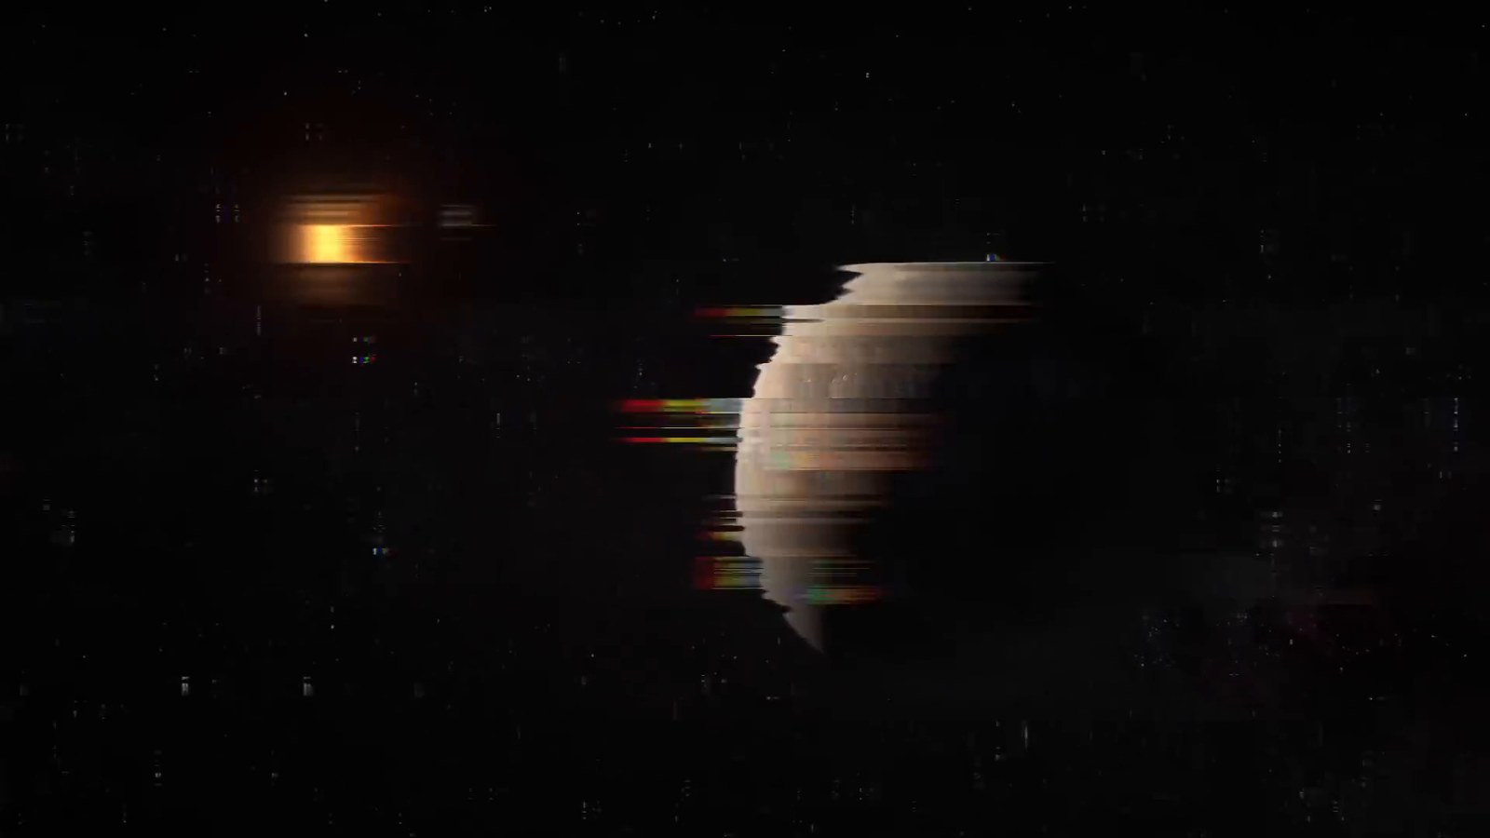
Matched transcript
Our journey now takes us to the grand scale of our home galaxy, the Milky Way.

Fragment 68
Time range: 06:16 - 06:22
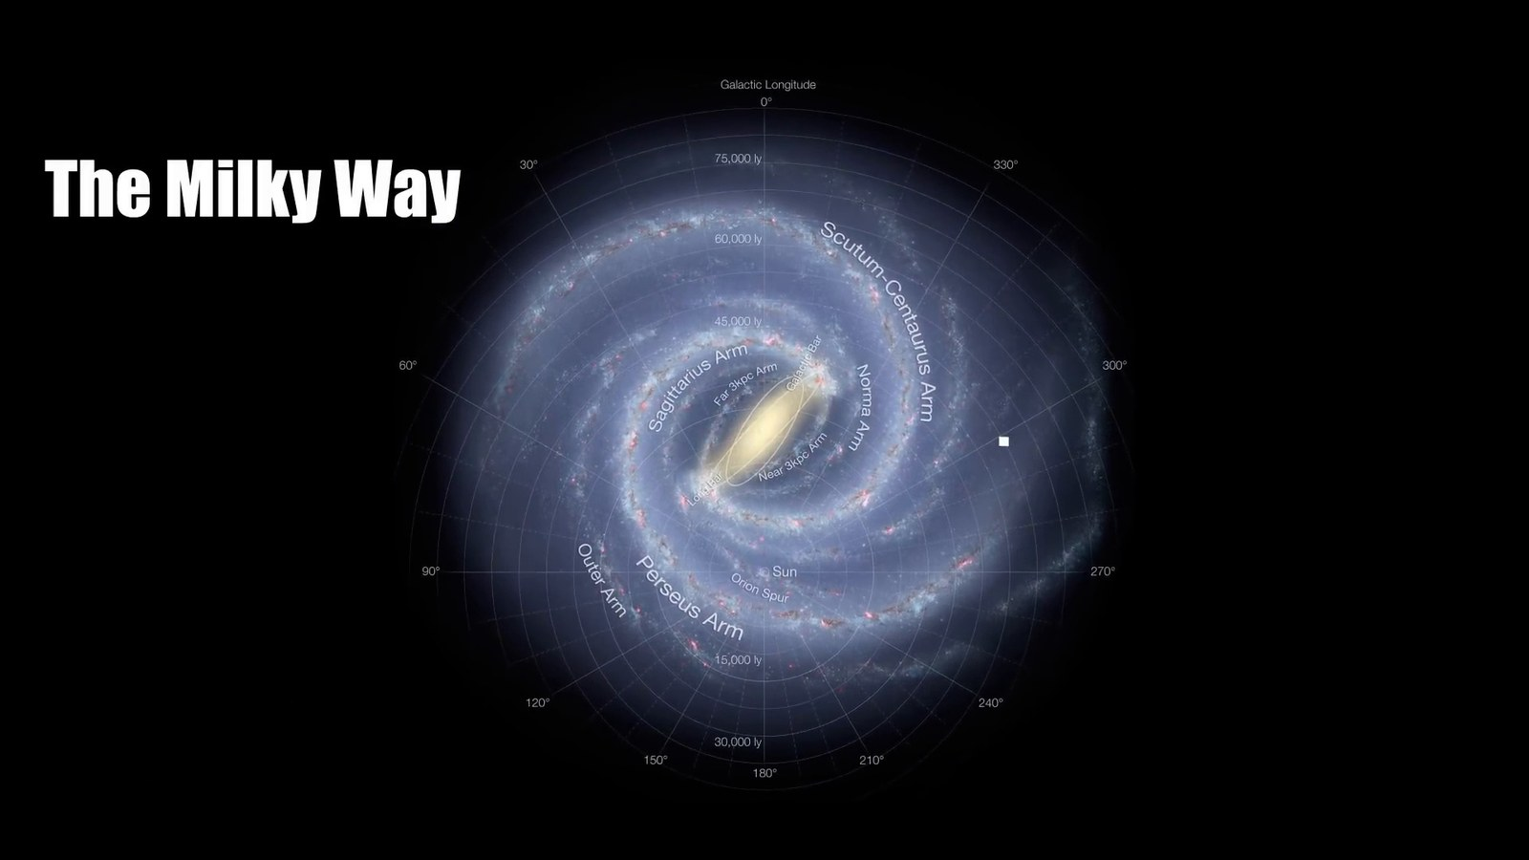
Matched transcript
Spanning about 100,000 light-years in diameter, this vast spiral galaxy is home to hundreds of billions of stars,

Fragment 69
Time range: 06:22 - 06:28
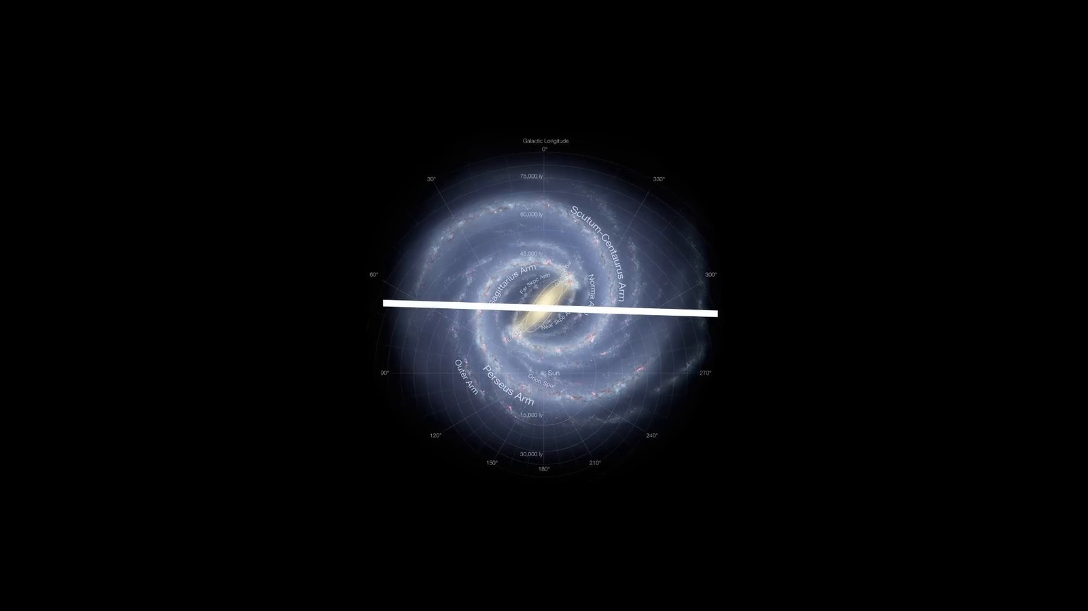
Matched transcript
this vast spiral galaxy is home to hundreds of billions of stars, each potentially hosting their own planetary systems. Within this immense structure, there's a tiny sphere known as the human radio bubble,

Fragment 70
Time range: 06:28 - 06:34
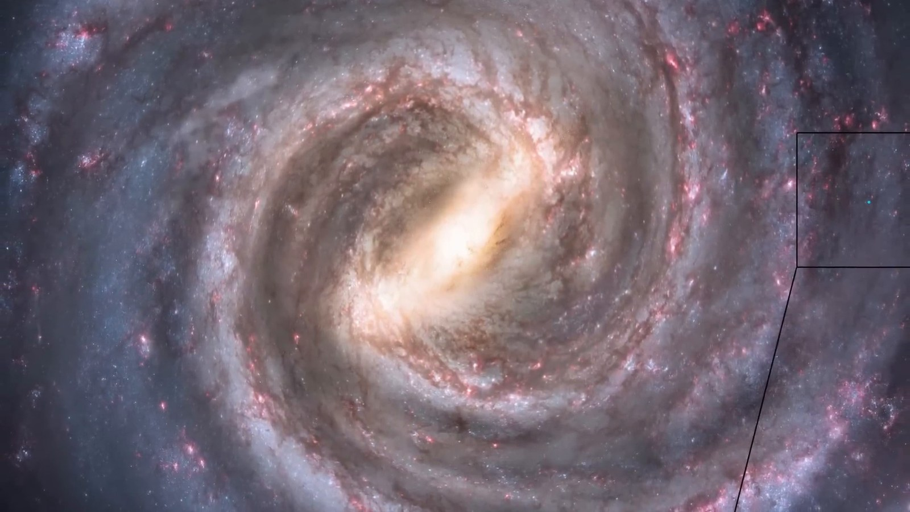
Matched transcript
Within this immense structure, there's a tiny sphere known as the human radio bubble, extending about 100 light-years from Earth.

Fragment 71
Time range: 06:34 - 06:40
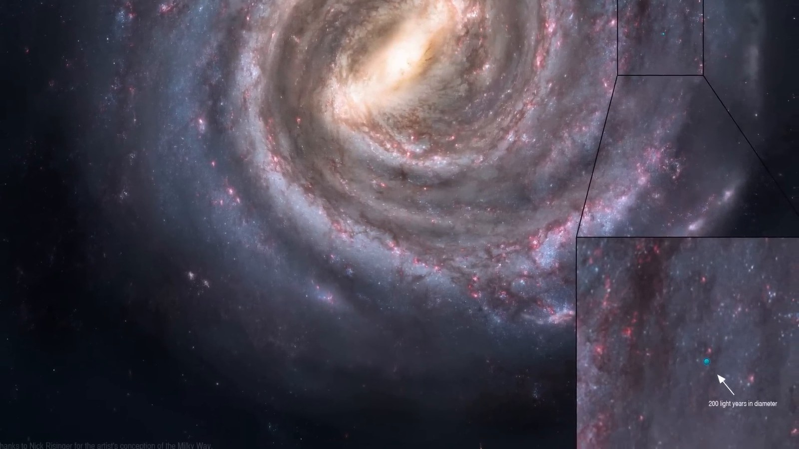
Matched transcript
extending about 100 light-years from Earth. This bubble represents the farthest extent of human influence in the cosmos, the reach of our radio and television broadcasts into space.

Fragment 72
Time range: 06:40 - 06:46
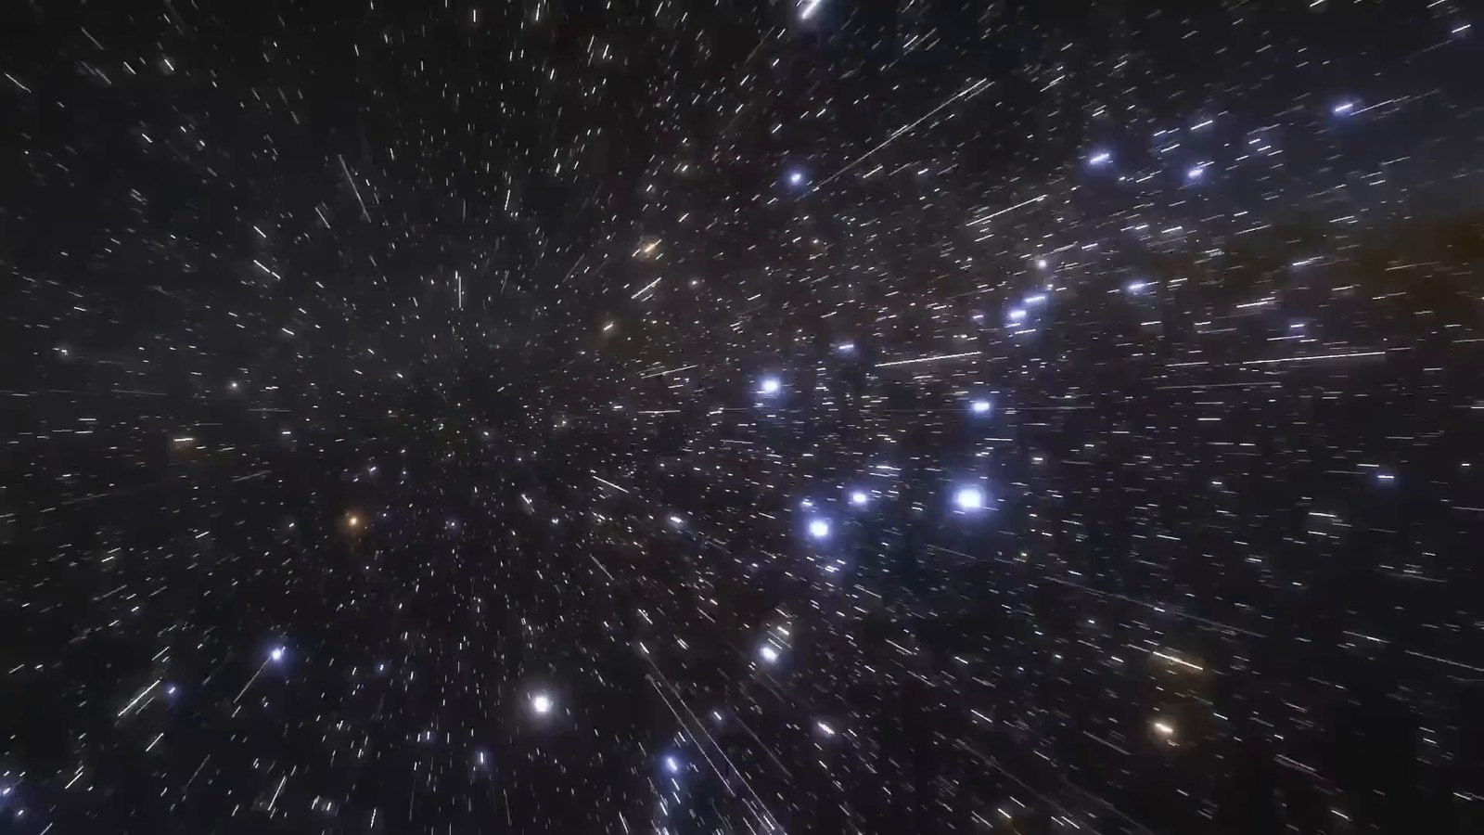
Matched transcript
the reach of our radio and television broadcasts into space. Beyond this bubble, it's as if humanity never existed.

Fragment 73
Time range: 06:46 - 06:49
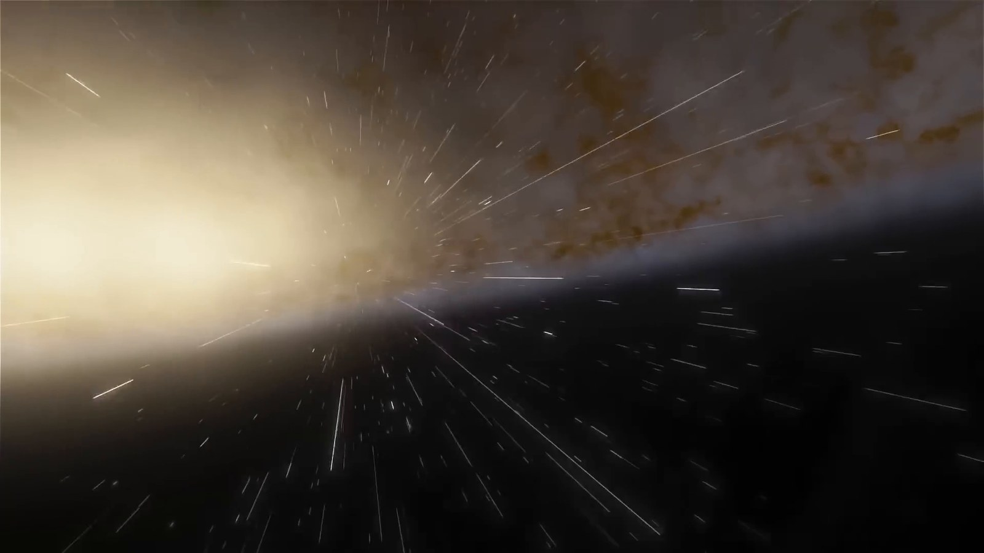
Matched transcript
Beyond this bubble, it's as if humanity never existed. Any civilizations residing in the vast majority of our galaxy would be oblivious to our presence,

Fragment 74
Time range: 06:49 - 06:55
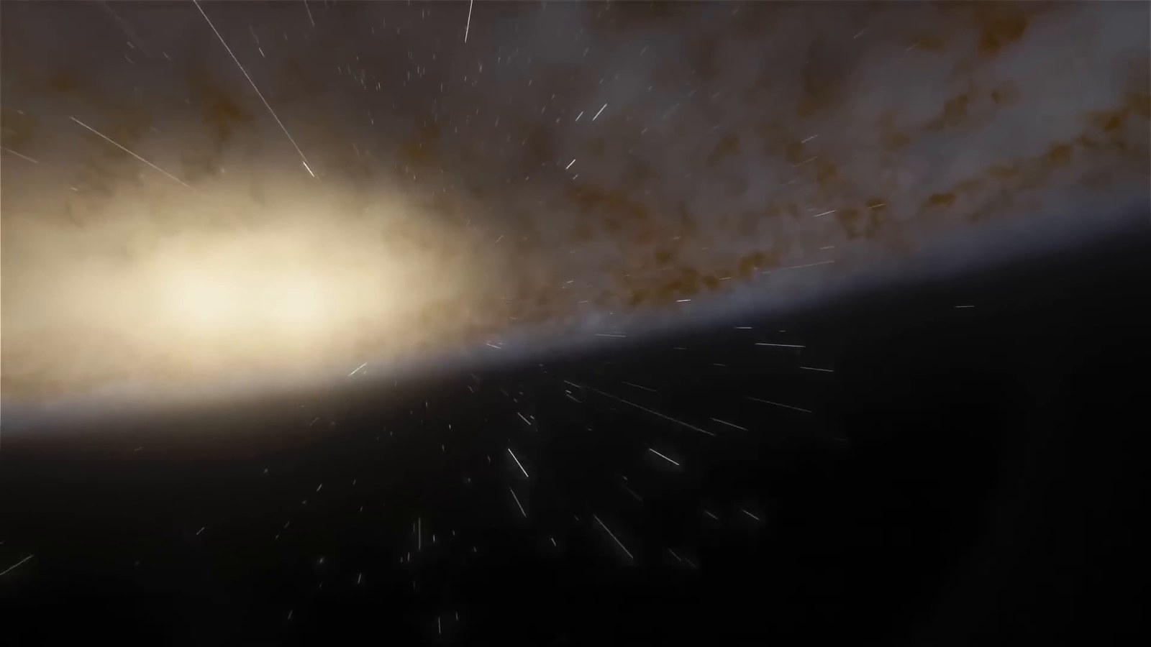
Matched transcript
Any civilizations residing in the vast majority of our galaxy would be oblivious to our presence, given that our signals haven't reached them yet.

Fragment 75
Time range: 06:55 - 07:00
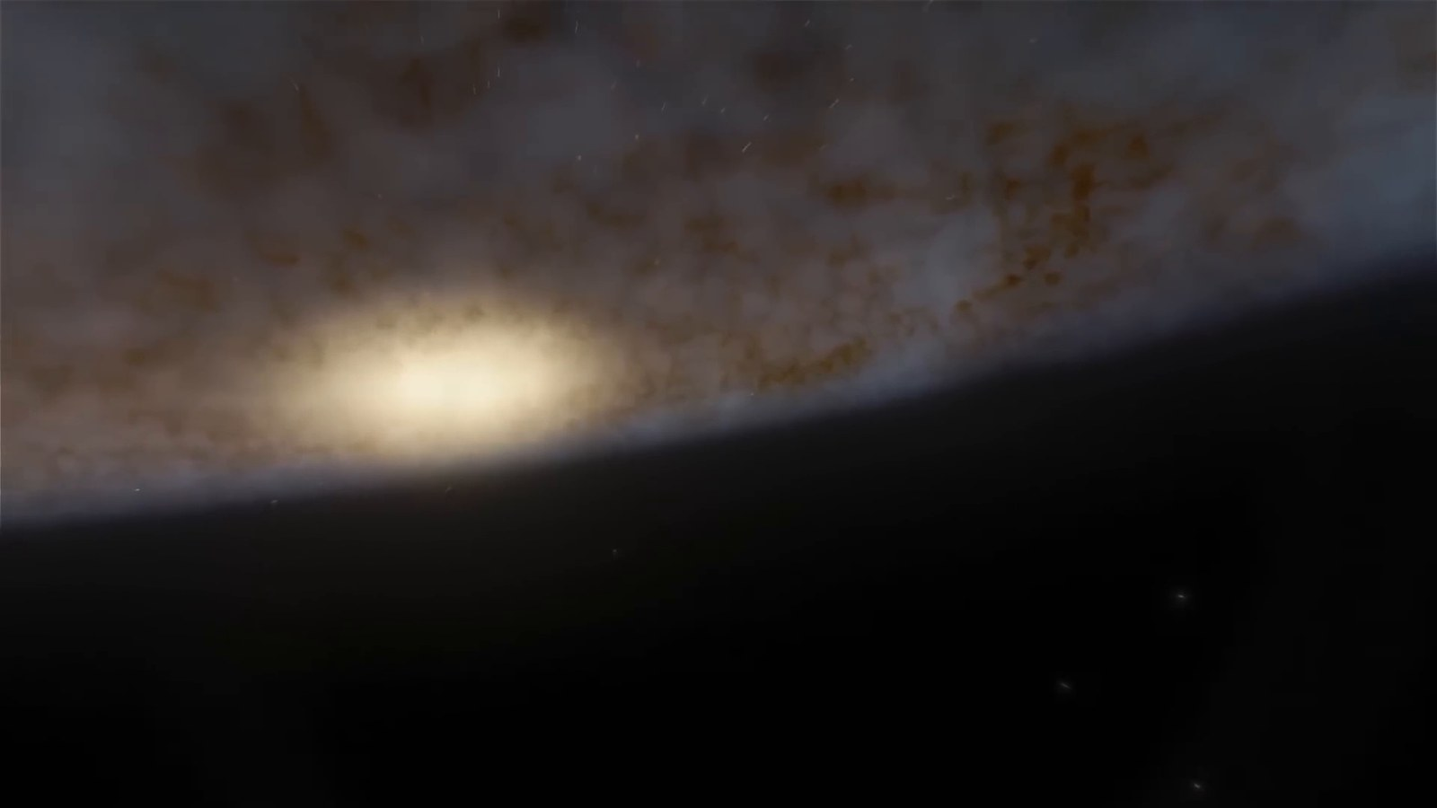
Matched transcript
given that our signals haven't reached them yet. The scale of the Milky Way is so vast that our entire recorded history is but a whisper in the cosmic wind,

Fragment 76
Time range: 07:00 - 07:08
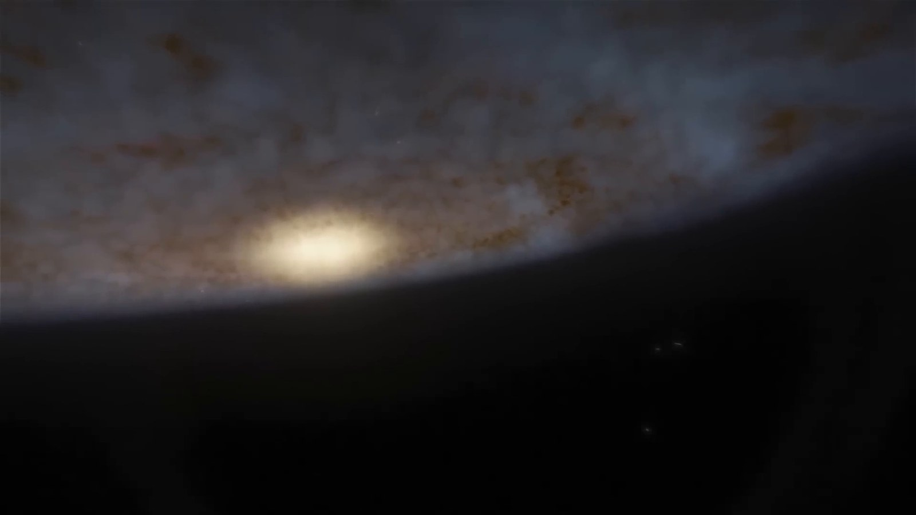
Matched transcript
The scale of the Milky Way is so vast that our entire recorded history is but a whisper in the cosmic wind, undetectable beyond this small bubble. As we leave the Milky Way, we enter the vast, almost incomprehensible realm of intergalactic space.

Fragment 77
Time range: 07:08 - 07:14
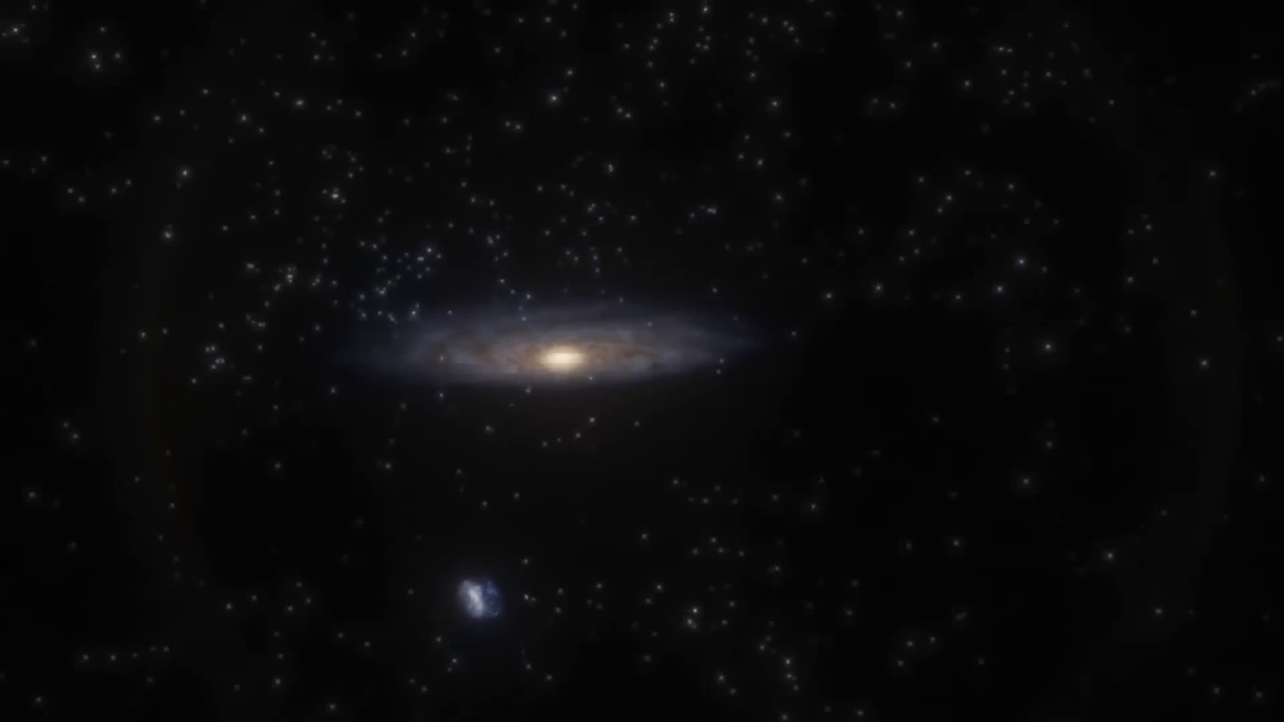
Matched transcript
As we leave the Milky Way, we enter the vast, almost incomprehensible realm of intergalactic space. Here, galaxies float in the cosmic ocean, separated by mind-boggling distances.

Fragment 78
Time range: 07:14 - 07:20
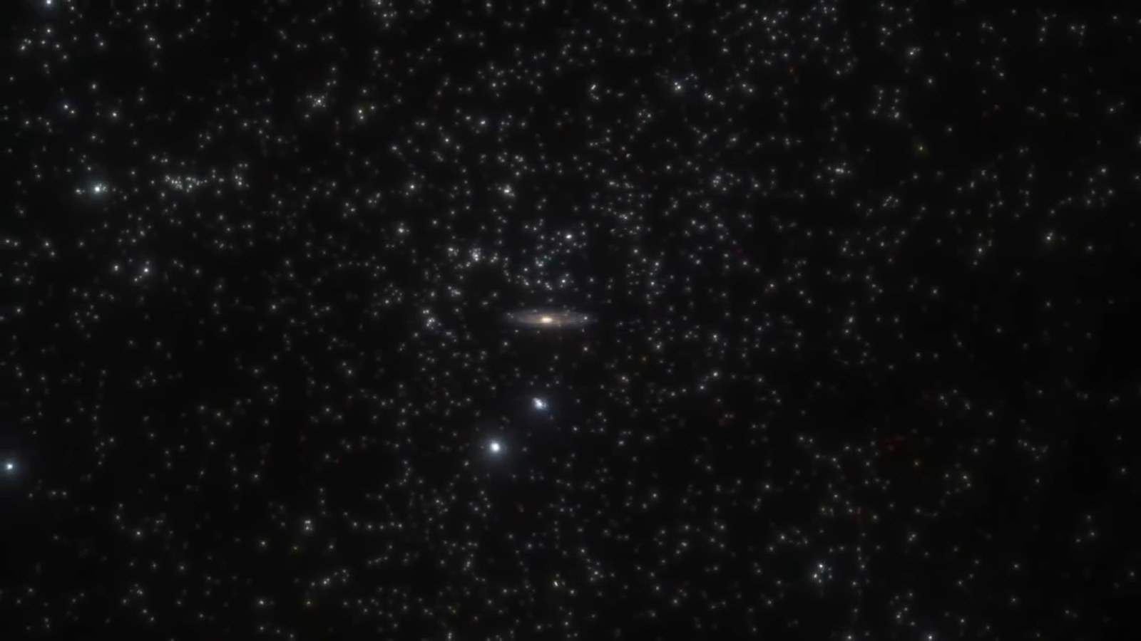
Matched transcript
Here, galaxies float in the cosmic ocean, separated by mind-boggling distances. Our galaxy is part of a small cosmic neighborhood known as the Local Group, a cluster of more

Fragment 79
Time range: 07:20 - 07:23
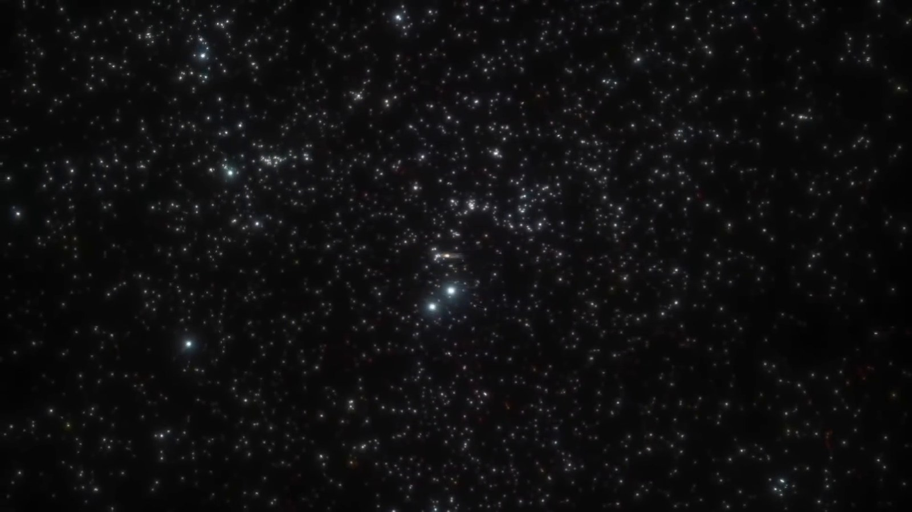
Matched transcript
Our galaxy is part of a small cosmic neighborhood known as the Local Group, a cluster of more

Fragment 80
Time range: 07:23 - 07:29
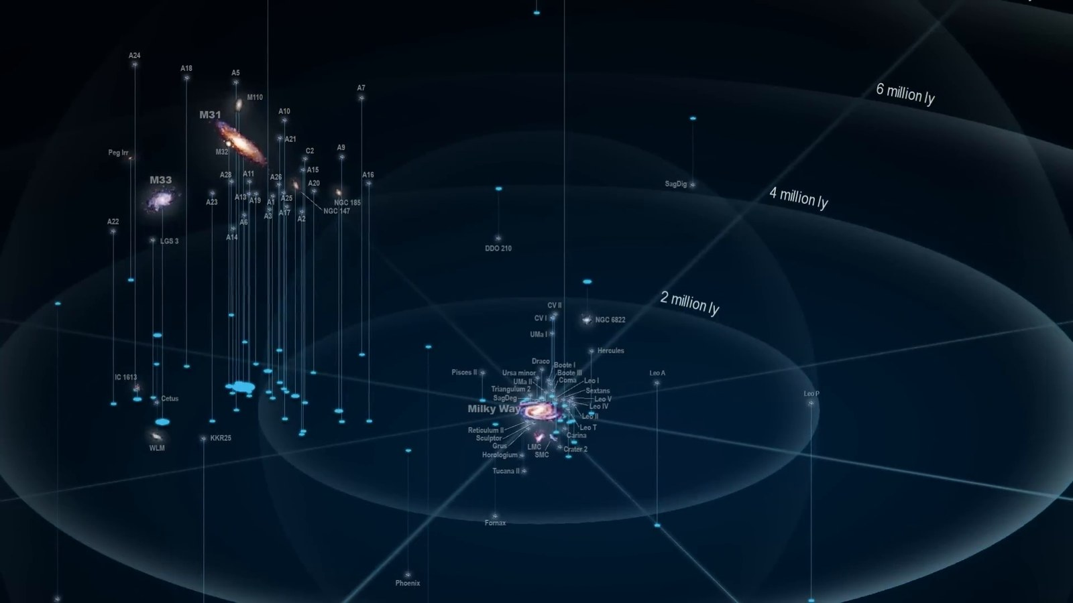
Matched transcript
Our galaxy is part of a small cosmic neighborhood known as the Local Group, a cluster of more than 50 galaxies spread across approximately 10 million light-years.

Fragment 81
Time range: 07:29 - 07:36
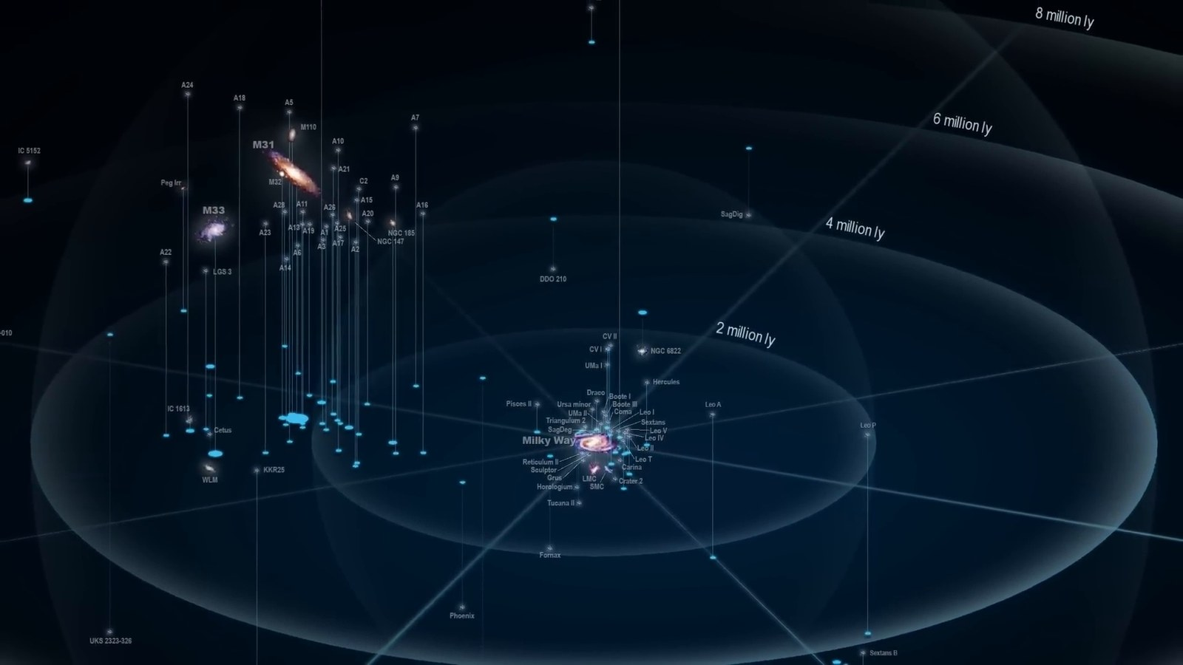
Matched transcript
than 50 galaxies spread across approximately 10 million light-years. The Local Group is a diverse assembly, including not just spiral galaxies like the Milky Way and Andromeda, but also a multitude of smaller dwarf galaxies.

Fragment 82
Time range: 07:36 - 07:42
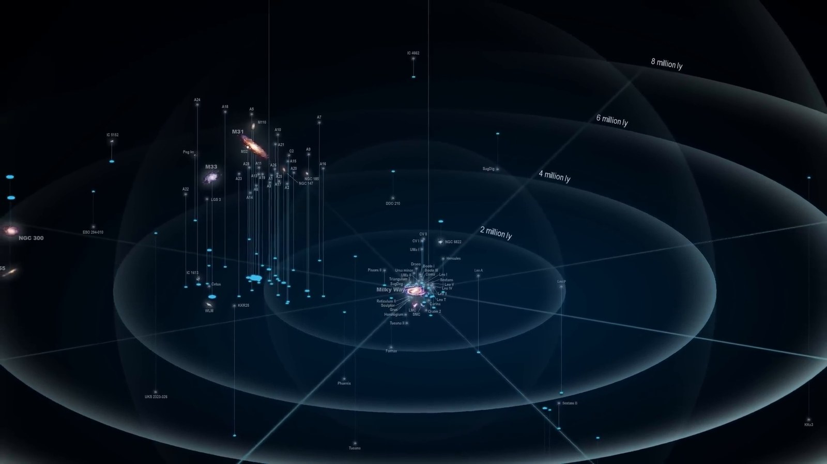
Matched transcript
and Andromeda, but also a multitude of smaller dwarf galaxies. The distances here are so vast that light from one end of the local group to the other

Fragment 83
Time range: 07:42 - 07:48
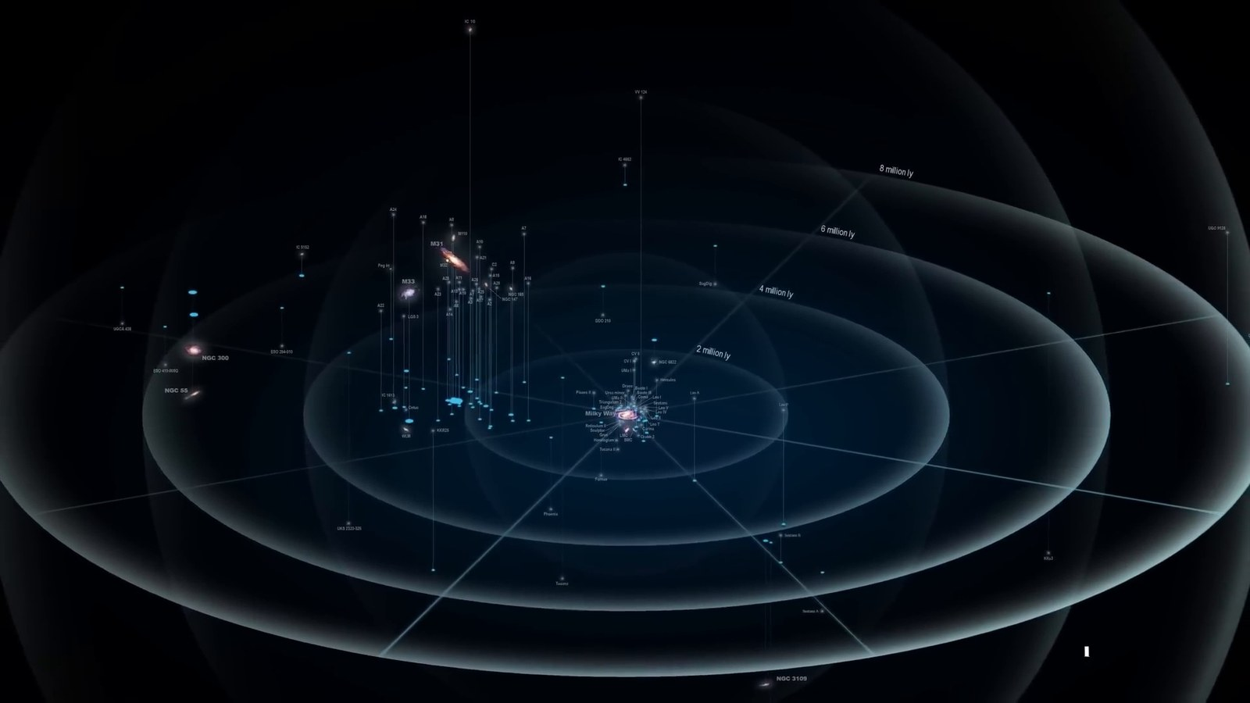
Matched transcript
The distances here are so vast that light from one end of the local group to the other would take 10 million years to traverse. This scale dwarfs anything within our own galaxy, underscoring the enormity of the universe.

Fragment 84
Time range: 07:48 - 07:51
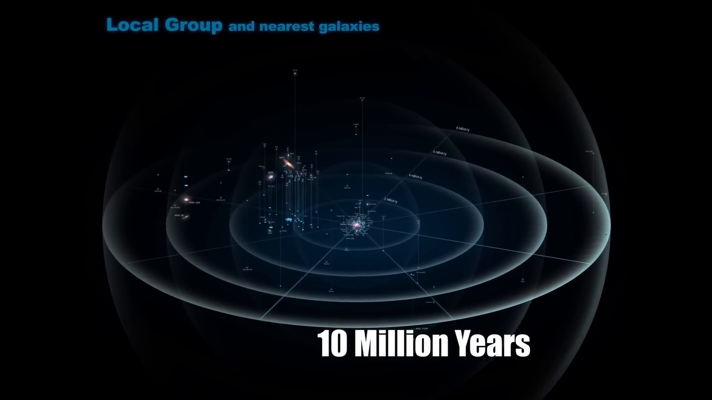
Matched transcript
This scale dwarfs anything within our own galaxy, underscoring the enormity of the universe.

Fragment 85
Time range: 07:51 - 07:57
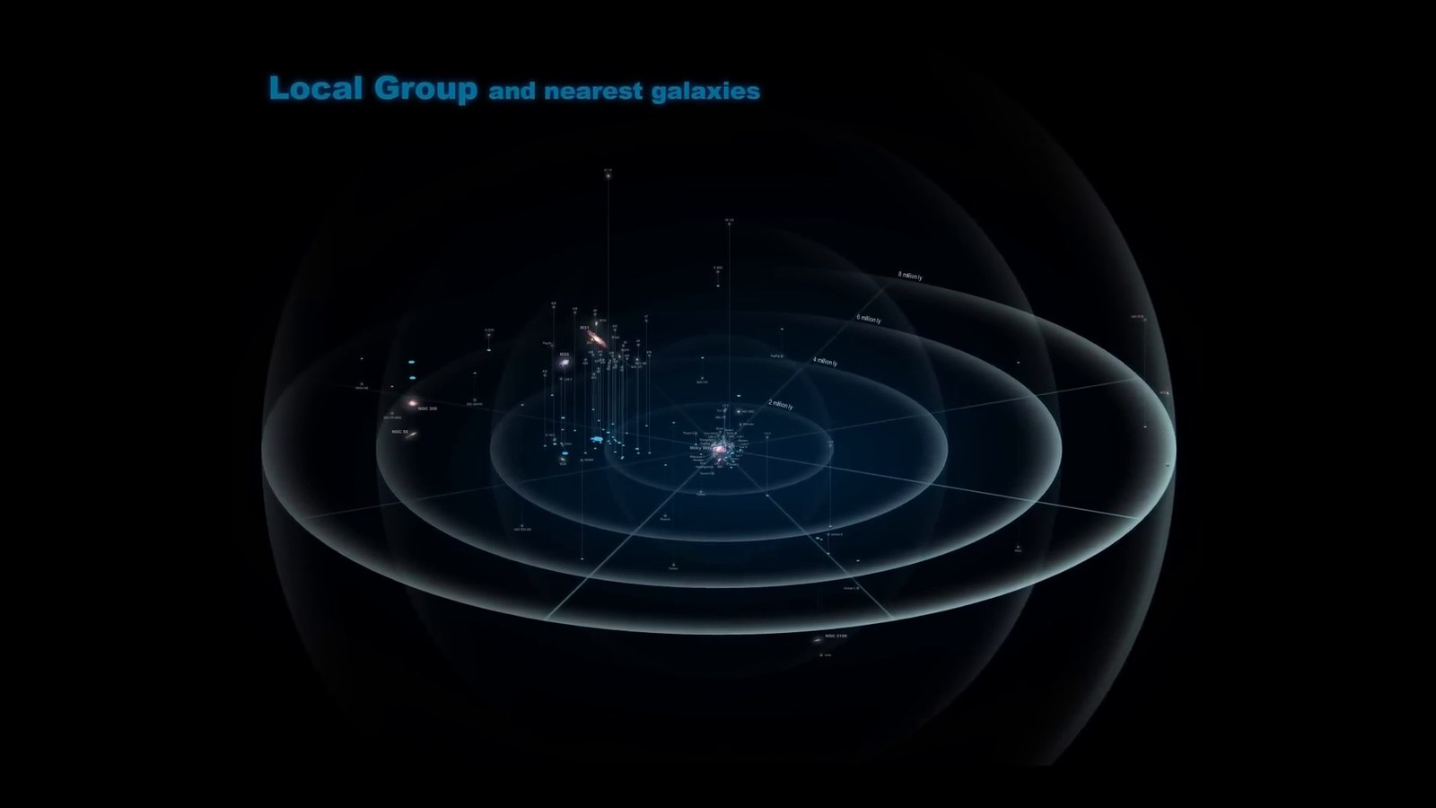
Matched transcript
This scale dwarfs anything within our own galaxy, underscoring the enormity of the universe. Intergalactic space is a silent expanse, a vast wilderness between the islands of galactic

Fragment 86
Time range: 07:57 - 08:03
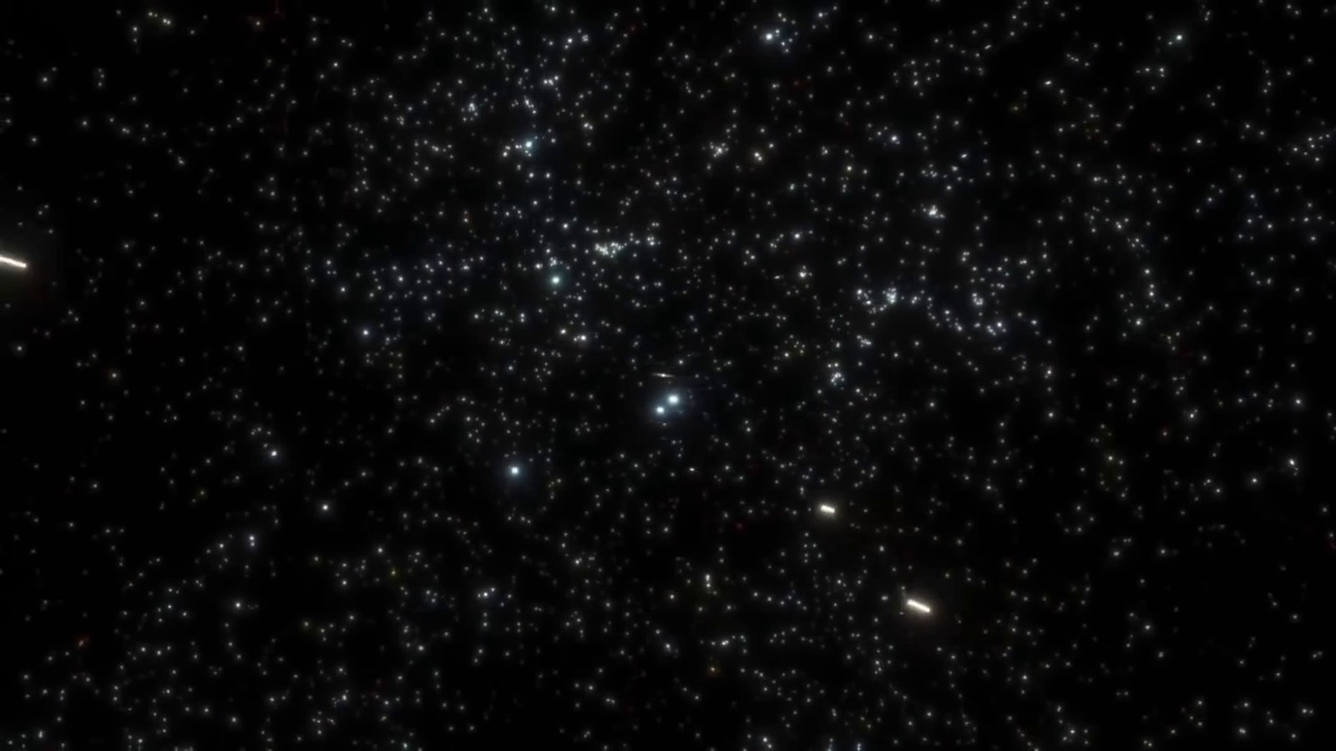
Matched transcript
Intergalactic space is a silent expanse, a vast wilderness between the islands of galactic light. In this immense void, our galaxy, home to our entire history, is just a tiny speck among

Fragment 87
Time range: 08:03 - 08:09
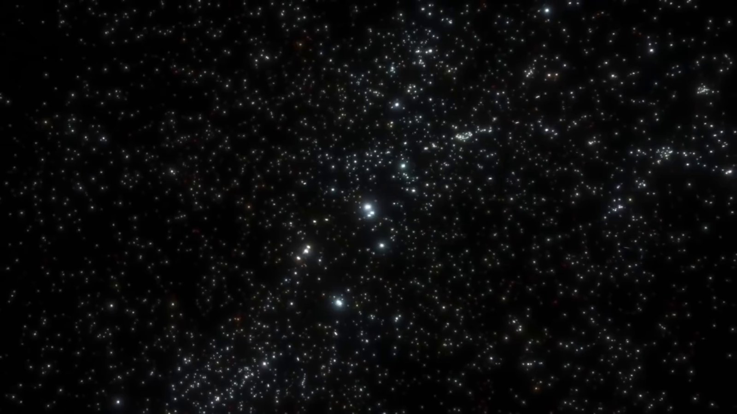
Matched transcript
In this immense void, our galaxy, home to our entire history, is just a tiny speck among a single story in the grand cosmic library. As we extend our cosmic gaze beyond the local

Fragment 88
Time range: 08:09 - 08:15
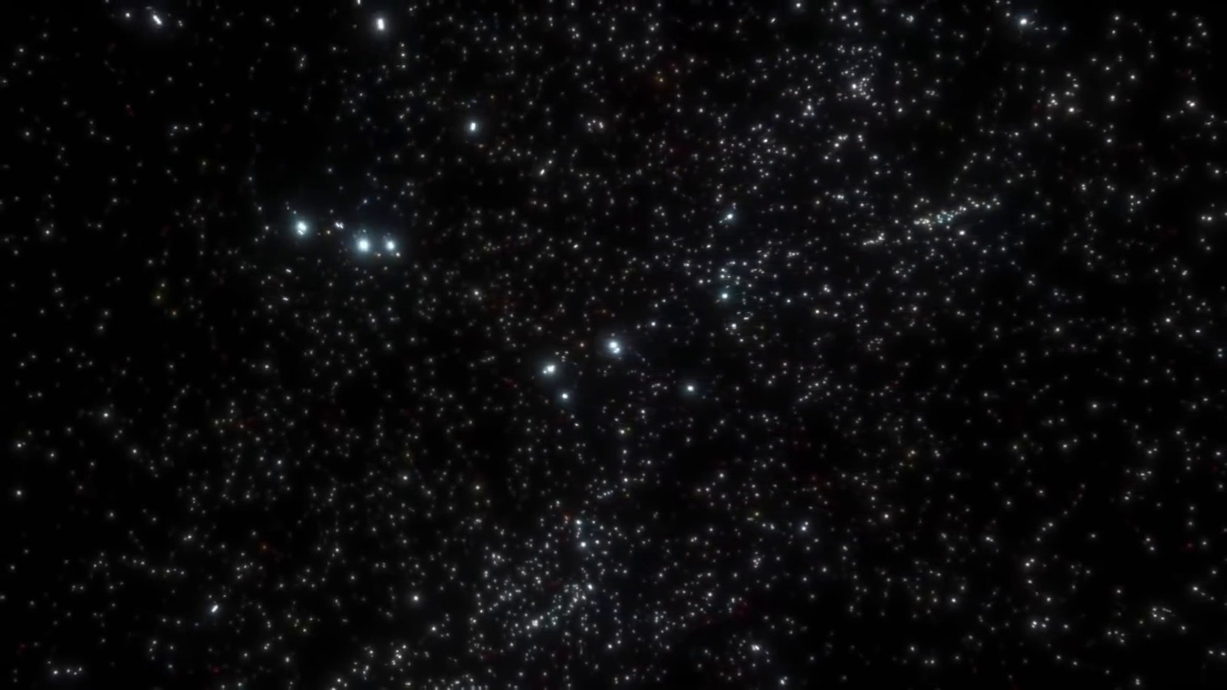
Matched transcript
a single story in the grand cosmic library. As we extend our cosmic gaze beyond the local group we encounter the colossal Virgo supercluster an immense collection of galaxy groups and clusters including our own local group Encompassing a region of space about 110 million light in diameter or 33 megaparsecs

Fragment 89
Time range: 08:15 - 08:21
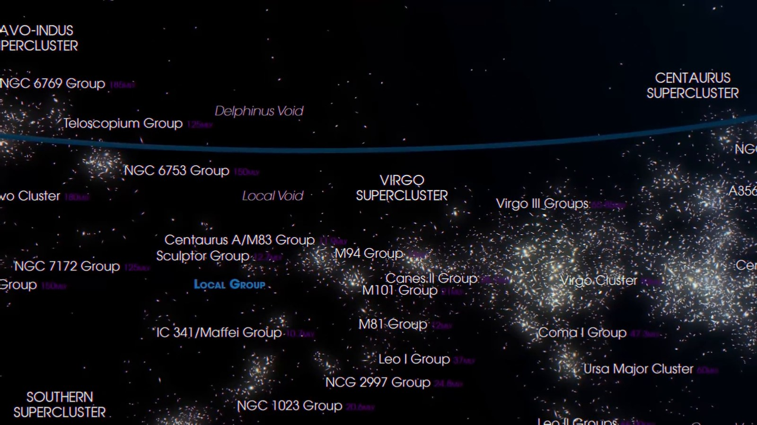
Matched transcript
group we encounter the colossal Virgo supercluster an immense collection of galaxy groups and clusters including our own local group Encompassing a region of space about 110 million light in diameter or 33 megaparsecs

Fragment 90
Time range: 08:21 - 08:24
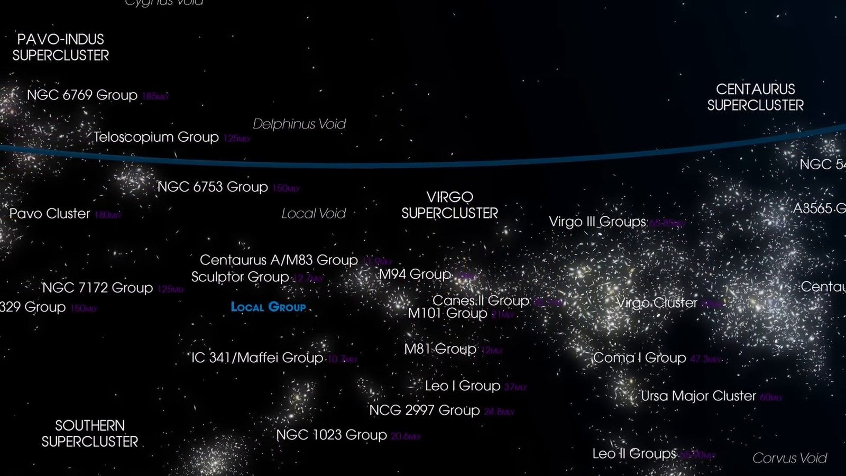
Matched transcript
group we encounter the colossal Virgo supercluster an immense collection of galaxy groups and clusters including our own local group Encompassing a region of space about 110 million light in diameter or 33 megaparsecs

Fragment 91
Time range: 08:24 - 08:33
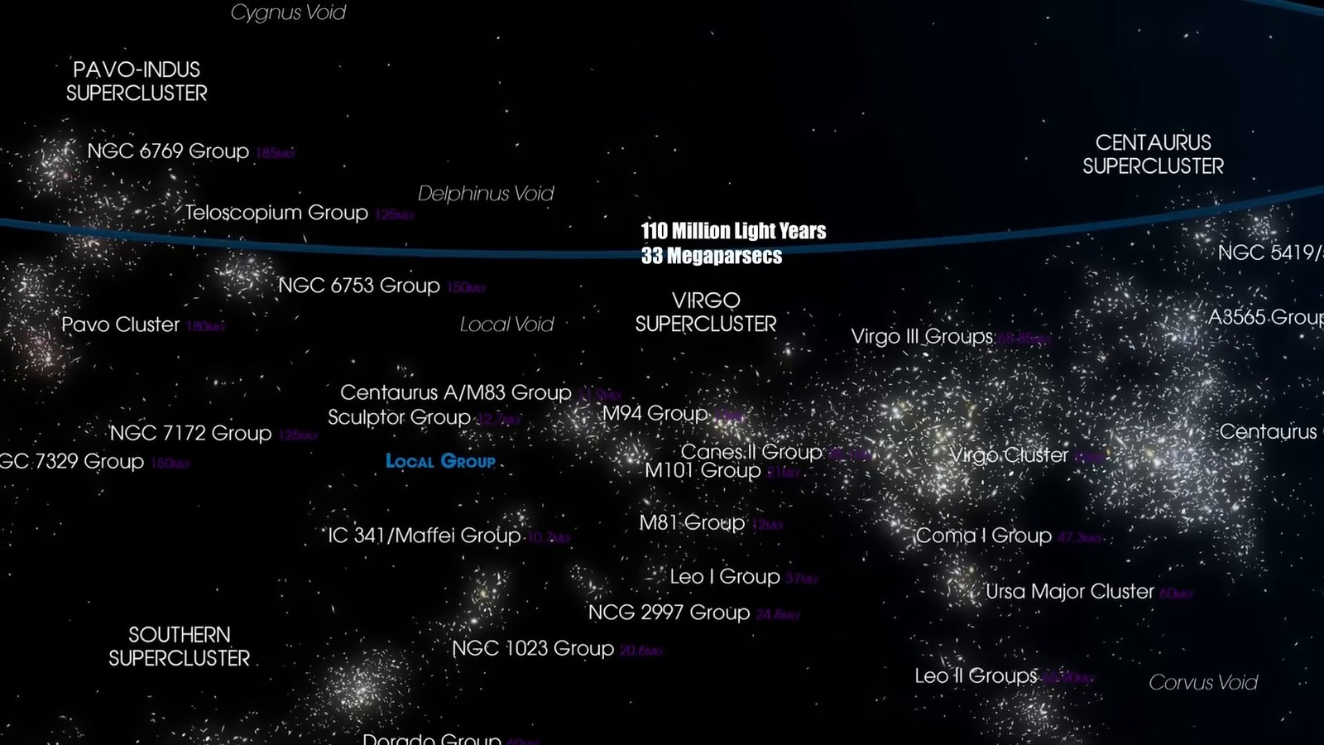
Matched transcript
group we encounter the colossal Virgo supercluster an immense collection of galaxy groups and clusters including our own local group Encompassing a region of space about 110 million light in diameter or 33 megaparsecs the Virgo supercluster is a titanic structure in the universe, containing thousands of galaxies from at least 100 galaxy groups and clusters,

Fragment 92
Time range: 08:33 - 08:36
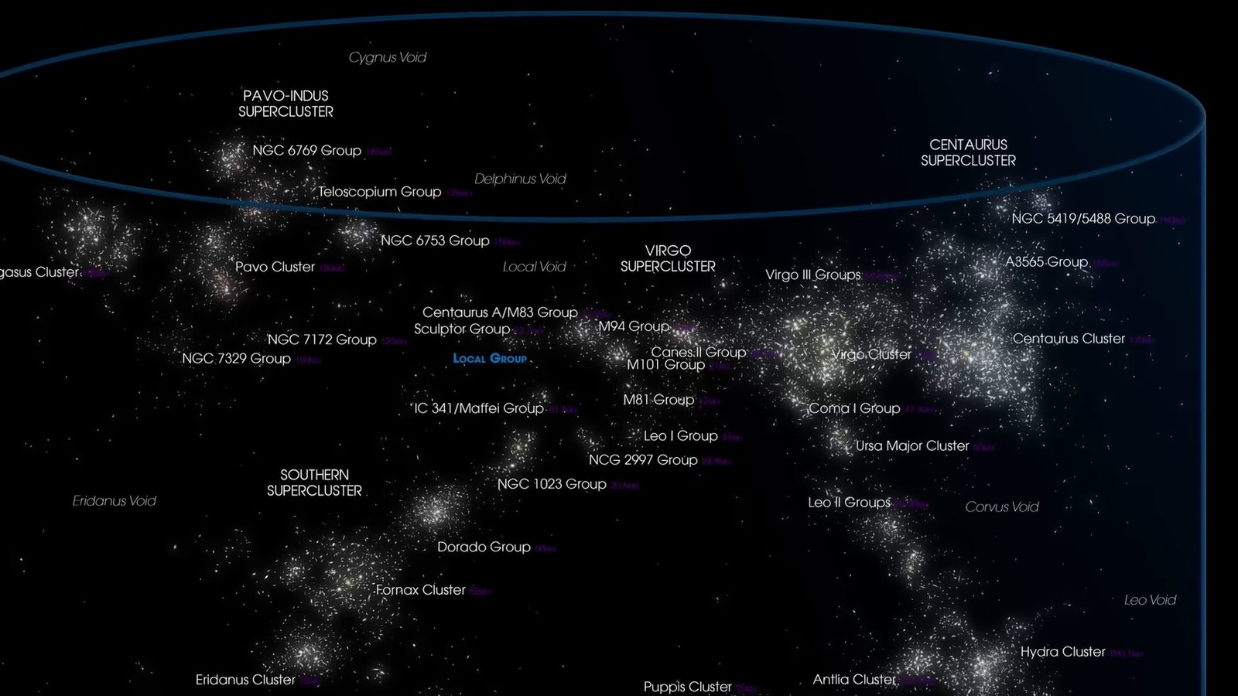
Matched transcript
containing thousands of galaxies from at least 100 galaxy groups and clusters,

Fragment 93
Time range: 08:36 - 08:42
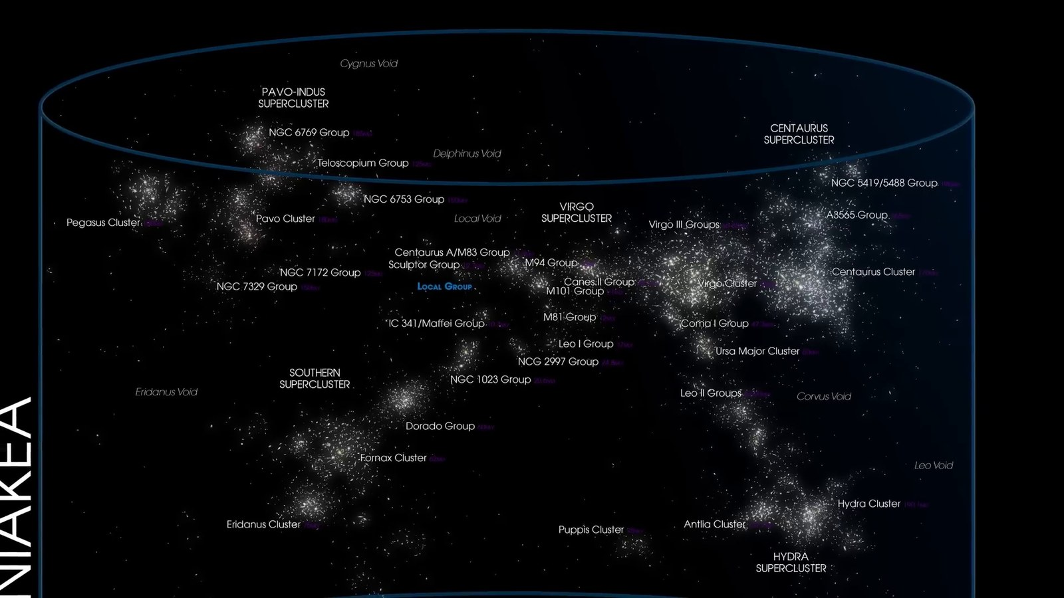
Matched transcript
containing thousands of galaxies from at least 100 galaxy groups and clusters, each with their own myriad stars and planets. As we journey outward from the Virgo supercluster,

Fragment 94
Time range: 08:42 - 08:47
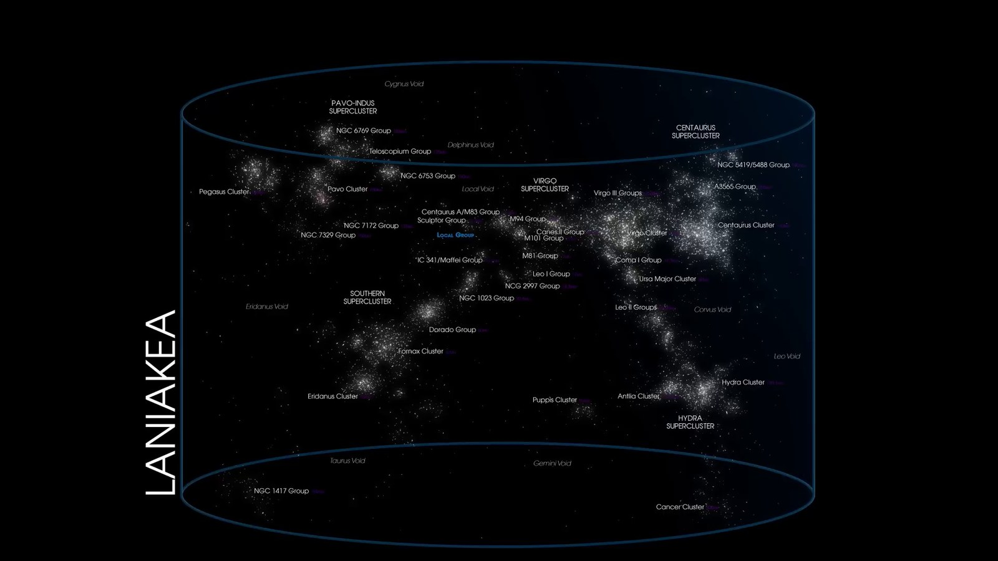
Matched transcript
As we journey outward from the Virgo supercluster, we arrive at an even more staggering cosmic structure, the Laniakia supercluster. This

Fragment 95
Time range: 08:47 - 08:56
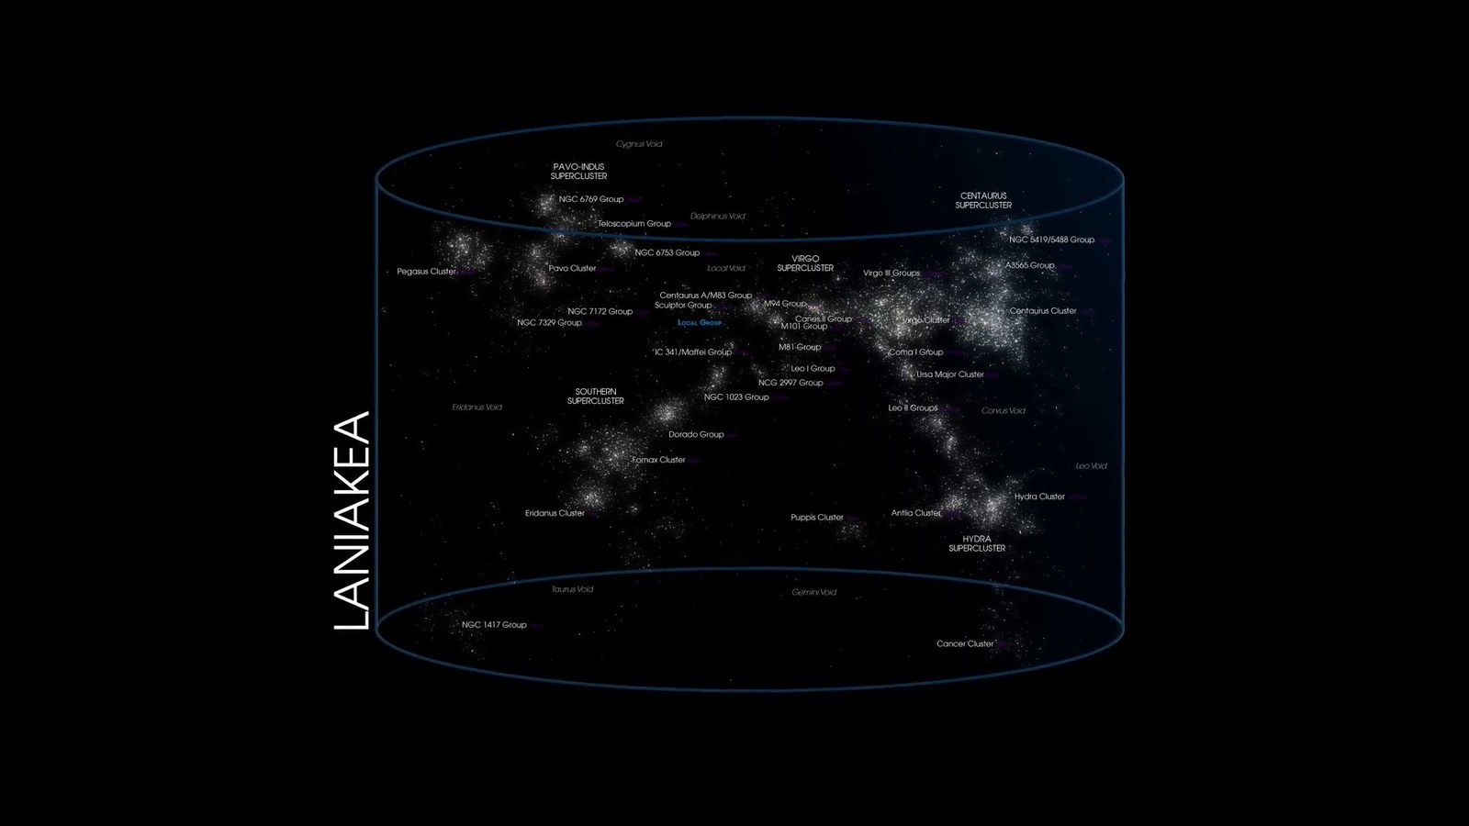
Matched transcript
we arrive at an even more staggering cosmic structure, the Laniakia supercluster. This immense congregation of galaxies, which includes the Virgo supercluster and extends over 500 million

Fragment 96
Time range: 08:56 - 08:59
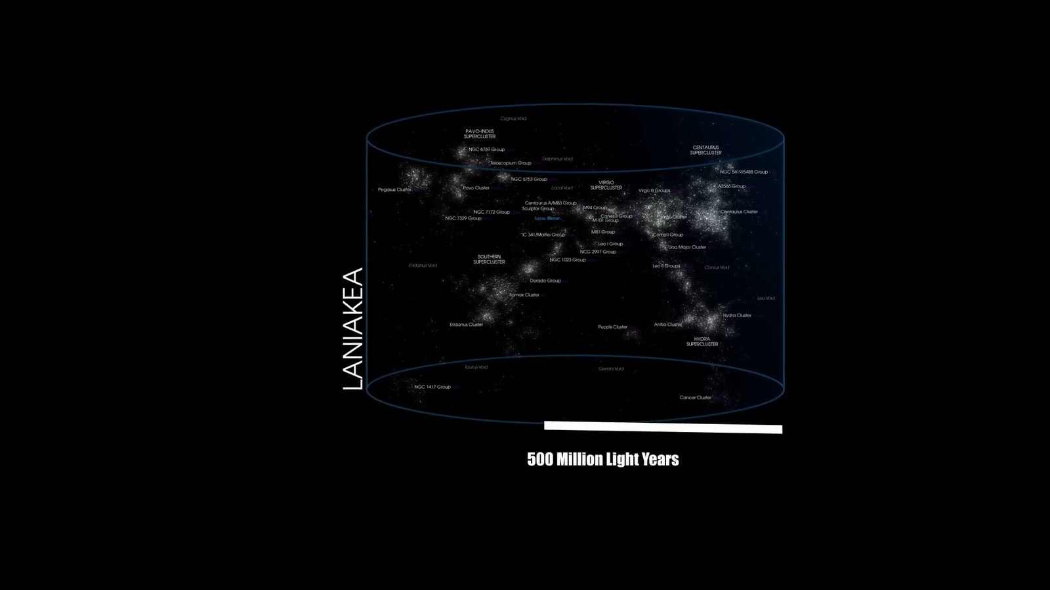
Matched transcript
immense congregation of galaxies, which includes the Virgo supercluster and extends over 500 million light-years, is our galactic home on a grand scale. Laniakia, meaning immense heaven in Hawaiian,

Fragment 97
Time range: 08:59 - 09:05
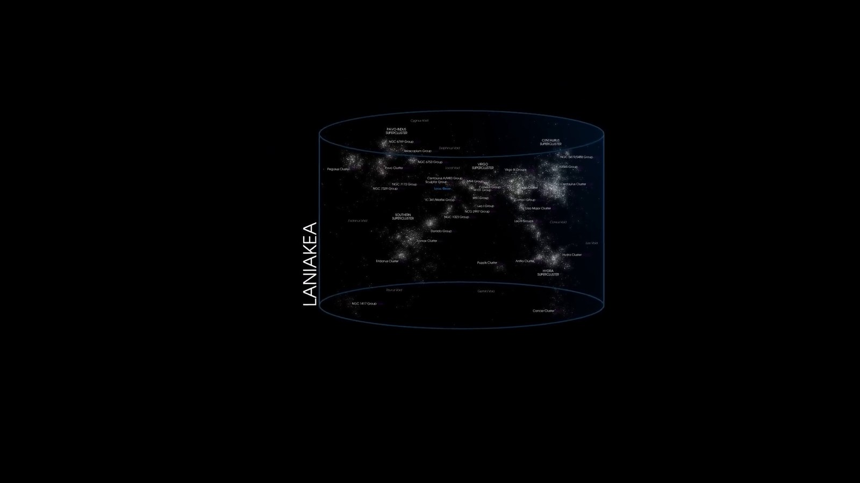
Matched transcript
light-years, is our galactic home on a grand scale. Laniakia, meaning immense heaven in Hawaiian, truly lives up to its name. Containing the mass of 100 million billion suns, Laniakia is a

Fragment 98
Time range: 09:05 - 09:11
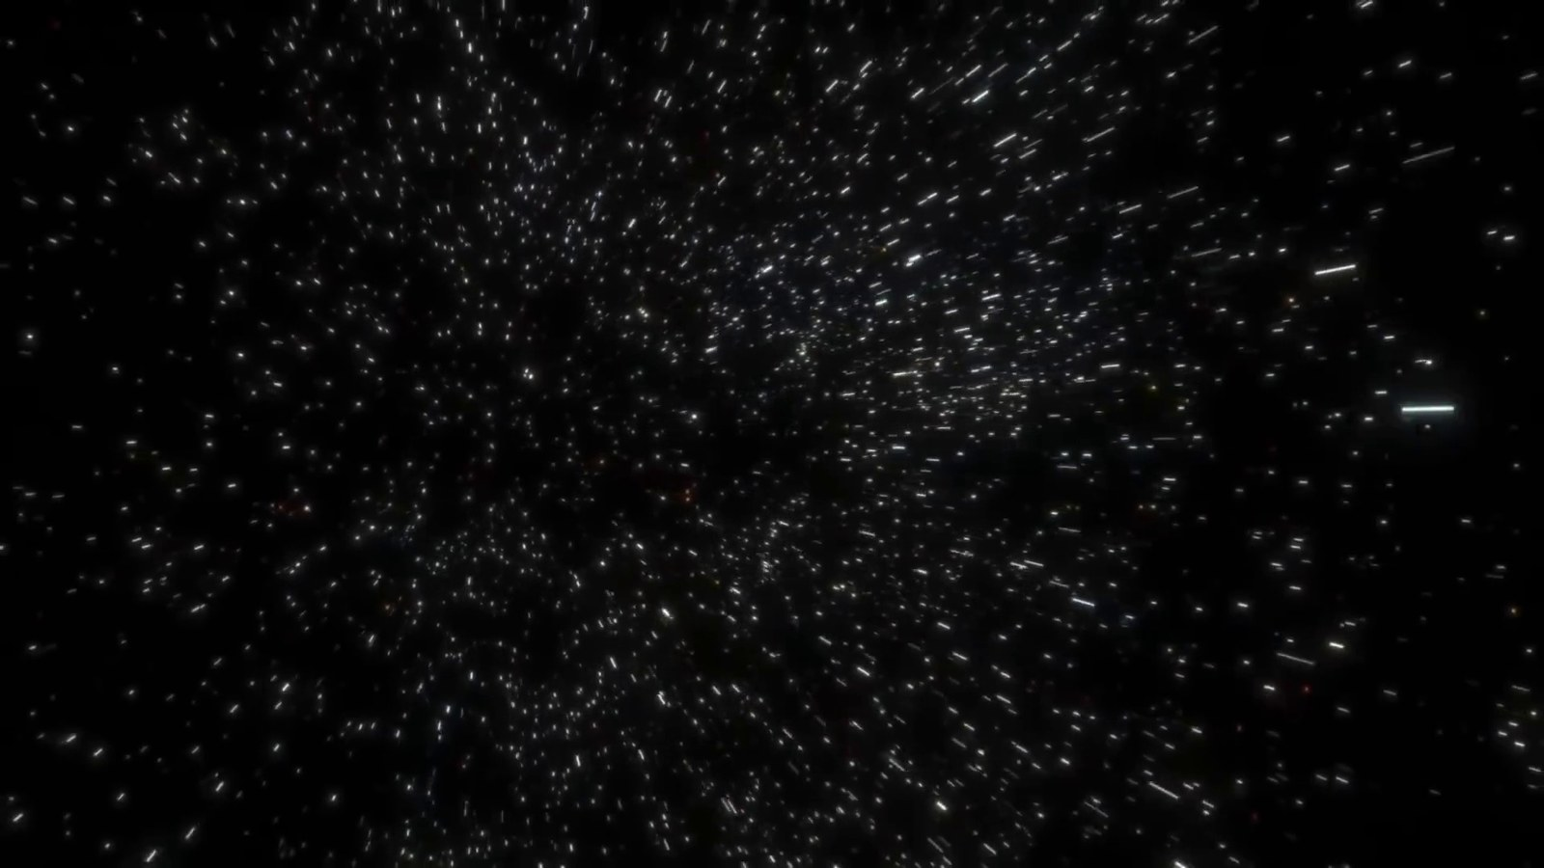
Matched transcript
truly lives up to its name. Containing the mass of 100 million billion suns, Laniakia is a gravitational masterpiece with galaxy clusters, superclusters, and countless celestial bodies

Fragment 99
Time range: 09:11 - 09:17
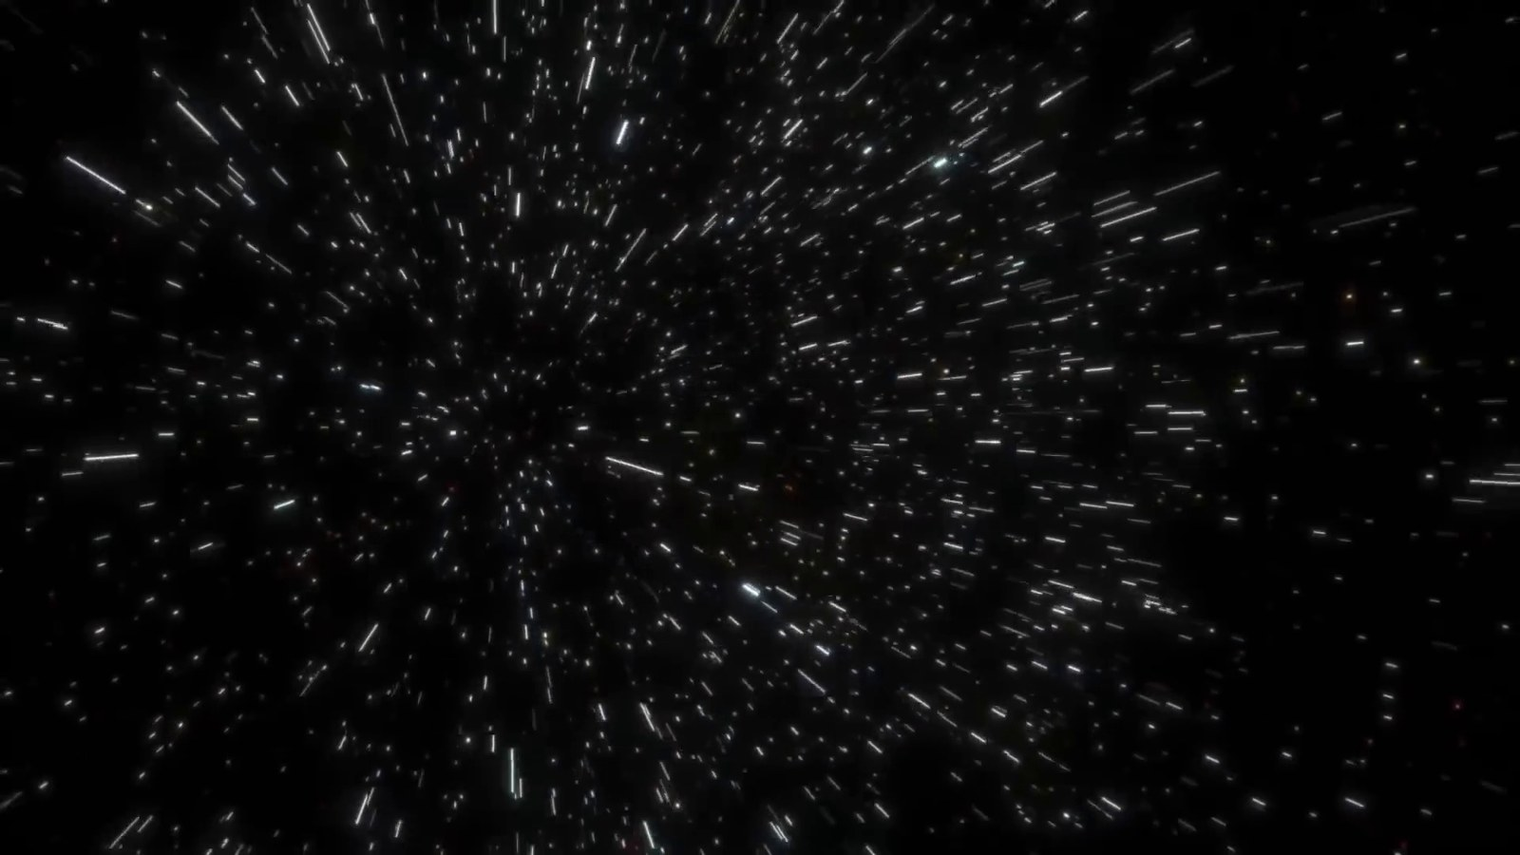
Matched transcript
gravitational masterpiece with galaxy clusters, superclusters, and countless celestial bodies bound in a cosmic web of attraction and motion. At the heart of Laniachia lies the Great Attractor,

Fragment 100
Time range: 09:17 - 09:23
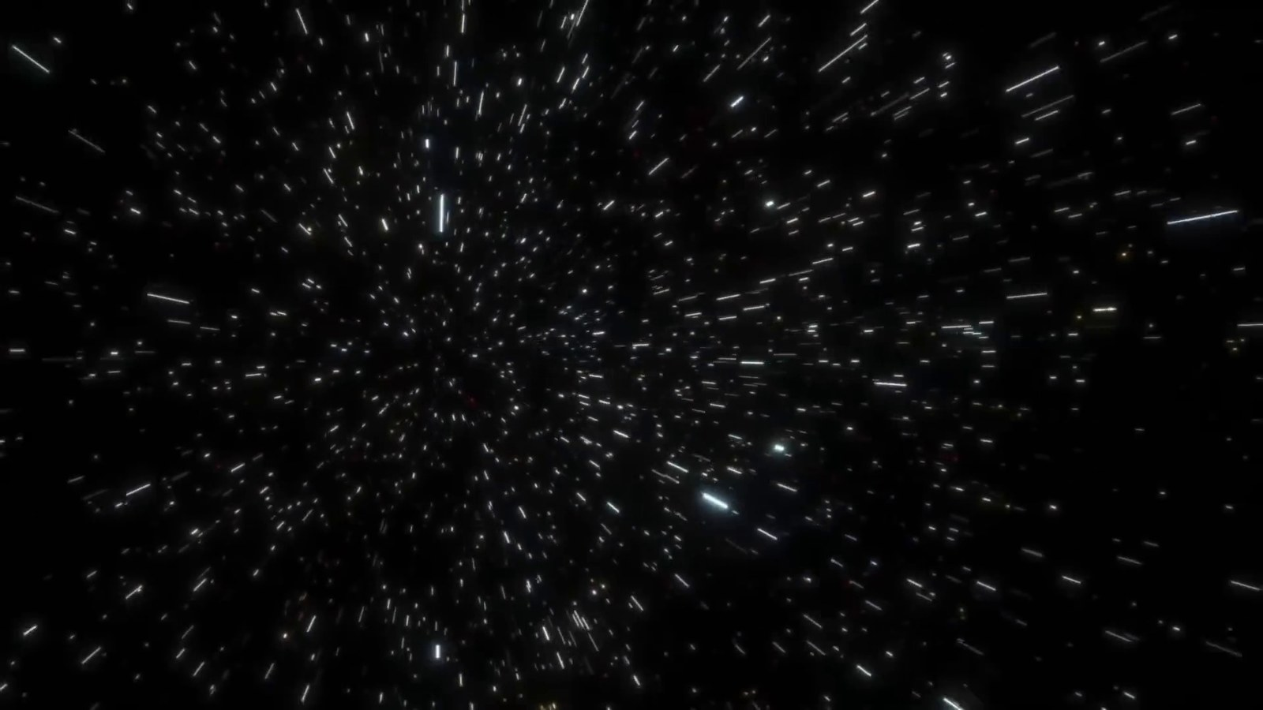
Matched transcript
bound in a cosmic web of attraction and motion. At the heart of Laniachia lies the Great Attractor,

Fragment 101
Time range: 09:23 - 09:26
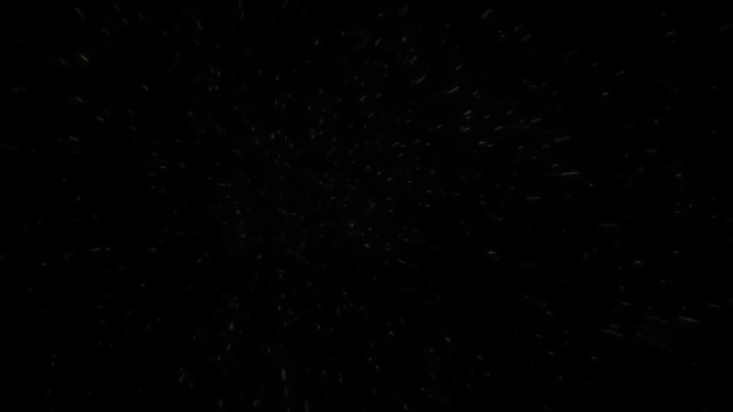
Matched transcript
bound in a cosmic web of attraction and motion. At the heart of Laniachia lies the Great Attractor, a mysterious region of space that exerts a massive gravitational pull on the galaxies

Fragment 102
Time range: 09:26 - 09:32
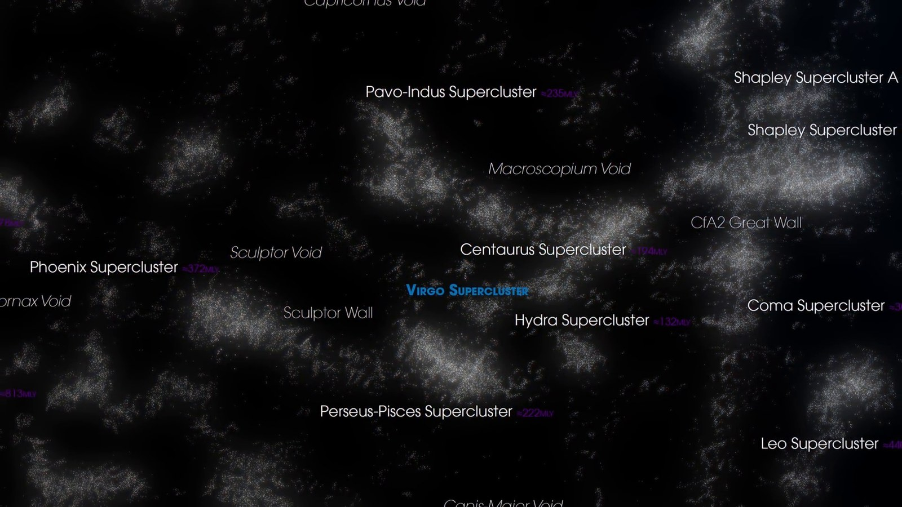
Matched transcript
a mysterious region of space that exerts a massive gravitational pull on the galaxies within this supercluster. In this vast expanse, our Milky Way, the entire local group, and even

Fragment 103
Time range: 09:32 - 09:38
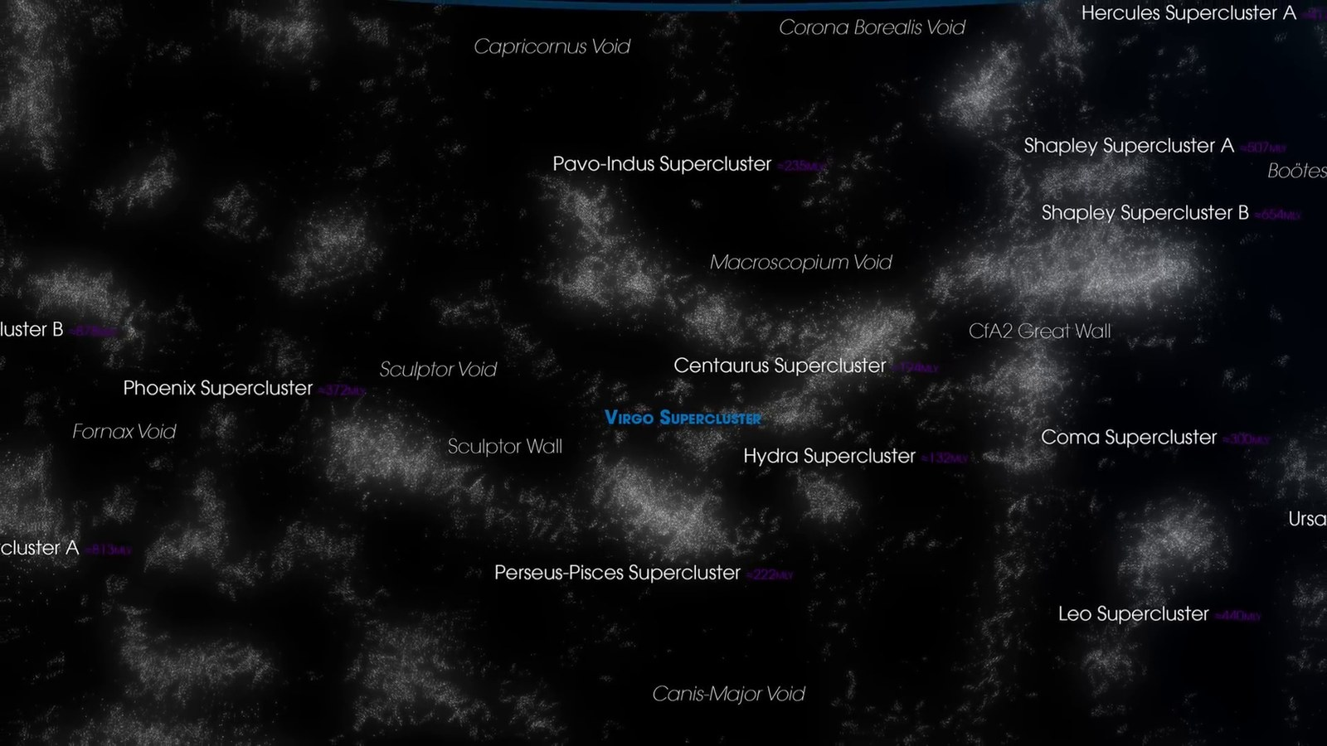
Matched transcript
within this supercluster. In this vast expanse, our Milky Way, the entire local group, and even the Virgo supercluster are just tiny components of this gigantic structure. Laniakia provides

Fragment 104
Time range: 09:38 - 09:44
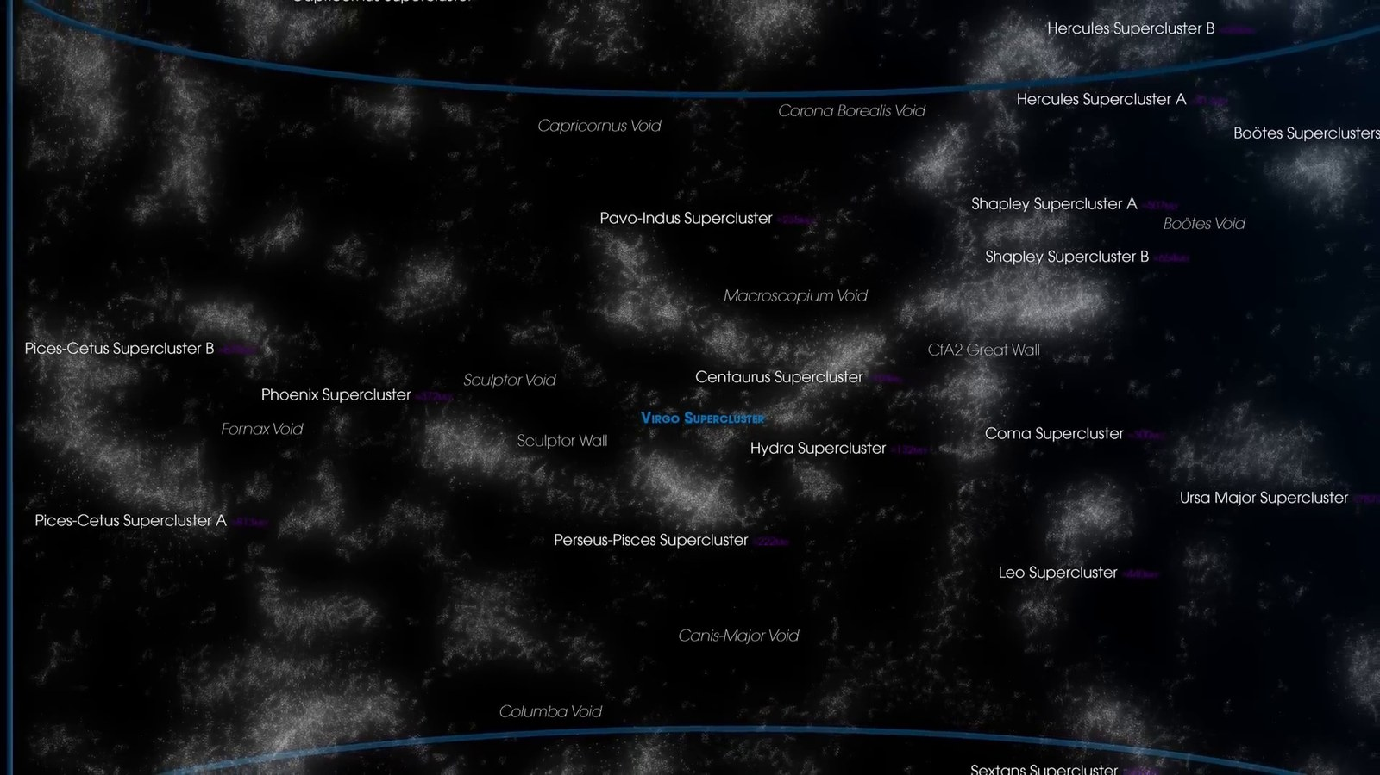
Matched transcript
the Virgo supercluster are just tiny components of this gigantic structure. Laniakia provides a profound context for our existence. In this immense supercluster, we are part of something

Fragment 105
Time range: 09:44 - 09:50
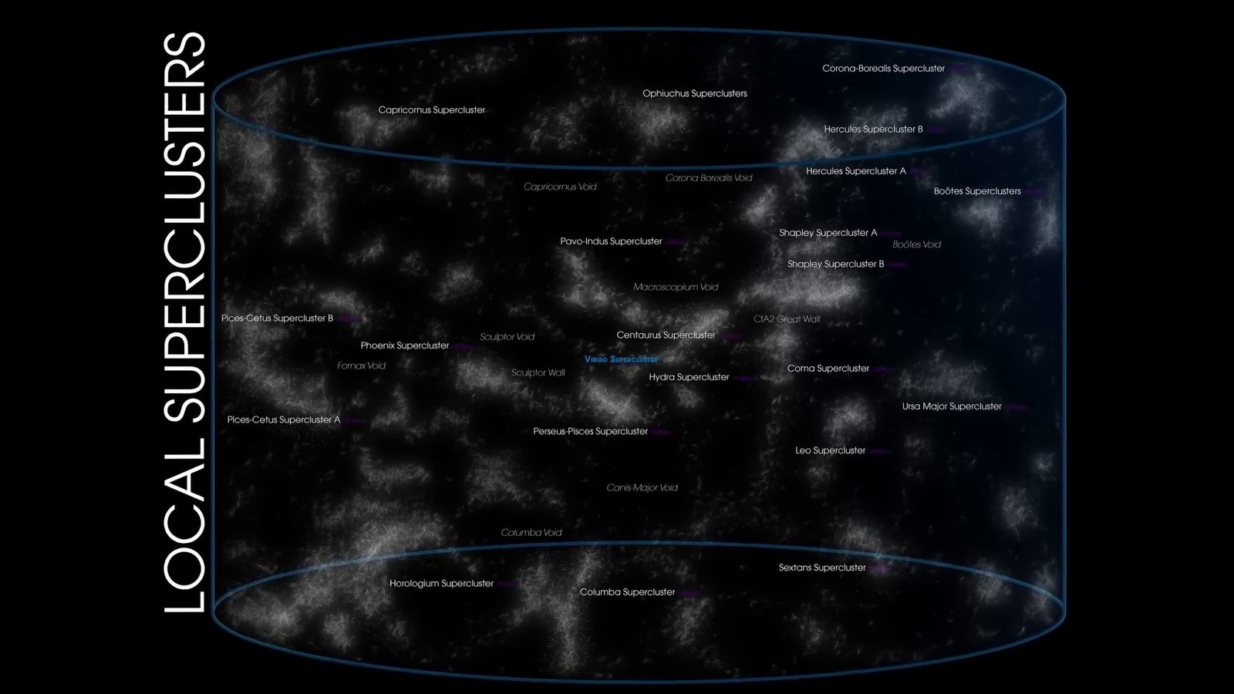
Matched transcript
a profound context for our existence. In this immense supercluster, we are part of something far greater and more majestic than we can fully comprehend.

Fragment 106
Time range: 09:50 - 09:56
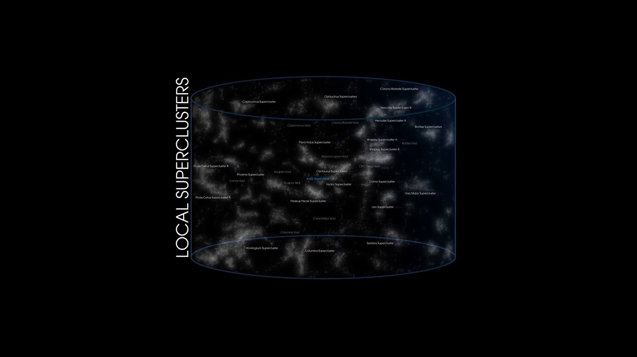
Matched transcript
far greater and more majestic than we can fully comprehend. As we reach the boundaries of our cosmic exploration, we encounter the limits of the observable

Fragment 107
Time range: 09:56 - 10:02
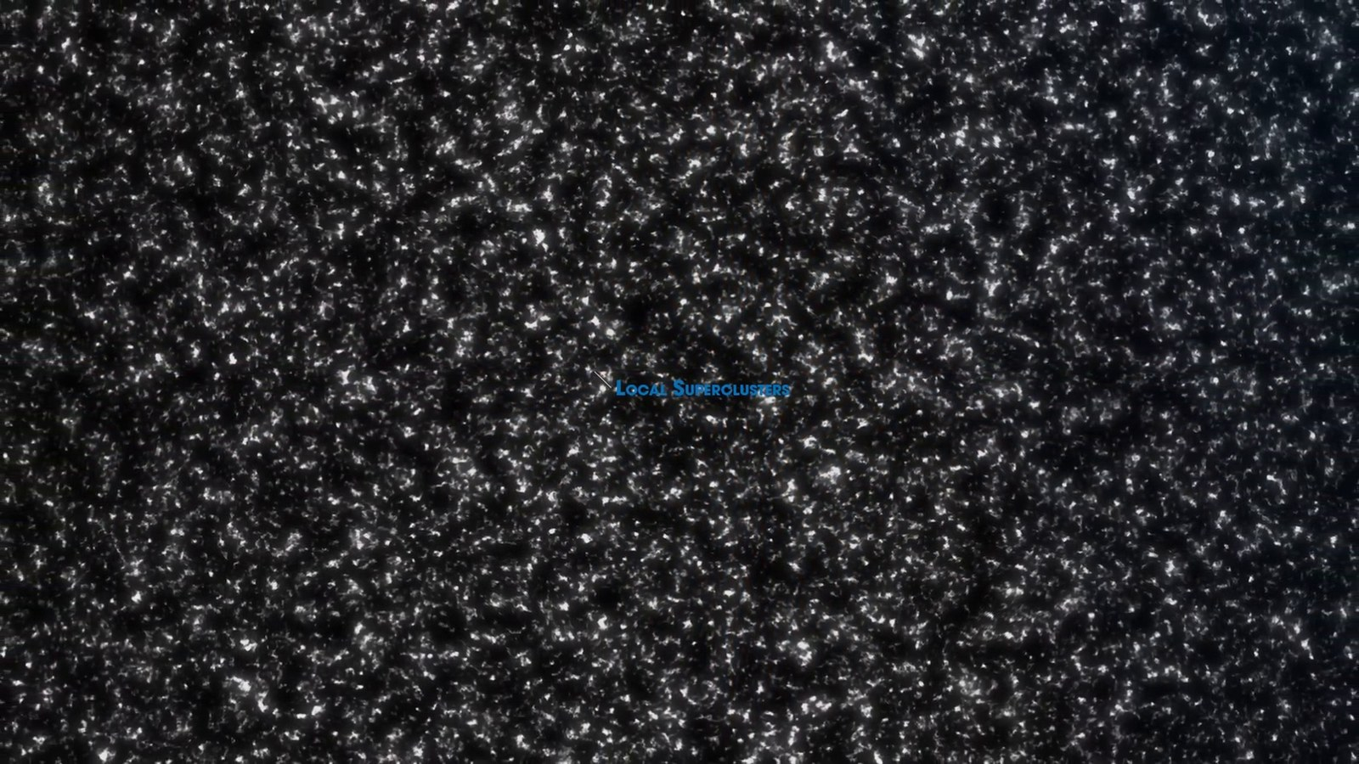
Matched transcript
As we reach the boundaries of our cosmic exploration, we encounter the limits of the observable universe, an astronomical marvel stretching about 93 billion light-years in diameter.

Fragment 108
Time range: 10:02 - 10:08
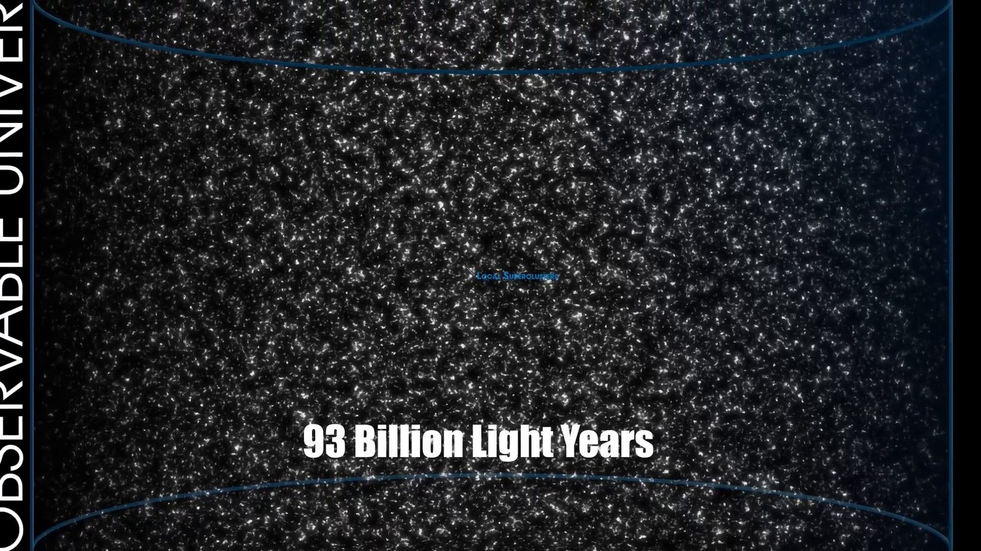
Matched transcript
universe, an astronomical marvel stretching about 93 billion light-years in diameter. This begs a fascinating question. If the universe is only 13.8 billion years old, how can it be so vast?

Fragment 109
Time range: 10:08 - 10:14
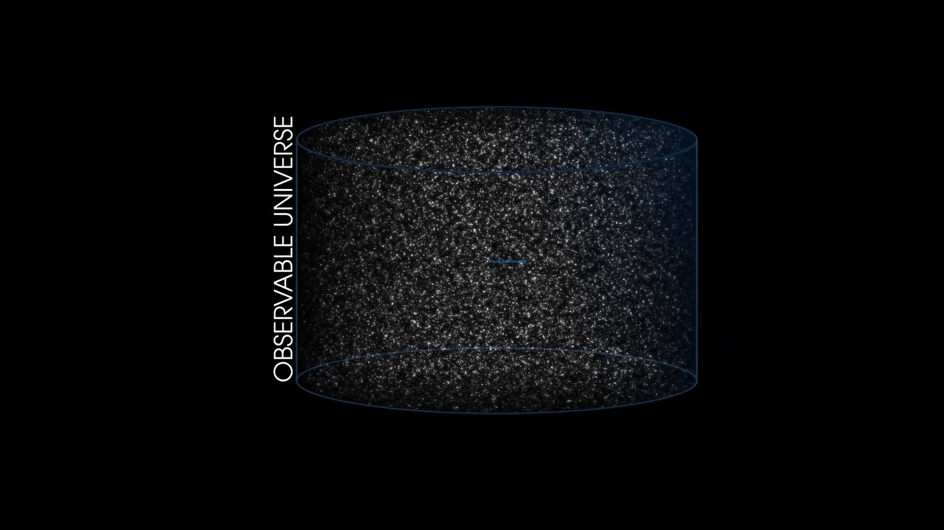
Matched transcript
If the universe is only 13.8 billion years old, how can it be so vast? The answer lies in the nature of cosmic expansion.

Fragment 110
Time range: 10:14 - 10:17
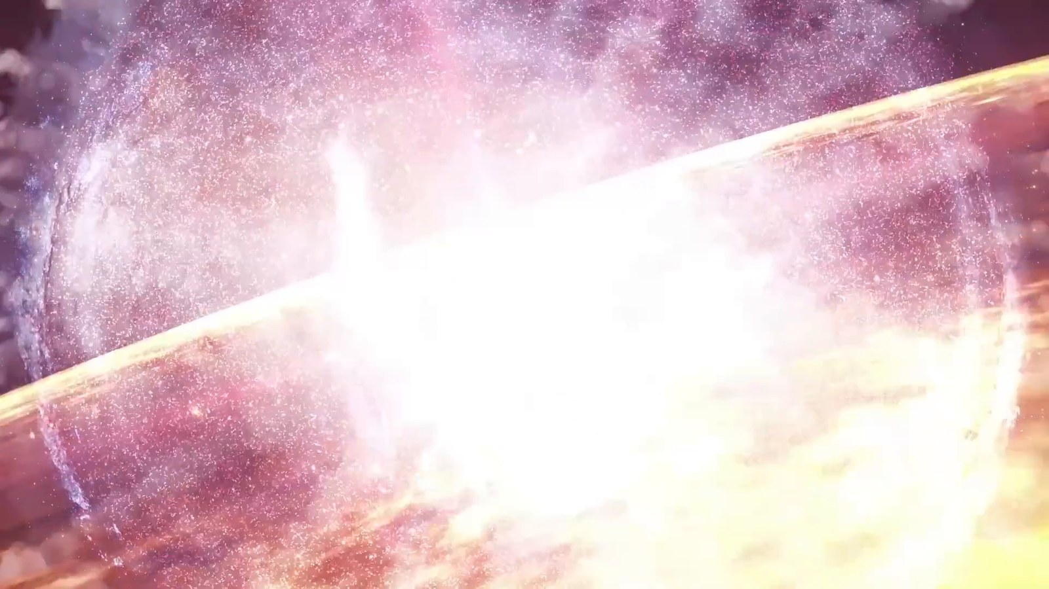
Matched transcript
The answer lies in the nature of cosmic expansion. The universe has been expanding since the Big Bang, stretching space and increasing distances

Fragment 111
Time range: 10:17 - 10:23
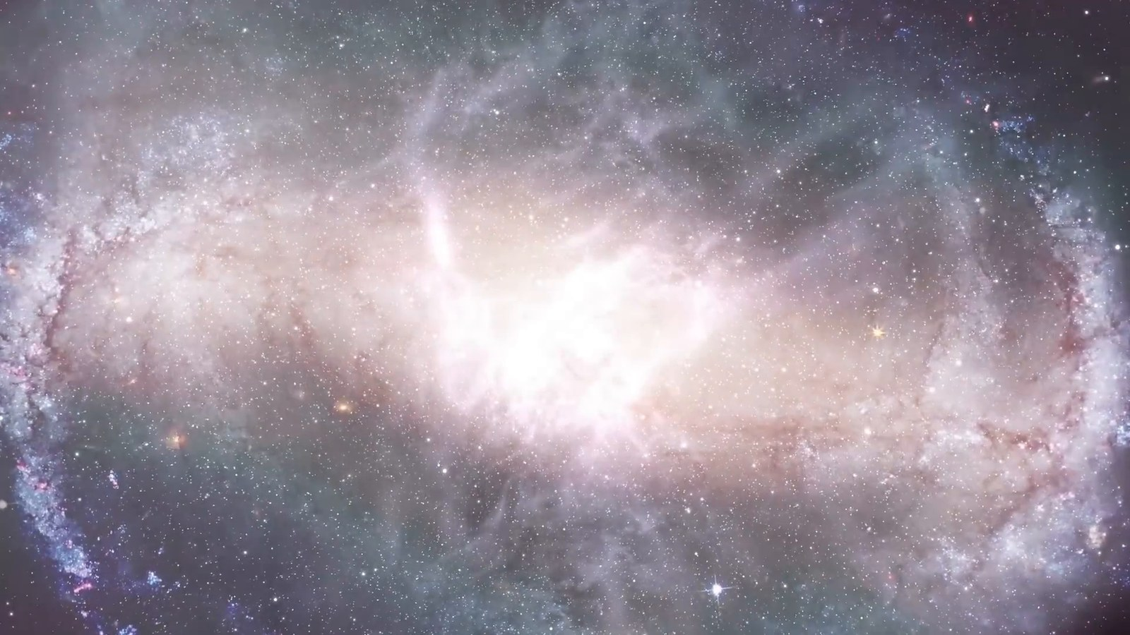
Matched transcript
The universe has been expanding since the Big Bang, stretching space and increasing distances between celestial bodies.

Fragment 112
Time range: 10:23 - 10:29
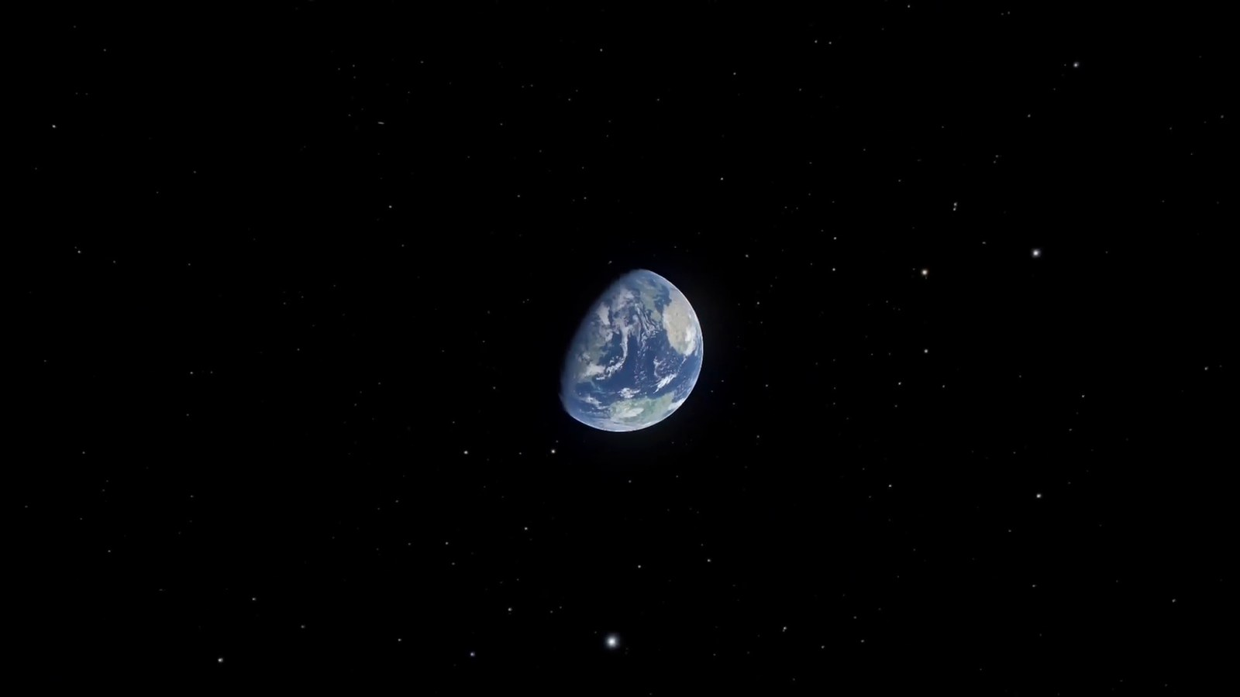
Matched transcript
between celestial bodies. But what lies beyond the observable universe? This remains one of the greatest mysteries of cosmology.

Fragment 113
Time range: 10:29 - 10:35
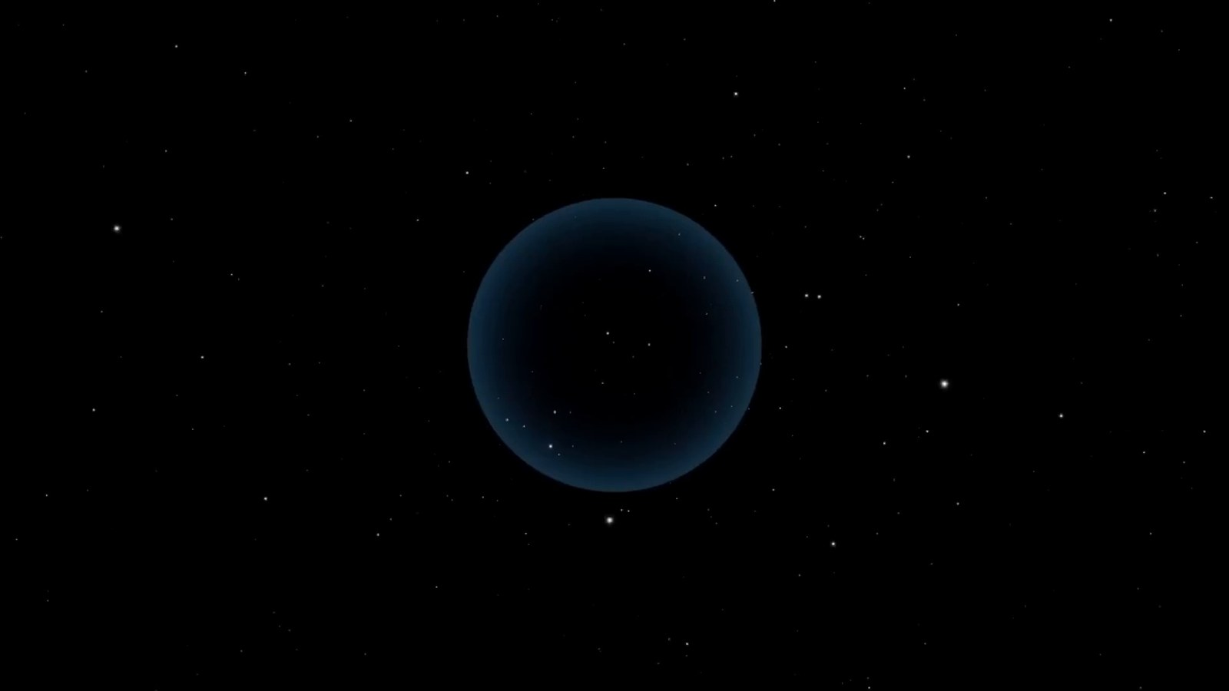
Matched transcript
This remains one of the greatest mysteries of cosmology. Some regions of space are expanding away from us faster than the speed of light, placing

Fragment 114
Time range: 10:35 - 10:41
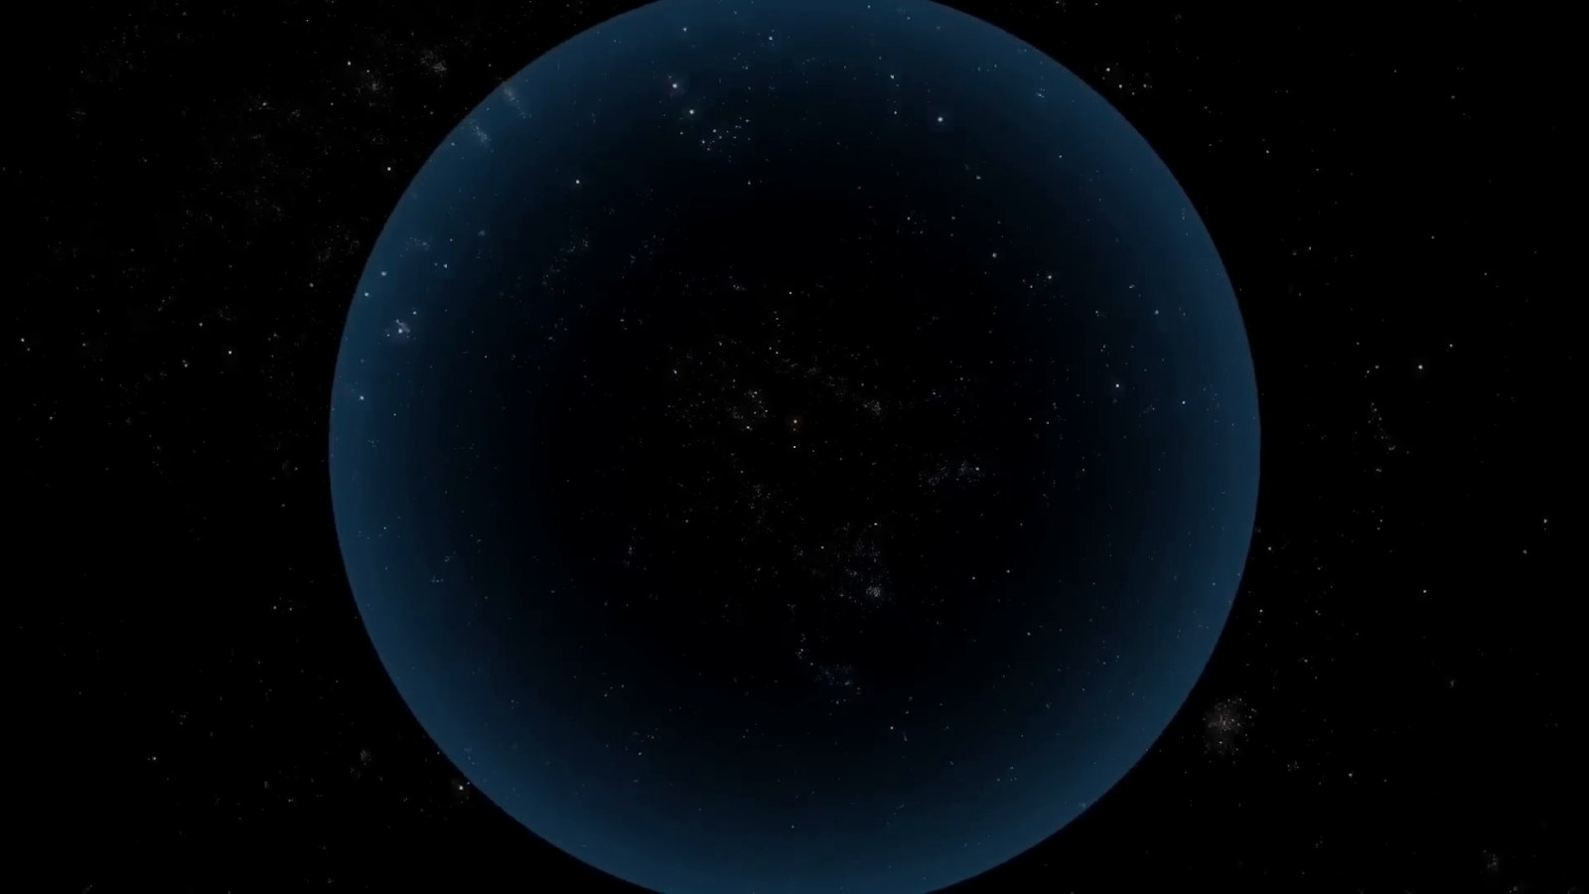
Matched transcript
Some regions of space are expanding away from us faster than the speed of light, placing them forever out of our view. Consequently, the true size of the entire universe remains unknown and potentially infinite.

Fragment 115
Time range: 10:41 - 10:51
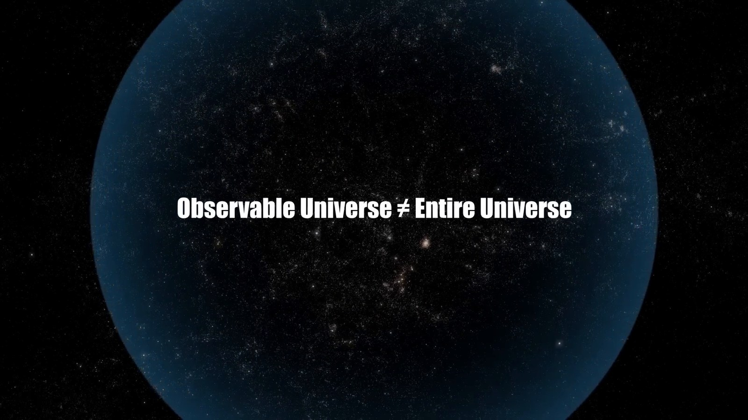
Matched transcript
Consequently, the true size of the entire universe remains unknown and potentially infinite. The observable universe, vast as it is, might just be a tiny fragment of the entire cosmic expanse.

Fragment 116
Time range: 10:51 - 10:54
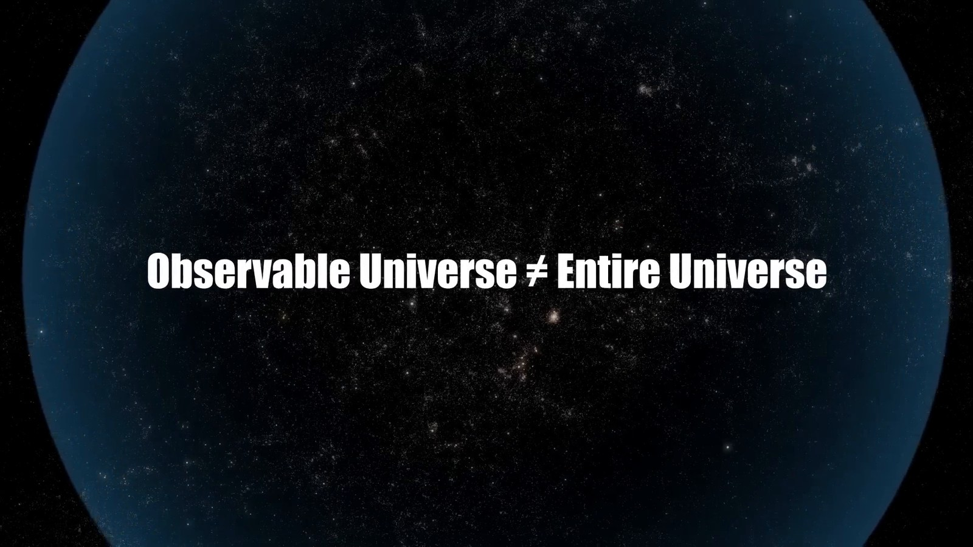
Matched transcript
expanse. We are left with the humbling realization that there might always be regions of space, entire

Fragment 117
Time range: 10:54 - 10:57
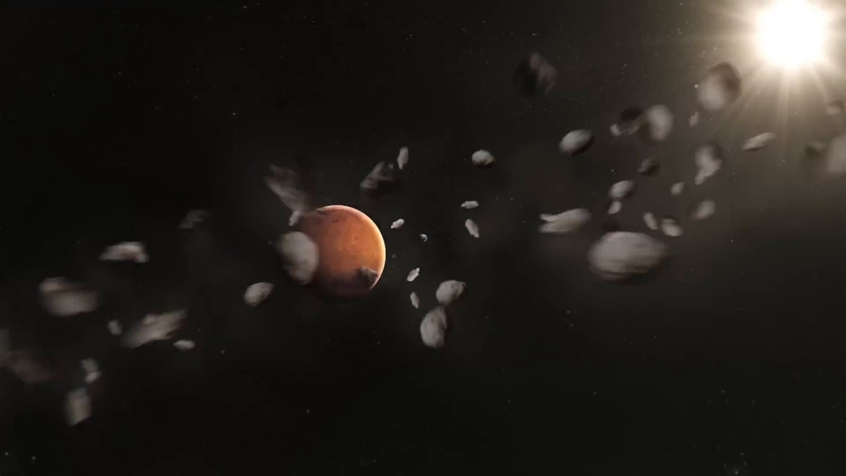
Matched transcript
We are left with the humbling realization that there might always be regions of space, entire

Fragment 118
Time range: 10:57 - 11:03
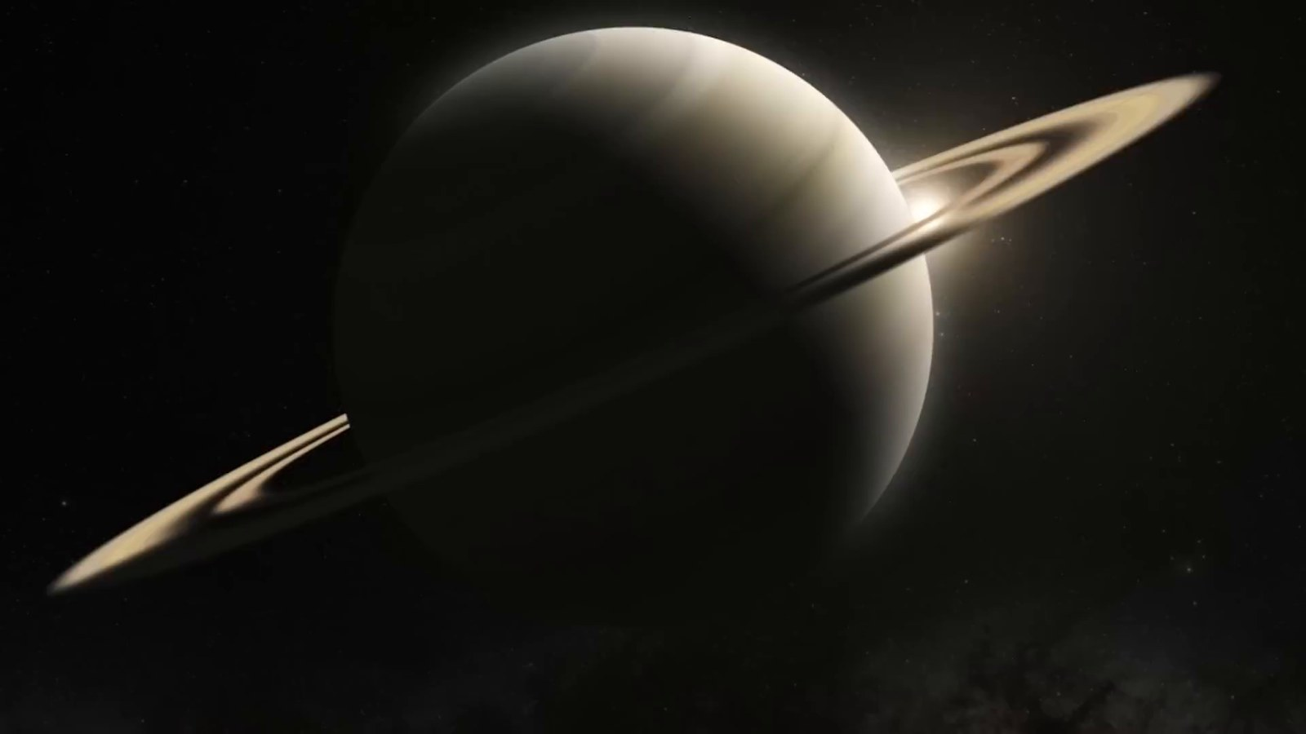
Matched transcript
We are left with the humbling realization that there might always be regions of space, entire galaxies and wonders that we will never witness as they retreat endlessly into the depths

Fragment 119
Time range: 11:03 - 11:09
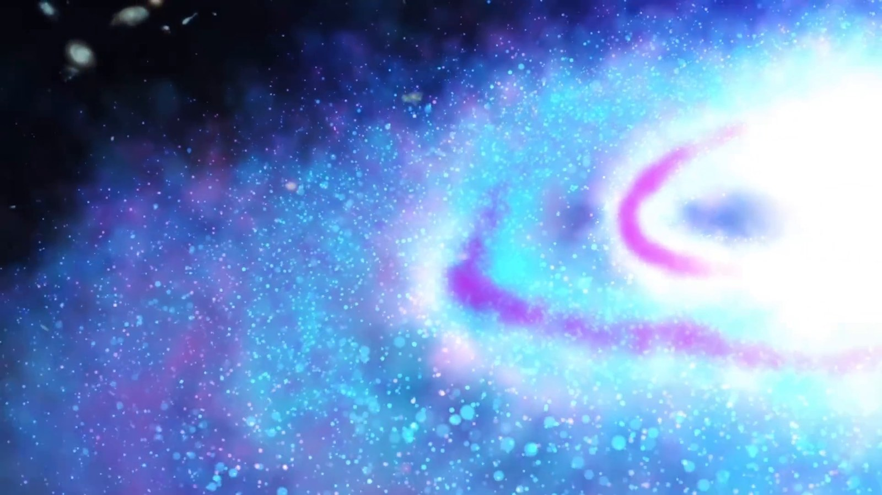
Matched transcript
galaxies and wonders that we will never witness as they retreat endlessly into the depths of the ever-expanding universe.

Fragment 120
Time range: 11:09 - 11:09
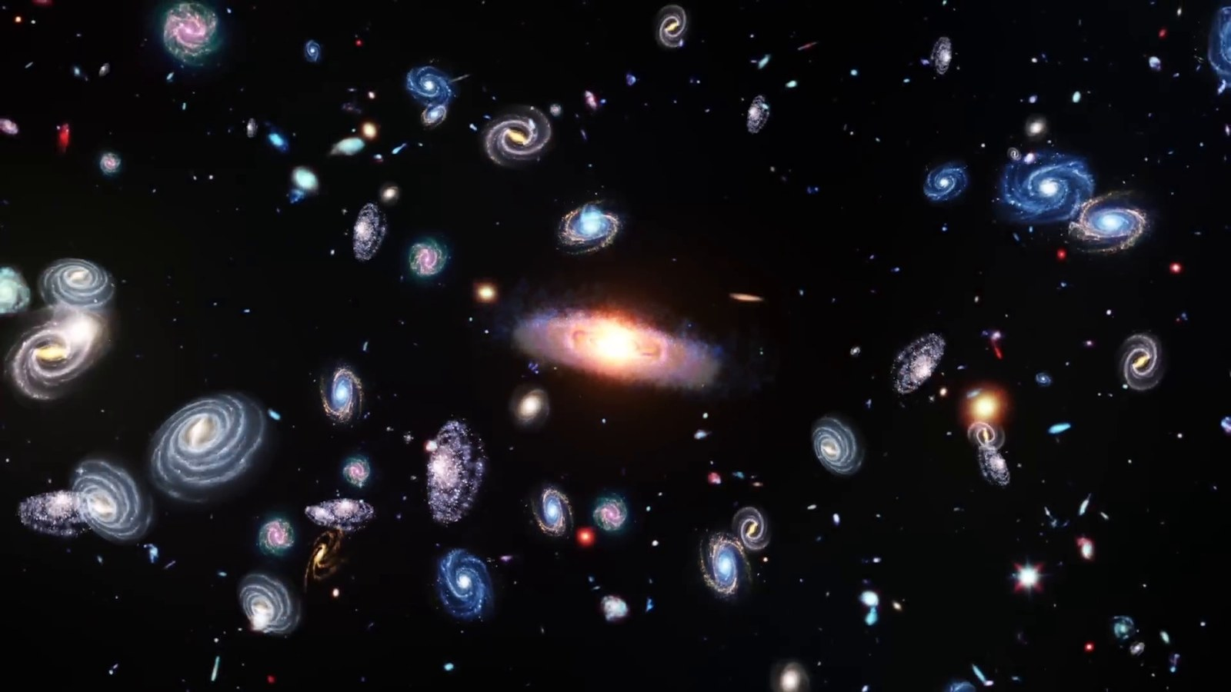
Matched transcript
No transcript was available for this time range.

Full Transcript
Language: English
Duration: 11 min 9 sec
Transcript quality: timestamped
The transcript includes timestamps and has been matched under the corresponding image by time range.
00:00 - 00:40
No. No, the rest would have got to be Mr. Bright, but he is certainly Mr. Seuss. The blue chase will meet with that star Jim Clancy for a couple of weeks. Earth. Our home planet. A tiny blue dot floating in the immense cosmic ocean. Here resides everyone you ever knew. Every human who ever lived. Every story that was ever told. It's where our journey begins. But as we zoom out, beyond our atmosphere, past the moon, beyond the familiar planets and the sun, we embark on an epic quest, a quest to grasp the true scale of our universe. As we leave Earth's embrace, the first marker
00:40 - 01:25
on our cosmic journey is the moon, about 384,400 kilometers away, a distance so vast that if you were to drive a car at a constant speed of 100 kilometers per hour, it would take you over 160 days to reach it. And from this lunar vantage point, Earth appears as a fragile sphere of blues and greens, cradled in the black void of space, a sight that puts our existence into a humbling perspective. This is Earth as seen from the moon. As we continue our outward journey, the next milestone is the sun, lying approximately one astronomical unit away from Earth. This unit, equivalent to about 150 million kilometers,
01:25 - 02:05
is the standard measuring stick for distances in our solar system. Imagine this. Light, traveling at an astounding speed of 300,000 kilometers per second, takes about 8 minutes and 20 seconds to journey from the sun to Earth. If you were to travel this distance in a commercial jet, flying at 900 kilometers per hour, it would take you about 19 years. This immense distance is a stark reminder of the vastness of space, even within our own solar system. The Sun, a fiery behemoth, provides life-sustaining energy to our planet from this incredible distance. Venturing beyond our home planet and its solar
02:05 - 02:41
companion, the Sun, we set our sights on Mars, our enigmatic red neighbor. Mars, at its closest approached to Earth is about 54.6 million kilometers away. However, this distance can stretch up to 401 million kilometers when the two planets are on opposite sides of the Sun. To put that in perspective, traveling to Mars at the speed of a commercial jet would take upwards of 50 years. This vast expanse of space between Earth and Mars has been a significant challenge for space exploration. The rovers and probes we have sent to the
02:41 - 03:20
red planet embark on a journey that is not just far but fraught with complexities due to the constantly changing distances and orbital dynamics As we journey to the outermost reaches of our solar system, we encounter Neptune, the distant ice giant. Lying roughly 4.5 billion kilometers from Earth, Neptune marks the edge of our solar neighborhood. Sunlight, racing across the vacuum of space takes about 4 hours and 15 minutes to reach Neptune from the Sun. This staggering distance showcases the enormity of our solar system.
03:20 - 04:04
Launched in 1977, the Voyager 1 space probe represents humanity's insatiable curiosity and our desire to explore beyond known boundaries. As of now, Voyager 1 has traveled for over four decades, covering a staggering distance of more than 22 billion kilometers from Earth. It's the farthest human-made object from our planet, a silent wanderer in the cosmic sea. In 1990, at the suggestion of the renowned astronomer Carl Sagan, Voyager 1 turned its camera back towards Earth for one final photograph. This resulted in the iconic pale blue dot image. At a distance of about 6 billion kilometers from Earth, our planet appeared as a tiny,
04:04 - 04:48
faint dot in the vastness of space. Sagan poetically reflected on this image, emphasizing our responsibility to cherish and preserve our only home, a small speck in the immense universe. At the very fringes of our solar system lies the Oort cloud, a vast theoretical sphere of icy objects. This distant cloud is thought to extend up to a staggering 100,000 astronomical units from the Sun. That's about 1.9 light-years, a distance so immense that it's on the cusp of interstellar space. Scientists determine the boundary of interstellar space, known as the heliopause, where the Sun's solar wind is stopped by the interstellar medium.
04:48 - 05:28
This is where the influence of our sun ceases and the vast realm of interstellar space begins. The Oort cloud represents the final frontier of our solar system, a boundary zone where the sun's influence wanes and the cosmic journey into the galaxy truly begins. As we venture beyond the confines of our solar system, our next point of interest is Alpha Centauri, the closest star system to our Sun. Located about 41.3 trillion kilometers away, this distance is equivalent to over 276,000 astronomical units. At such colossal distances,
05:28 - 06:09
the AU a measure so convenient within our solar system begins to lose its practicality Hence astronomers use the light year the distance light travels in one year for interstellar measurements Alpha Centauri is about 4.4 light years away from us. Considering our current space travel technology, a journey to Alpha Centauri is almost unfathomable. For instance, the Voyager spacecraft, traveling at about 17 kilometers per second, would take over 70,000 years to reach this neighboring star system. This immense distance underscores the vastness of space that separates the stars and highlights the challenges of interstellar travel.
06:10 - 06:52
Our journey now takes us to the grand scale of our home galaxy, the Milky Way. Spanning about 100,000 light-years in diameter, this vast spiral galaxy is home to hundreds of billions of stars, each potentially hosting their own planetary systems. Within this immense structure, there's a tiny sphere known as the human radio bubble, extending about 100 light-years from Earth. This bubble represents the farthest extent of human influence in the cosmos, the reach of our radio and television broadcasts into space. Beyond this bubble, it's as if humanity never existed. Any civilizations residing in the vast majority of our galaxy would be oblivious to our presence,
06:53 - 07:34
given that our signals haven't reached them yet. The scale of the Milky Way is so vast that our entire recorded history is but a whisper in the cosmic wind, undetectable beyond this small bubble. As we leave the Milky Way, we enter the vast, almost incomprehensible realm of intergalactic space. Here, galaxies float in the cosmic ocean, separated by mind-boggling distances. Our galaxy is part of a small cosmic neighborhood known as the Local Group, a cluster of more than 50 galaxies spread across approximately 10 million light-years. The Local Group is a diverse assembly, including not just spiral galaxies like the Milky Way
07:34 - 08:12
and Andromeda, but also a multitude of smaller dwarf galaxies. The distances here are so vast that light from one end of the local group to the other would take 10 million years to traverse. This scale dwarfs anything within our own galaxy, underscoring the enormity of the universe. Intergalactic space is a silent expanse, a vast wilderness between the islands of galactic light. In this immense void, our galaxy, home to our entire history, is just a tiny speck among a single story in the grand cosmic library. As we extend our cosmic gaze beyond the local
08:12 - 08:56
group we encounter the colossal Virgo supercluster an immense collection of galaxy groups and clusters including our own local group Encompassing a region of space about 110 million light in diameter or 33 megaparsecs the Virgo supercluster is a titanic structure in the universe, containing thousands of galaxies from at least 100 galaxy groups and clusters, each with their own myriad stars and planets. As we journey outward from the Virgo supercluster, we arrive at an even more staggering cosmic structure, the Laniakia supercluster. This immense congregation of galaxies, which includes the Virgo supercluster and extends over 500 million
08:56 - 09:35
light-years, is our galactic home on a grand scale. Laniakia, meaning immense heaven in Hawaiian, truly lives up to its name. Containing the mass of 100 million billion suns, Laniakia is a gravitational masterpiece with galaxy clusters, superclusters, and countless celestial bodies bound in a cosmic web of attraction and motion. At the heart of Laniachia lies the Great Attractor, a mysterious region of space that exerts a massive gravitational pull on the galaxies within this supercluster. In this vast expanse, our Milky Way, the entire local group, and even
09:35 - 10:16
the Virgo supercluster are just tiny components of this gigantic structure. Laniakia provides a profound context for our existence. In this immense supercluster, we are part of something far greater and more majestic than we can fully comprehend. As we reach the boundaries of our cosmic exploration, we encounter the limits of the observable universe, an astronomical marvel stretching about 93 billion light-years in diameter. This begs a fascinating question. If the universe is only 13.8 billion years old, how can it be so vast? The answer lies in the nature of cosmic expansion.
10:16 - 10:57
The universe has been expanding since the Big Bang, stretching space and increasing distances between celestial bodies. But what lies beyond the observable universe? This remains one of the greatest mysteries of cosmology. Some regions of space are expanding away from us faster than the speed of light, placing them forever out of our view. Consequently, the true size of the entire universe remains unknown and potentially infinite. The observable universe, vast as it is, might just be a tiny fragment of the entire cosmic expanse. We are left with the humbling realization that there might always be regions of space, entire
10:57 - 11:04
galaxies and wonders that we will never witness as they retreat endlessly into the depths of the ever-expanding universe.

